SEC Form 3
FORM 3 | UNITED STATES SECURITIES AND EXCHANGE COMMISSION
 | Washington, D.C. 20549
 | Washington, D.C. 20549 |  | OMB APPROVAL
 | INITIAL STATEMENT OF BENEFICIAL OWNERSHIP OF SECURITIES
 | INITIAL STATEMENT OF BENEFICIAL OWNERSHIP OF SECURITIES |  | OMB Number: | 3235-0104
 |  |  | Estimated average burden
 | Filed pursuant to Section 16(a) of the Securities Exchange Act of 1934 |  | hours per response: | 0.5
or Section 30(h) of the Investment Company Act of 1940
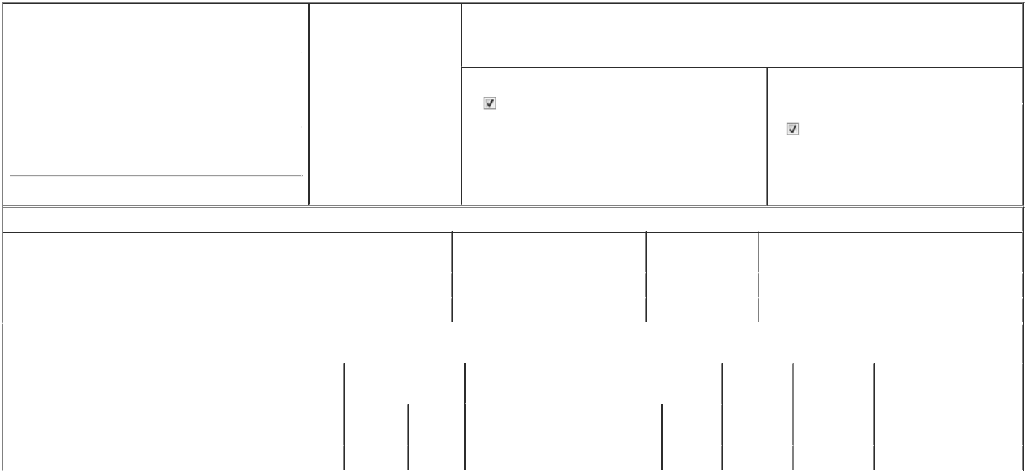

1. Name and Address of Reporting Person* |  |  |  |  |  | 2. Date of Event Requiring
 |  | JACOBS PAUL E |  |  |  | Statement (Month/Day/Year)
 |  |  |  |  | 03/18/2026
 |  | (Last) | (First) |  | (Middle)
 |  | C/O ARM HOLDINGS PLC
 |  | 110 FULBOURN ROAD
(Street)
 |  | CAMBRIDGE |  |  | CB1 9NJ

3. Issuer Name and Ticker or Trading Symbol

ARM HOLDINGS PLC /UK [ ARM ]

4. Relationship of Reporting Person(s) to Issuer |  | 5. | If Amendment, Date of Original Filed (Month/Day/Year)
(Check all applicable)
Director | 10% Owner
Director | 10% Owner | 6. | Individual or Joint/Group Filing (Check Applicable Line)
Officer (give title | Other (specify below) | 6. | Individual or Joint/Group Filing (Check Applicable Line)
Officer (give title | Other (specify below) |  | Form filed by One Reporting Person
below) | Other (specify below) |  | Form filed by One Reporting Person

Form filed by More than One Reporting Person

(City) (State) (Zip)

Table I - Non-Derivative Securities Beneficially Owned

1. Title of Security (Instr. 4) | 2. Amount of Securities Beneficially | 3. Ownership Form: | 4. Nature of Indirect Beneficial Ownership (Instr. 5)
 | Owned (Instr. 4) | Direct (D) or Indirect
 |  | (I) (Instr. 5)

 | Ordinary Shares⁽¹⁾ |  |  |  | 5,301 | D
 | Ordinary Shares⁽¹⁾ |  |  |  | 2,130 | I | By Trust
 |  |  | Table II - Derivative Securities Beneficially Owned
 |  | (e.g., puts, calls, warrants, options, convertible securities)
 | 1. Title of Derivative Security (Instr. 4) |  | 2. Date Exercisable and |  | 3. Title and Amount of Securities Underlying |  | 4. | 5. Ownership | 6. Nature of Indirect Beneficial
 |  |  | Expiration Date |  | Derivative Security (Instr. 4) |  | Conversion | Form: Direct | Ownership (Instr. 5)
 |  |  | (Month/Day/Year) |  |  |  | or Exercise | (D) or Indirect
 |  |  |  |  |  |  | Price of | (I) (Instr. 5)
 |  |  |  |  |  | Amount or | Price of | (I) (Instr. 5)
 |  |  |  |  |  | Amount or | Derivative
 |  |  | Date | Expiration | Title | Number of | Security
 |  |  | Exercisable | Date | Title | Shares
 | Restricted Stock Units | (2) |  | (2) | Ordinary Shares⁽¹⁾ | 2,141 | (3) | D
 | Explanation of Responses:

- Ordinary shares, nominal value 0.001 GBP per share ("Ordinary Shares"), are held in the form of American Depositary Shares ("ADSs"). Each ADS represents 1 Ordinary Share.

- The restricted stock units ("RSUs") will vest in full on May 15, 2026, subject to continued service to Arm Holdings plc.

- Each RSU represents the right to receive, following vesting, 1 Ordinary Share held in the form of an ADS.

Remarks:

Exhibit 24 - Power of Attorney
/s/ George Kanelos, as Attorney-in-Fact _{03/18/2026}
for Paul E. Jacobs

** Signature of Reporting Person Date

Reminder: Report on a separate line for each class of securities beneficially owned directly or indirectly.

* If the form is filed by more than one reporting person, see Instruction 5 (b)(v).

- Intentional misstatements or omissions of facts constitute Federal Criminal Violations See 18 U.S.C. 1001 and 15 U.S.C. 78ff(a). Note: File three copies of this Form, one of which must be manually signed. If space is insufficient, see Instruction 6 for procedure.
Persons who respond to the collection of information contained in this form are not required to respond unless the form displays a currently valid OMB Number.



