UNITED STATES
SECURITIES AND EXCHANGE COMMISSION
Washington, D.C. 20549

Form 6-K

REPORT OF FOREIGN PRIVATE ISSUER PURSUANT TO RULE 13a-16 OR 15d-16 UNDER THE SECURITIES EXCHANGE ACT OF 1934

For the month of August, 2026

Commission File Number 001-41800

Arm Holdings plc

110 Fulbourn Road
Cambridge CB1 9NJ
United Kingdom
(Address of principal executive office)
Indicate by check mark whether the registrant files or will file annual reports under cover of Form 20-F or Form 40-F.
Form 20-F ☒ Form 40-F ☐

2026 Annual General Meeting of Arm Holdings plc
On August 10, 2026, Arm Holdings plc (the “Company”) distributed to the holders of record of the Company’s ordinary shares, nominal value of £0.001 per share (“Ordinary Shares”), as of July 31, 2026 (A) a notice of the annual general meeting (the “Shareholders AGM Notice”) to be held at 110 Fulbourn Road, Cambridge CB1 9NJ, United Kingdom on September 9, 2026 at 3:00 p.m. (British Summer Time) (the “AGM”), and (B) the attendance card, the poll card and a form of proxy for the AGM (the “Proxy Materials”). The Shareholders AGM Notice and the Proxy Materials are furnished as Exhibits 99.1 and 99.2, respectively, to this report on Form 6-K.
On or about August 10, 2026, Citibank, N.A., in its capacity as the depositary bank (the “Depositary”) for the Company’s American depositary shares (“ADSs”), each representing one Ordinary Share, commenced mailing notice materials (the “Depositary’s Notice”) and voting instruction cards (the “ADS Voting Instruction Card”) to ADS holders to enable ADS holders of record as of July 31, 2026 to instruct the Depositary to vote the Ordinary Shares represented by their ADSs at the AGM. Additionally, on August 10, 2026, the Company distributed to the ADS holders of record as of July 31, 2026 a notice of the AGM (the “ADS AGM Notice”). The Depositary’s Notice, the ADS Voting Instruction Card and the ADS AGM Notice are furnished as Exhibits 99.3, 99.4 and 99.5, respectively, to this report on Form 6-K.
The Company’s annual report and accounts for the year ended March 31, 2026 (the “UK Annual Report”) and other materials related to the AGM are posted on the investor relations section of the Company’s website at https://investors.arm.com/ir-resources/annual-meeting.
The information contained in this report on Form 6-K, including Exhibits 99.1, 99.2, 99.3, 99.4 and 99.5, is intended to be furnished and shall not be deemed “filed” for purposes of Section 18 of the Securities Exchange Act of 1934, as amended (the “Exchange Act”), or incorporated by reference in any filing under the Securities Act of 1933, as amended, or the Exchange Act, unless expressly set forth by specific reference in such a filing.
Exhibits
Reference is made to the Exhibit Index included hereto.

EXHIBIT INDEX

Exhibit Number |  |  | Description
99.1 |  |  | Notice to Shareholders of Arm Holdings plc of Annual General Meeting
99.2 |  |  | Attendance Card, Poll Card and Form of Proxy
99.3 |  |  | Depositary’s Notice to ADS Holders of Arm Holdings plc of Annual General Meeting
99.4 |  |  | ADS Voting Instruction Card for Annual General Meeting
99.5 |  |  | Arm Holdings plc’s Notice to ADS Holders of Annual General Meeting

SIGNATURES
Pursuant to the requirements of the Securities Exchange Act of 1934, the registrant has duly caused this report to be signed on its behalf by the undersigned, thereunto duly authorized.
 |  |  | ARM HOLDINGS PLC
Date: August 10, 2026 |  |  | By: |  |  | /s/ Laura Bartels
 |  |  | Name: |  |  | Laura Bartels
 |  |  | Title: |  |  | Chief Accounting Officer  (Principal Accounting Officer)

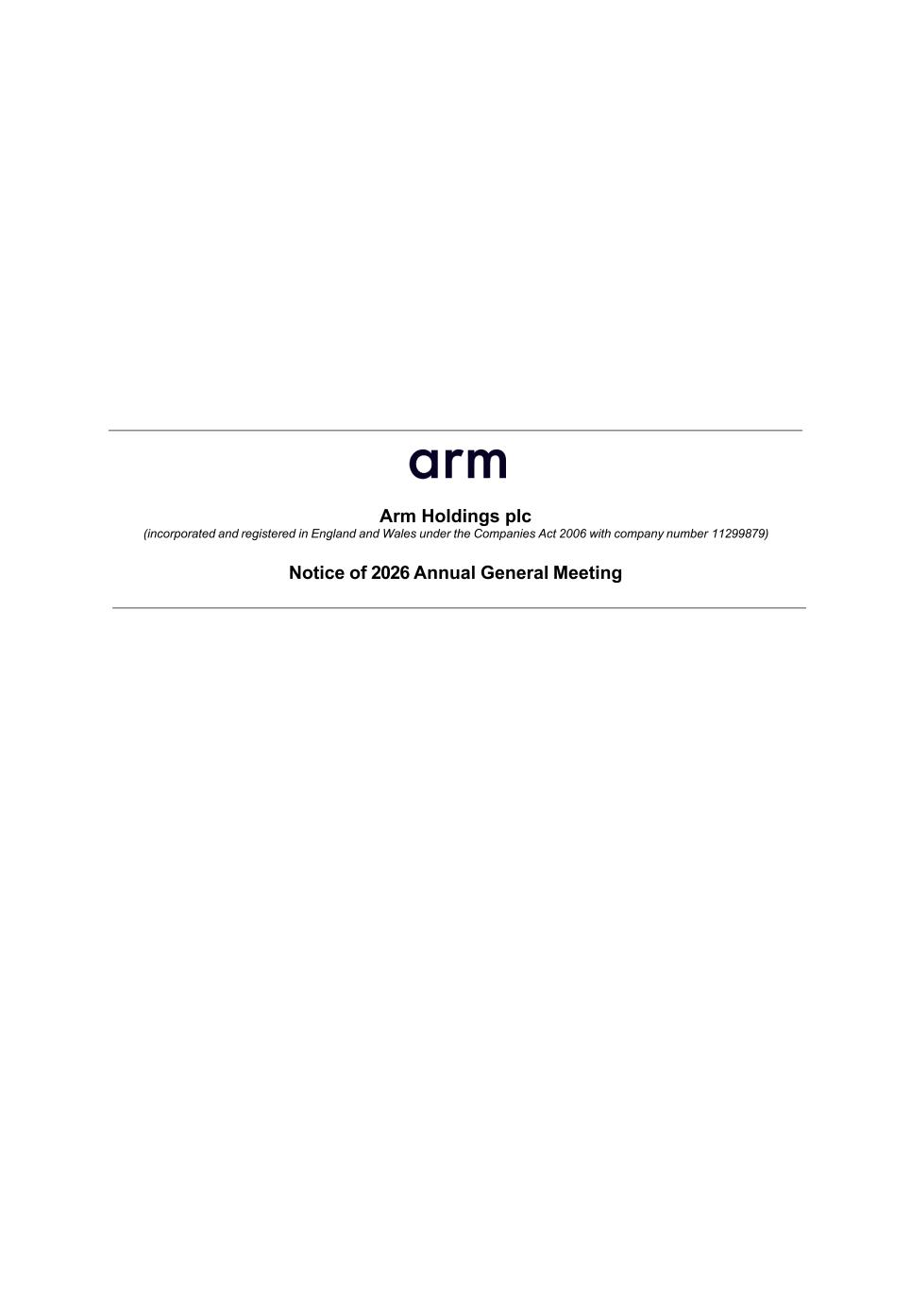

Arm Holdings plc (incorporated and registered in England and Wales under the Companies Act 2006 with company number 11299879) Notice of 2026 Annual General Meeting

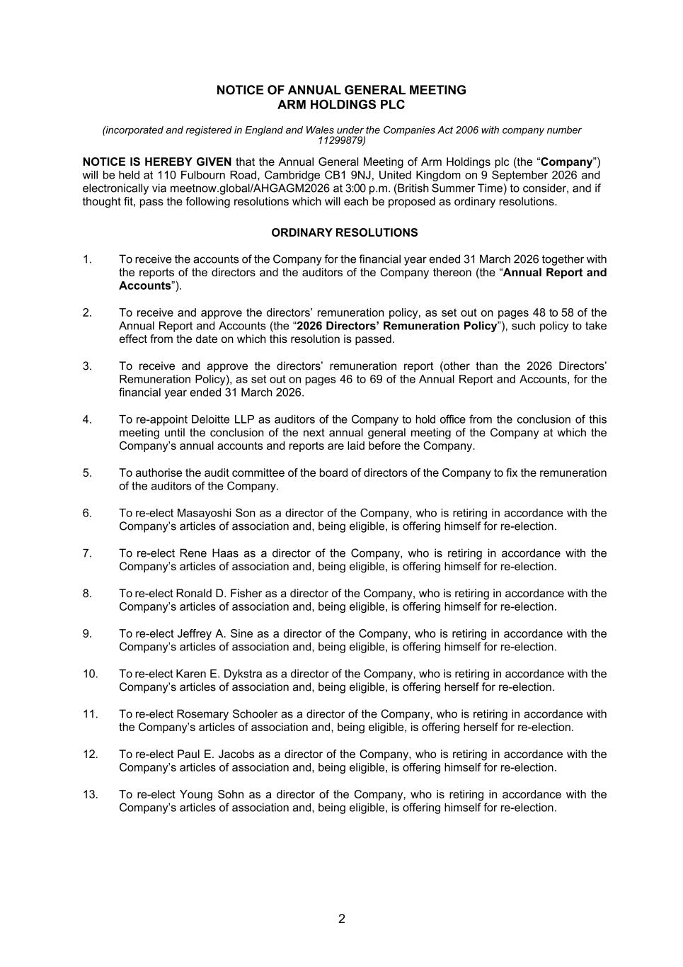
2 NOTICE OF ANNUAL GENERAL MEETING ARM HOLDINGS PLC (incorporated and registered in England and Wales under the Companies Act 2006 with company number 11299879) NOTICE IS HEREBY GIVEN that the Annual General Meeting of Arm Holdings plc (the “Company”) will be held at 110 Fulbourn Road, Cambridge CB1 9NJ, United Kingdom on 9 September 2026 and electronically via meetnow.global/AHGAGM2026 at 3:00 p.m. (British Summer Time) to consider, and if thought fit, pass the following resolutions which will each be proposed as ordinary resolutions. ORDINARY RESOLUTIONS 1. To receive the accounts of the Company for the financial year ended 31 March 2026 together with the reports of the directors and the auditors of the Company thereon (the “Annual Report and Accounts”). 2. To receive and approve the directors’ remuneration policy, as set out on pages 48 to 58 of the Annual Report and Accounts (the “2026 Directors’ Remuneration Policy”), such policy to take effect from the date on which this resolution is passed. 3. To receive and approve the directors’ remuneration report (other than the 2026 Directors’ Remuneration Policy), as set out on pages 46 to 69 of the Annual Report and Accounts, for the financial year ended 31 March 2026. 4. To re-appoint Deloitte LLP as auditors of the Company to hold office from the conclusion of this meeting until the conclusion of the next annual general meeting of the Company at which the Company’s annual accounts and reports are laid before the Company. 5. To authorise the audit committee of the board of directors of the Company to fix the remuneration of the auditors of the Company. 6. To re-elect Masayoshi Son as a director of the Company, who is retiring in accordance with the Company’s articles of association and, being eligible, is offering himself for re-election. 7. To re-elect Rene Haas as a director of the Company, who is retiring in accordance with the Company’s articles of association and, being eligible, is offering himself for re-election. 8. To re-elect Ronald D. Fisher as a director of the Company, who is retiring in accordance with the Company’s articles of association and, being eligible, is offering himself for re-election. 9. To re-elect Jeffrey A. Sine as a director of the Company, who is retiring in accordance with the Company’s articles of association and, being eligible, is offering himself for re-election. 10. To re-elect Karen E. Dykstra as a director of the Company, who is retiring in accordance with the Company’s articles of association and, being eligible, is offering herself for re-election. 11. To re-elect Rosemary Schooler as a director of the Company, who is retiring in accordance with the Company’s articles of association and, being eligible, is offering herself for re-election. 12. To re-elect Paul E. Jacobs as a director of the Company, who is retiring in accordance with the Company’s articles of association and, being eligible, is offering himself for re-election. 13. To re-elect Young Sohn as a director of the Company, who is retiring in accordance with the Company’s articles of association and, being eligible, is offering himself for re-election.


3 Registered Office BY ORDER OF THE BOARD 110 Fulbourn Road Cambridge CB1 9NJ United Kingdom /s/ Spencer Collins Spencer Collins 6 August 2026 Company Secretary

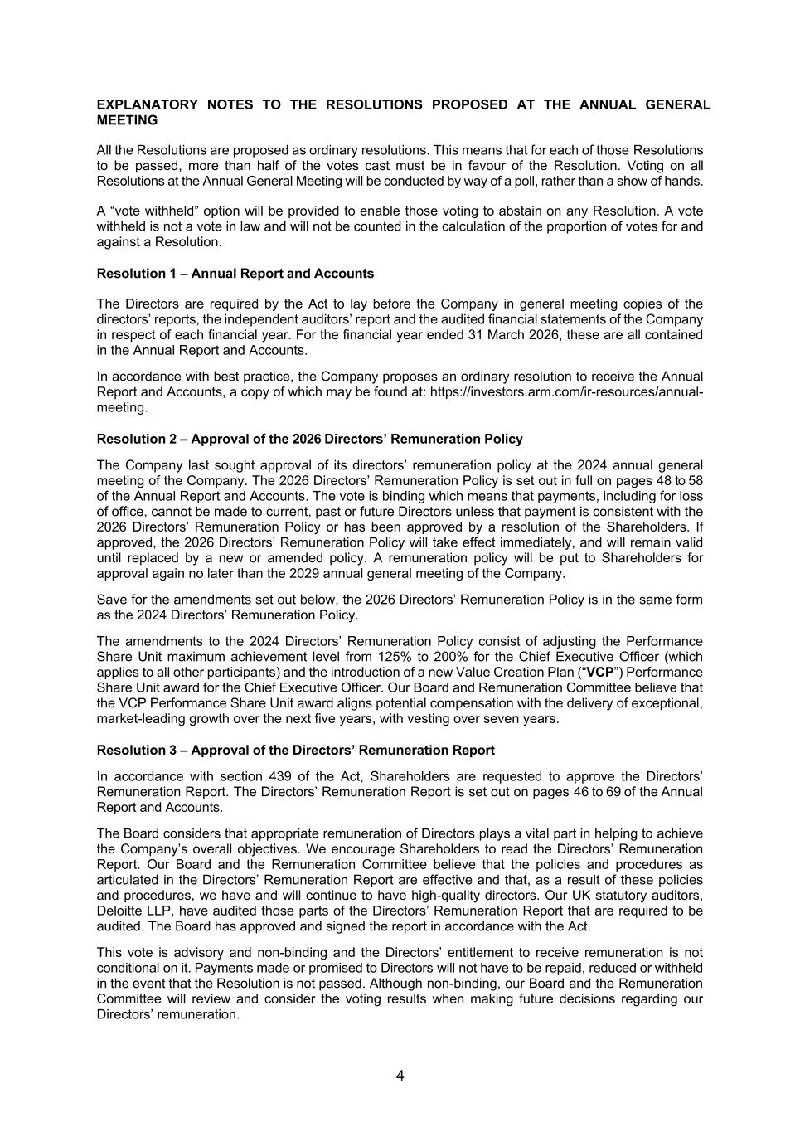
4 EXPLANATORY NOTES TO THE RESOLUTIONS PROPOSED AT THE ANNUAL GENERAL MEETING All the Resolutions are proposed as ordinary resolutions. This means that for each of those Resolutions to be passed, more than half of the votes cast must be in favour of the Resolution. Voting on all Resolutions at the Annual General Meeting will be conducted by way of a poll, rather than a show of hands. A “vote withheld” option will be provided to enable those voting to abstain on any Resolution. A vote withheld is not a vote in law and will not be counted in the calculation of the proportion of votes for and against a Resolution. Resolution 1 – Annual Report and Accounts The Directors are required by the Act to lay before the Company in general meeting copies of the directors’ reports, the independent auditors’ report and the audited financial statements of the Company in respect of each financial year. For the financial year ended 31 March 2026, these are all contained in the Annual Report and Accounts. In accordance with best practice, the Company proposes an ordinary resolution to receive the Annual Report and Accounts, a copy of which may be found at: https://investors.arm.com/ir-resources/annual- meeting. Resolution 2 – Approval of the 2026 Directors’ Remuneration Policy The Company last sought approval of its directors’ remuneration policy at the 2024 annual general meeting of the Company. The 2026 Directors’ Remuneration Policy is set out in full on pages 48 to 58 of the Annual Report and Accounts. The vote is binding which means that payments, including for loss of office, cannot be made to current, past or future Directors unless that payment is consistent with the 2026 Directors’ Remuneration Policy or has been approved by a resolution of the Shareholders. If approved, the 2026 Directors’ Remuneration Policy will take effect immediately, and will remain valid until replaced by a new or amended policy. A remuneration policy will be put to Shareholders for approval again no later than the 2029 annual general meeting of the Company. Save for the amendments set out below, the 2026 Directors’ Remuneration Policy is in the same form as the 2024 Directors’ Remuneration Policy. The amendments to the 2024 Directors’ Remuneration Policy consist of adjusting the Performance Share Unit maximum achievement level from 125% to 200% for the Chief Executive Officer (which applies to all other participants) and the introduction of a new Value Creation Plan (“VCP”) Performance Share Unit award for the Chief Executive Officer. Our Board and Remuneration Committee believe that the VCP Performance Share Unit award aligns potential compensation with the delivery of exceptional, market-leading growth over the next five years, with vesting over seven years. Resolution 3 – Approval of the Directors’ Remuneration Report In accordance with section 439 of the Act, Shareholders are requested to approve the Directors’ Remuneration Report. The Directors’ Remuneration Report is set out on pages 46 to 69 of the Annual Report and Accounts. The Board considers that appropriate remuneration of Directors plays a vital part in helping to achieve the Company’s overall objectives. We encourage Shareholders to read the Directors’ Remuneration Report. Our Board and the Remuneration Committee believe that the policies and procedures as articulated in the Directors’ Remuneration Report are effective and that, as a result of these policies and procedures, we have and will continue to have high-quality directors. Our UK statutory auditors, Deloitte LLP, have audited those parts of the Directors’ Remuneration Report that are required to be audited. The Board has approved and signed the report in accordance with the Act. This vote is advisory and non-binding and the Directors’ entitlement to receive remuneration is not conditional on it. Payments made or promised to Directors will not have to be repaid, reduced or withheld in the event that the Resolution is not passed. Although non-binding, our Board and the Remuneration Committee will review and consider the voting results when making future decisions regarding our Directors’ remuneration.

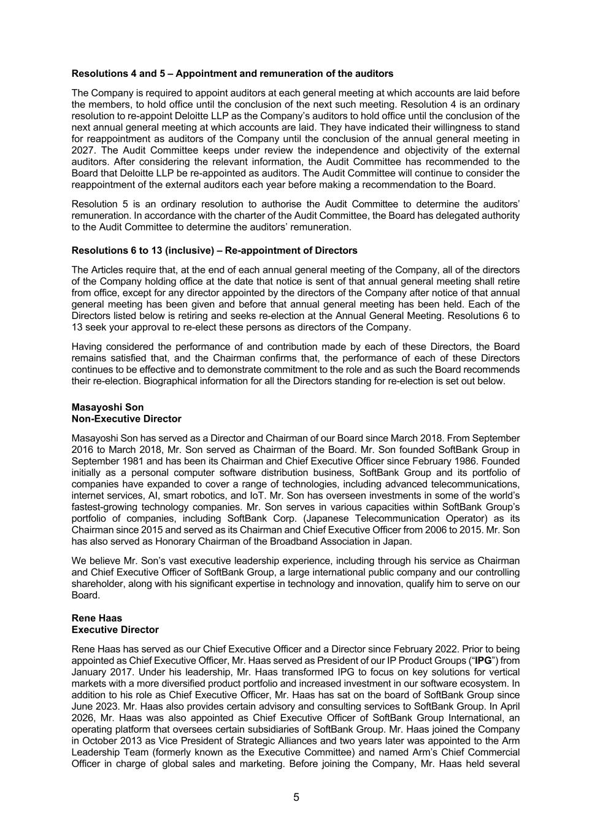
5 Resolutions 4 and 5 – Appointment and remuneration of the auditors The Company is required to appoint auditors at each general meeting at which accounts are laid before the members, to hold office until the conclusion of the next such meeting. Resolution 4 is an ordinary resolution to re-appoint Deloitte LLP as the Company’s auditors to hold office until the conclusion of the next annual general meeting at which accounts are laid. They have indicated their willingness to stand for reappointment as auditors of the Company until the conclusion of the annual general meeting in 2027. The Audit Committee keeps under review the independence and objectivity of the external auditors. After considering the relevant information, the Audit Committee has recommended to the Board that Deloitte LLP be re-appointed as auditors. The Audit Committee will continue to consider the reappointment of the external auditors each year before making a recommendation to the Board. Resolution 5 is an ordinary resolution to authorise the Audit Committee to determine the auditors’ remuneration. In accordance with the charter of the Audit Committee, the Board has delegated authority to the Audit Committee to determine the auditors’ remuneration. Resolutions 6 to 13 (inclusive) – Re-appointment of Directors The Articles require that, at the end of each annual general meeting of the Company, all of the directors of the Company holding office at the date that notice is sent of that annual general meeting shall retire from office, except for any director appointed by the directors of the Company after notice of that annual general meeting has been given and before that annual general meeting has been held. Each of the Directors listed below is retiring and seeks re-election at the Annual General Meeting. Resolutions 6 to 13 seek your approval to re-elect these persons as directors of the Company. Having considered the performance of and contribution made by each of these Directors, the Board remains satisfied that, and the Chairman confirms that, the performance of each of these Directors continues to be effective and to demonstrate commitment to the role and as such the Board recommends their re-election. Biographical information for all the Directors standing for re-election is set out below. Masayoshi Son Non-Executive Director Masayoshi Son has served as a Director and Chairman of our Board since March 2018. From September 2016 to March 2018, Mr. Son served as Chairman of the Board. Mr. Son founded SoftBank Group in September 1981 and has been its Chairman and Chief Executive Officer since February 1986. Founded initially as a personal computer software distribution business, SoftBank Group and its portfolio of companies have expanded to cover a range of technologies, including advanced telecommunications, internet services, AI, smart robotics, and IoT. Mr. Son has overseen investments in some of the world’s fastest-growing technology companies. Mr. Son serves in various capacities within SoftBank Group’s portfolio of companies, including SoftBank Corp. (Japanese Telecommunication Operator) as its Chairman since 2015 and served as its Chairman and Chief Executive Officer from 2006 to 2015. Mr. Son has also served as Honorary Chairman of the Broadband Association in Japan. We believe Mr. Son’s vast executive leadership experience, including through his service as Chairman and Chief Executive Officer of SoftBank Group, a large international public company and our controlling shareholder, along with his significant expertise in technology and innovation, qualify him to serve on our Board. Rene Haas Executive Director Rene Haas has served as our Chief Executive Officer and a Director since February 2022. Prior to being appointed as Chief Executive Officer, Mr. Haas served as President of our IP Product Groups (“IPG”) from January 2017. Under his leadership, Mr. Haas transformed IPG to focus on key solutions for vertical markets with a more diversified product portfolio and increased investment in our software ecosystem. In addition to his role as Chief Executive Officer, Mr. Haas has sat on the board of SoftBank Group since June 2023. Mr. Haas also provides certain advisory and consulting services to SoftBank Group. In April 2026, Mr. Haas was also appointed as Chief Executive Officer of SoftBank Group International, an operating platform that oversees certain subsidiaries of SoftBank Group. Mr. Haas joined the Company in October 2013 as Vice President of Strategic Alliances and two years later was appointed to the Arm Leadership Team (formerly known as the Executive Committee) and named Arm’s Chief Commercial Officer in charge of global sales and marketing. Before joining the Company, Mr. Haas held several

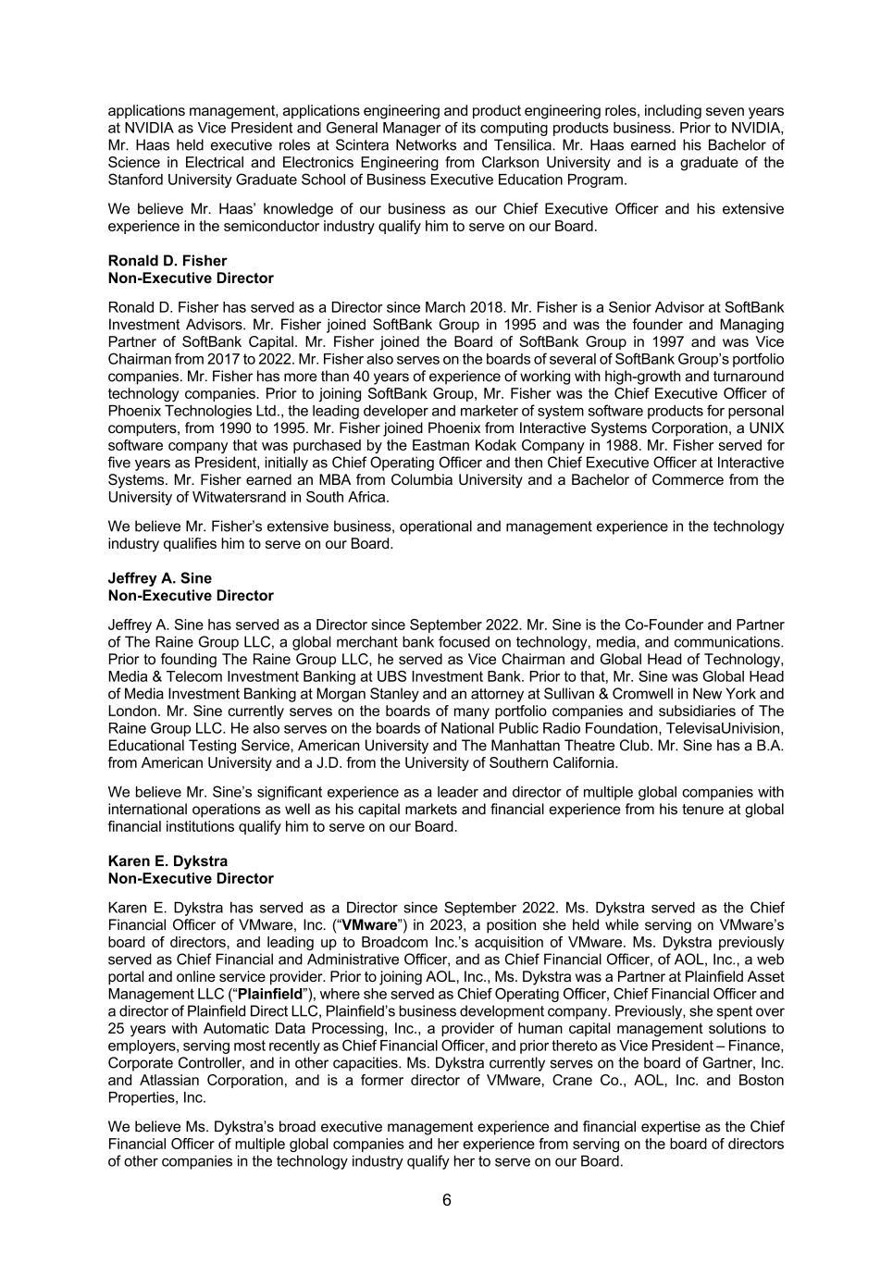
6 applications management, applications engineering and product engineering roles, including seven years at NVIDIA as Vice President and General Manager of its computing products business. Prior to NVIDIA, Mr. Haas held executive roles at Scintera Networks and Tensilica. Mr. Haas earned his Bachelor of Science in Electrical and Electronics Engineering from Clarkson University and is a graduate of the Stanford University Graduate School of Business Executive Education Program. We believe Mr. Haas’ knowledge of our business as our Chief Executive Officer and his extensive experience in the semiconductor industry qualify him to serve on our Board. Ronald D. Fisher Non-Executive Director Ronald D. Fisher has served as a Director since March 2018. Mr. Fisher is a Senior Advisor at SoftBank Investment Advisors. Mr. Fisher joined SoftBank Group in 1995 and was the founder and Managing Partner of SoftBank Capital. Mr. Fisher joined the Board of SoftBank Group in 1997 and was Vice Chairman from 2017 to 2022. Mr. Fisher also serves on the boards of several of SoftBank Group’s portfolio companies. Mr. Fisher has more than 40 years of experience of working with high-growth and turnaround technology companies. Prior to joining SoftBank Group, Mr. Fisher was the Chief Executive Officer of Phoenix Technologies Ltd., the leading developer and marketer of system software products for personal computers, from 1990 to 1995. Mr. Fisher joined Phoenix from Interactive Systems Corporation, a UNIX software company that was purchased by the Eastman Kodak Company in 1988. Mr. Fisher served for five years as President, initially as Chief Operating Officer and then Chief Executive Officer at Interactive Systems. Mr. Fisher earned an MBA from Columbia University and a Bachelor of Commerce from the University of Witwatersrand in South Africa. We believe Mr. Fisher’s extensive business, operational and management experience in the technology industry qualifies him to serve on our Board. Jeffrey A. Sine Non-Executive Director Jeffrey A. Sine has served as a Director since September 2022. Mr. Sine is the Co-Founder and Partner of The Raine Group LLC, a global merchant bank focused on technology, media, and communications. Prior to founding The Raine Group LLC, he served as Vice Chairman and Global Head of Technology, Media & Telecom Investment Banking at UBS Investment Bank. Prior to that, Mr. Sine was Global Head of Media Investment Banking at Morgan Stanley and an attorney at Sullivan & Cromwell in New York and London. Mr. Sine currently serves on the boards of many portfolio companies and subsidiaries of The Raine Group LLC. He also serves on the boards of National Public Radio Foundation, TelevisaUnivision, Educational Testing Service, American University and The Manhattan Theatre Club. Mr. Sine has a B.A. from American University and a J.D. from the University of Southern California. We believe Mr. Sine’s significant experience as a leader and director of multiple global companies with international operations as well as his capital markets and financial experience from his tenure at global financial institutions qualify him to serve on our Board. Karen E. Dykstra Non-Executive Director Karen E. Dykstra has served as a Director since September 2022. Ms. Dykstra served as the Chief Financial Officer of VMware, Inc. (“VMware”) in 2023, a position she held while serving on VMware’s board of directors, and leading up to Broadcom Inc.’s acquisition of VMware. Ms. Dykstra previously served as Chief Financial and Administrative Officer, and as Chief Financial Officer, of AOL, Inc., a web portal and online service provider. Prior to joining AOL, Inc., Ms. Dykstra was a Partner at Plainfield Asset Management LLC (“Plainfield”), where she served as Chief Operating Officer, Chief Financial Officer and a director of Plainfield Direct LLC, Plainfield’s business development company. Previously, she spent over 25 years with Automatic Data Processing, Inc., a provider of human capital management solutions to employers, serving most recently as Chief Financial Officer, and prior thereto as Vice President – Finance, Corporate Controller, and in other capacities. Ms. Dykstra currently serves on the board of Gartner, Inc. and Atlassian Corporation, and is a former director of VMware, Crane Co., AOL, Inc. and Boston Properties, Inc. We believe Ms. Dykstra’s broad executive management experience and financial expertise as the Chief Financial Officer of multiple global companies and her experience from serving on the board of directors of other companies in the technology industry qualify her to serve on our Board.

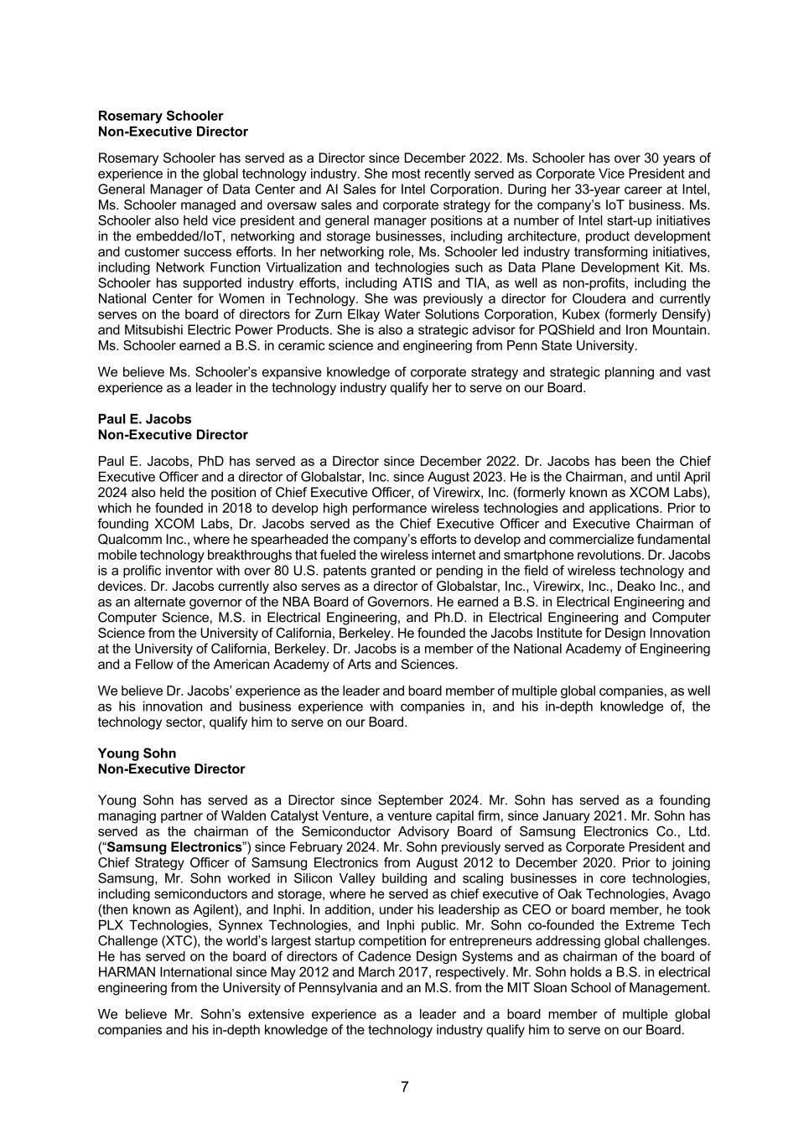
7 Rosemary Schooler Non-Executive Director Rosemary Schooler has served as a Director since December 2022. Ms. Schooler has over 30 years of experience in the global technology industry. She most recently served as Corporate Vice President and General Manager of Data Center and AI Sales for Intel Corporation. During her 33-year career at Intel, Ms. Schooler managed and oversaw sales and corporate strategy for the company’s IoT business. Ms. Schooler also held vice president and general manager positions at a number of Intel start-up initiatives in the embedded/IoT, networking and storage businesses, including architecture, product development and customer success efforts. In her networking role, Ms. Schooler led industry transforming initiatives, including Network Function Virtualization and technologies such as Data Plane Development Kit. Ms. Schooler has supported industry efforts, including ATIS and TIA, as well as non-profits, including the National Center for Women in Technology. She was previously a director for Cloudera and currently serves on the board of directors for Zurn Elkay Water Solutions Corporation, Kubex (formerly Densify) and Mitsubishi Electric Power Products. She is also a strategic advisor for PQShield and Iron Mountain. Ms. Schooler earned a B.S. in ceramic science and engineering from Penn State University. We believe Ms. Schooler’s expansive knowledge of corporate strategy and strategic planning and vast experience as a leader in the technology industry qualify her to serve on our Board. Paul E. Jacobs Non-Executive Director Paul E. Jacobs, PhD has served as a Director since December 2022. Dr. Jacobs has been the Chief Executive Officer and a director of Globalstar, Inc. since August 2023. He is the Chairman, and until April 2024 also held the position of Chief Executive Officer, of Virewirx, Inc. (formerly known as XCOM Labs), which he founded in 2018 to develop high performance wireless technologies and applications. Prior to founding XCOM Labs, Dr. Jacobs served as the Chief Executive Officer and Executive Chairman of Qualcomm Inc., where he spearheaded the company’s efforts to develop and commercialize fundamental mobile technology breakthroughs that fueled the wireless internet and smartphone revolutions. Dr. Jacobs is a prolific inventor with over 80 U.S. patents granted or pending in the field of wireless technology and devices. Dr. Jacobs currently also serves as a director of Globalstar, Inc., Virewirx, Inc., Deako Inc., and as an alternate governor of the NBA Board of Governors. He earned a B.S. in Electrical Engineering and Computer Science, M.S. in Electrical Engineering, and Ph.D. in Electrical Engineering and Computer Science from the University of California, Berkeley. He founded the Jacobs Institute for Design Innovation at the University of California, Berkeley. Dr. Jacobs is a member of the National Academy of Engineering and a Fellow of the American Academy of Arts and Sciences. We believe Dr. Jacobs’ experience as the leader and board member of multiple global companies, as well as his innovation and business experience with companies in, and his in-depth knowledge of, the technology sector, qualify him to serve on our Board. Young Sohn Non-Executive Director Young Sohn has served as a Director since September 2024. Mr. Sohn has served as a founding managing partner of Walden Catalyst Venture, a venture capital firm, since January 2021. Mr. Sohn has served as the chairman of the Semiconductor Advisory Board of Samsung Electronics Co., Ltd. (“Samsung Electronics”) since February 2024. Mr. Sohn previously served as Corporate President and Chief Strategy Officer of Samsung Electronics from August 2012 to December 2020. Prior to joining Samsung, Mr. Sohn worked in Silicon Valley building and scaling businesses in core technologies, including semiconductors and storage, where he served as chief executive of Oak Technologies, Avago (then known as Agilent), and Inphi. In addition, under his leadership as CEO or board member, he took PLX Technologies, Synnex Technologies, and Inphi public. Mr. Sohn co-founded the Extreme Tech Challenge (XTC), the world’s largest startup competition for entrepreneurs addressing global challenges. He has served on the board of directors of Cadence Design Systems and as chairman of the board of HARMAN International since May 2012 and March 2017, respectively. Mr. Sohn holds a B.S. in electrical engineering from the University of Pennsylvania and an M.S. from the MIT Sloan School of Management. We believe Mr. Sohn’s extensive experience as a leader and a board member of multiple global companies and his in-depth knowledge of the technology industry qualify him to serve on our Board.

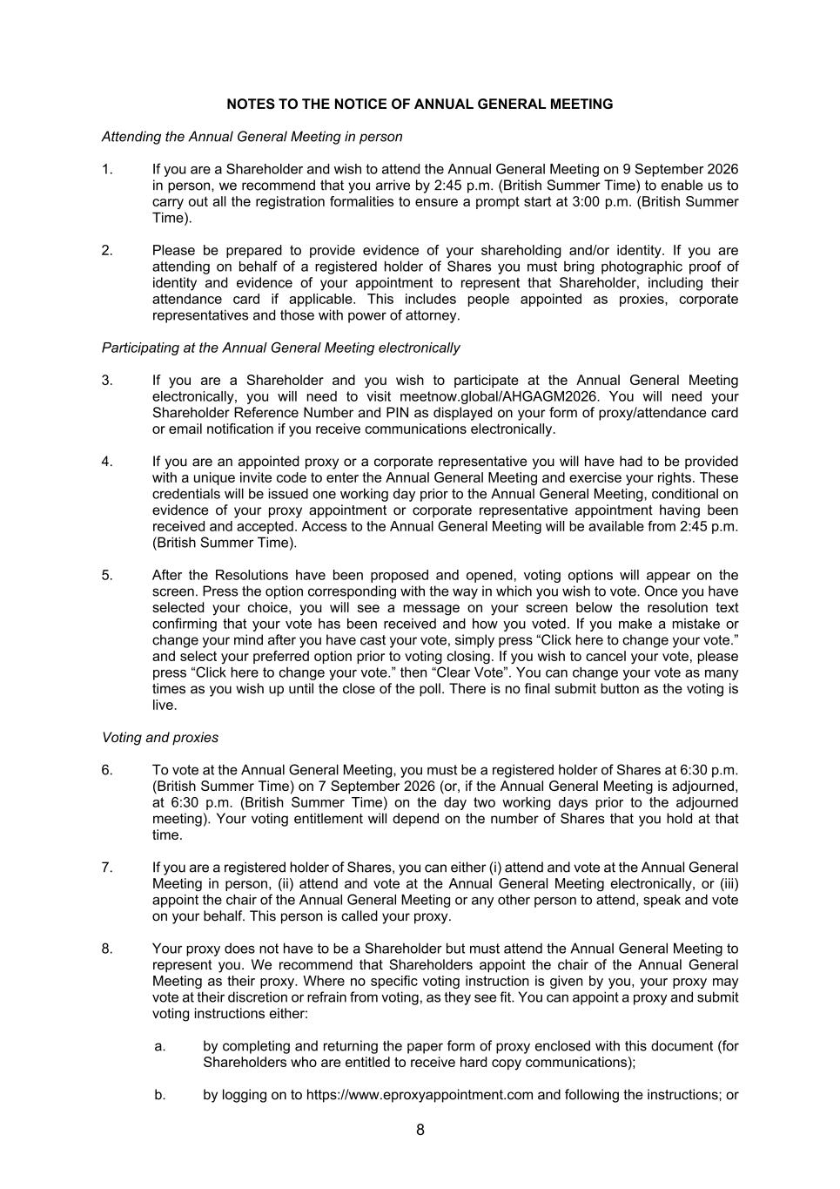
8 NOTES TO THE NOTICE OF ANNUAL GENERAL MEETING Attending the Annual General Meeting in person 1. If you are a Shareholder and wish to attend the Annual General Meeting on 9 September 2026 in person, we recommend that you arrive by 2:45 p.m. (British Summer Time) to enable us to carry out all the registration formalities to ensure a prompt start at 3:00 p.m. (British Summer Time). 2. Please be prepared to provide evidence of your shareholding and/or identity. If you are attending on behalf of a registered holder of Shares you must bring photographic proof of identity and evidence of your appointment to represent that Shareholder, including their attendance card if applicable. This includes people appointed as proxies, corporate representatives and those with power of attorney. Participating at the Annual General Meeting electronically 3. If you are a Shareholder and you wish to participate at the Annual General Meeting electronically, you will need to visit meetnow.global/AHGAGM2026. You will need your Shareholder Reference Number and PIN as displayed on your form of proxy/attendance card or email notification if you receive communications electronically. 4. If you are an appointed proxy or a corporate representative you will have had to be provided with a unique invite code to enter the Annual General Meeting and exercise your rights. These credentials will be issued one working day prior to the Annual General Meeting, conditional on evidence of your proxy appointment or corporate representative appointment having been received and accepted. Access to the Annual General Meeting will be available from 2:45 p.m. (British Summer Time). 5. After the Resolutions have been proposed and opened, voting options will appear on the screen. Press the option corresponding with the way in which you wish to vote. Once you have selected your choice, you will see a message on your screen below the resolution text confirming that your vote has been received and how you voted. If you make a mistake or change your mind after you have cast your vote, simply press “Click here to change your vote.” and select your preferred option prior to voting closing. If you wish to cancel your vote, please press “Click here to change your vote.” then “Clear Vote”. You can change your vote as many times as you wish up until the close of the poll. There is no final submit button as the voting is live. Voting and proxies 6. To vote at the Annual General Meeting, you must be a registered holder of Shares at 6:30 p.m. (British Summer Time) on 7 September 2026 (or, if the Annual General Meeting is adjourned, at 6:30 p.m. (British Summer Time) on the day two working days prior to the adjourned meeting). Your voting entitlement will depend on the number of Shares that you hold at that time. 7. If you are a registered holder of Shares, you can either (i) attend and vote at the Annual General Meeting in person, (ii) attend and vote at the Annual General Meeting electronically, or (iii) appoint the chair of the Annual General Meeting or any other person to attend, speak and vote on your behalf. This person is called your proxy. 8. Your proxy does not have to be a Shareholder but must attend the Annual General Meeting to represent you. We recommend that Shareholders appoint the chair of the Annual General Meeting as their proxy. Where no specific voting instruction is given by you, your proxy may vote at their discretion or refrain from voting, as they see fit. You can appoint a proxy and submit voting instructions either: a. by completing and returning the paper form of proxy enclosed with this document (for Shareholders who are entitled to receive hard copy communications); b. by logging on to https://www.eproxyappointment.com and following the instructions; or

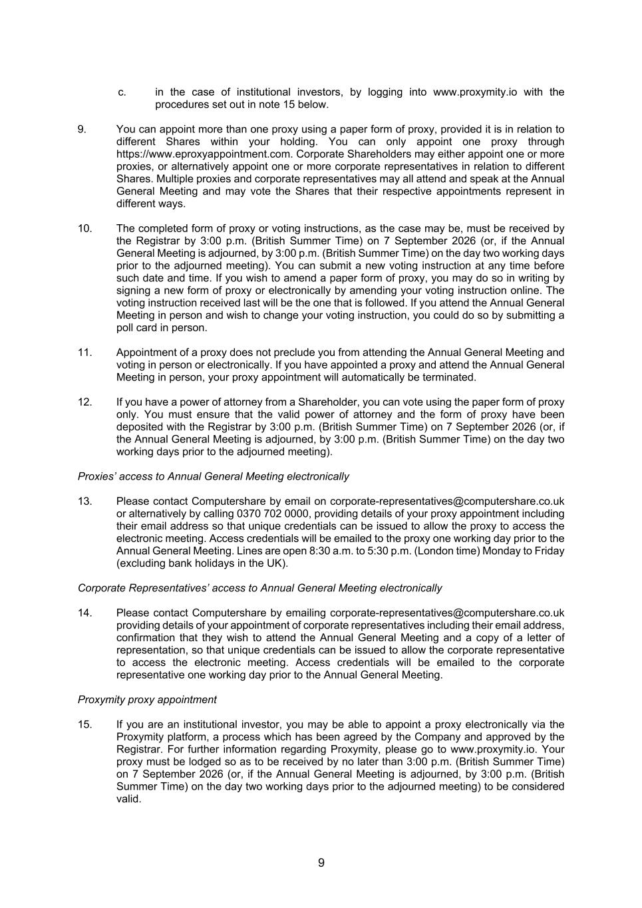
9 c. in the case of institutional investors, by logging into www.proxymity.io with the procedures set out in note 15 below. 9. You can appoint more than one proxy using a paper form of proxy, provided it is in relation to different Shares within your holding. You can only appoint one proxy through https://www.eproxyappointment.com. Corporate Shareholders may either appoint one or more proxies, or alternatively appoint one or more corporate representatives in relation to different Shares. Multiple proxies and corporate representatives may all attend and speak at the Annual General Meeting and may vote the Shares that their respective appointments represent in different ways. 10. The completed form of proxy or voting instructions, as the case may be, must be received by the Registrar by 3:00 p.m. (British Summer Time) on 7 September 2026 (or, if the Annual General Meeting is adjourned, by 3:00 p.m. (British Summer Time) on the day two working days prior to the adjourned meeting). You can submit a new voting instruction at any time before such date and time. If you wish to amend a paper form of proxy, you may do so in writing by signing a new form of proxy or electronically by amending your voting instruction online. The voting instruction received last will be the one that is followed. If you attend the Annual General Meeting in person and wish to change your voting instruction, you could do so by submitting a poll card in person. 11. Appointment of a proxy does not preclude you from attending the Annual General Meeting and voting in person or electronically. If you have appointed a proxy and attend the Annual General Meeting in person, your proxy appointment will automatically be terminated. 12. If you have a power of attorney from a Shareholder, you can vote using the paper form of proxy only. You must ensure that the valid power of attorney and the form of proxy have been deposited with the Registrar by 3:00 p.m. (British Summer Time) on 7 September 2026 (or, if the Annual General Meeting is adjourned, by 3:00 p.m. (British Summer Time) on the day two working days prior to the adjourned meeting). Proxies’ access to Annual General Meeting electronically 13. Please contact Computershare by email on corporate-representatives@computershare.co.uk or alternatively by calling 0370 702 0000, providing details of your proxy appointment including their email address so that unique credentials can be issued to allow the proxy to access the electronic meeting. Access credentials will be emailed to the proxy one working day prior to the Annual General Meeting. Lines are open 8:30 a.m. to 5:30 p.m. (London time) Monday to Friday (excluding bank holidays in the UK). Corporate Representatives’ access to Annual General Meeting electronically 14. Please contact Computershare by emailing corporate-representatives@computershare.co.uk providing details of your appointment of corporate representatives including their email address, confirmation that they wish to attend the Annual General Meeting and a copy of a letter of representation, so that unique credentials can be issued to allow the corporate representative to access the electronic meeting. Access credentials will be emailed to the corporate representative one working day prior to the Annual General Meeting. Proxymity proxy appointment 15. If you are an institutional investor, you may be able to appoint a proxy electronically via the Proxymity platform, a process which has been agreed by the Company and approved by the Registrar. For further information regarding Proxymity, please go to www.proxymity.io. Your proxy must be lodged so as to be received by no later than 3:00 p.m. (British Summer Time) on 7 September 2026 (or, if the Annual General Meeting is adjourned, by 3:00 p.m. (British Summer Time) on the day two working days prior to the adjourned meeting) to be considered valid.

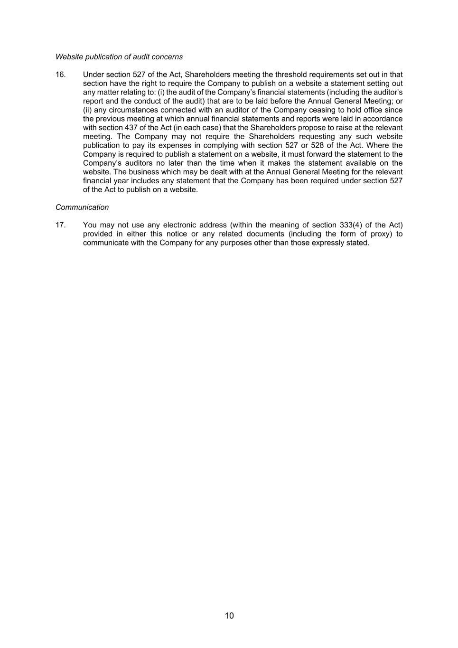
10 Website publication of audit concerns 16. Under section 527 of the Act, Shareholders meeting the threshold requirements set out in that section have the right to require the Company to publish on a website a statement setting out any matter relating to: (i) the audit of the Company’s financial statements (including the auditor’s report and the conduct of the audit) that are to be laid before the Annual General Meeting; or (ii) any circumstances connected with an auditor of the Company ceasing to hold office since the previous meeting at which annual financial statements and reports were laid in accordance with section 437 of the Act (in each case) that the Shareholders propose to raise at the relevant meeting. The Company may not require the Shareholders requesting any such website publication to pay its expenses in complying with section 527 or 528 of the Act. Where the Company is required to publish a statement on a website, it must forward the statement to the Company’s auditors no later than the time when it makes the statement available on the website. The business which may be dealt with at the Annual General Meeting for the relevant financial year includes any statement that the Company has been required under section 527 of the Act to publish on a website. Communication 17. You may not use any electronic address (within the meaning of section 333(4) of the Act) provided in either this notice or any related documents (including the form of proxy) to communicate with the Company for any purposes other than those expressly stated.

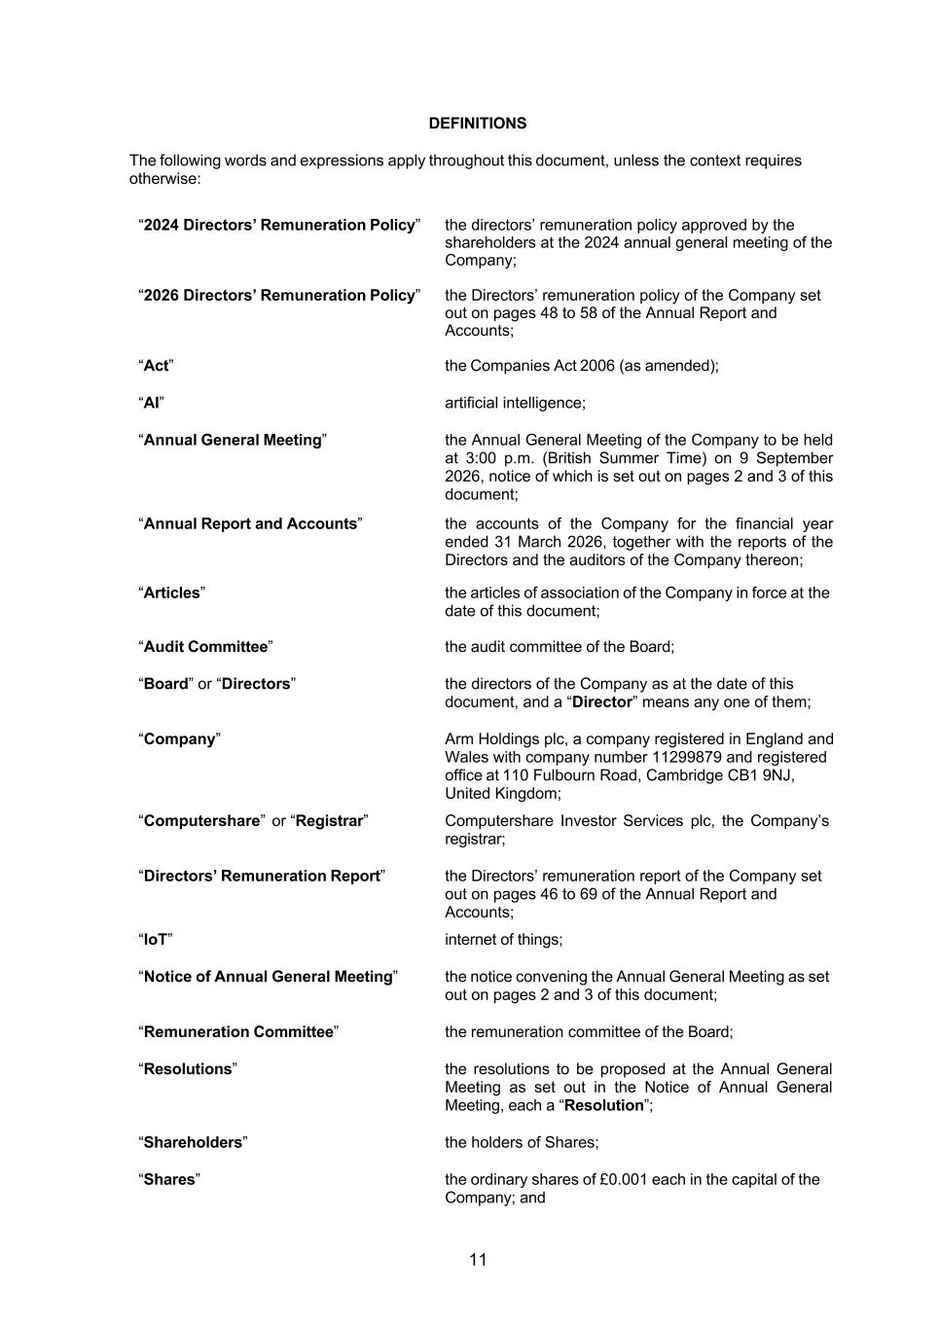
11 DEFINITIONS The following words and expressions apply throughout this document, unless the context requires otherwise: “2024 Directors’ Remuneration Policy” the directors’ remuneration policy approved by the shareholders at the 2024 annual general meeting of the Company; “2026 Directors’ Remuneration Policy” the Directors’ remuneration policy of the Company set out on pages 48 to 58 of the Annual Report and Accounts; “Act” the Companies Act 2006 (as amended); “AI” artificial intelligence; “Annual General Meeting” the Annual General Meeting of the Company to be held at 3:00 p.m. (British Summer Time) on 9 September 2026, notice of which is set out on pages 2 and 3 of this document; “Annual Report and Accounts” the accounts of the Company for the financial year ended 31 March 2026, together with the reports of the Directors and the auditors of the Company thereon; “Articles” the articles of association of the Company in force at the date of this document; “Audit Committee” the audit committee of the Board; “Board” or “Directors” the directors of the Company as at the date of this document, and a “Director” means any one of them; “Company” Arm Holdings plc, a company registered in England and Wales with company number 11299879 and registered office at 110 Fulbourn Road, Cambridge CB1 9NJ, United Kingdom; “Computershare” or “Registrar” Computershare Investor Services plc, the Company’s registrar; “Directors’ Remuneration Report” the Directors’ remuneration report of the Company set out on pages 46 to 69 of the Annual Report and Accounts; “IoT” internet of things; “Notice of Annual General Meeting” the notice convening the Annual General Meeting as set out on pages 2 and 3 of this document; “Remuneration Committee” the remuneration committee of the Board; “Resolutions” the resolutions to be proposed at the Annual General Meeting as set out in the Notice of Annual General Meeting, each a “Resolution”; “Shareholders” the holders of Shares; “Shares” the ordinary shares of £0.001 each in the capital of the Company; and


12 “SoftBank Group” SoftBank Group Corp.

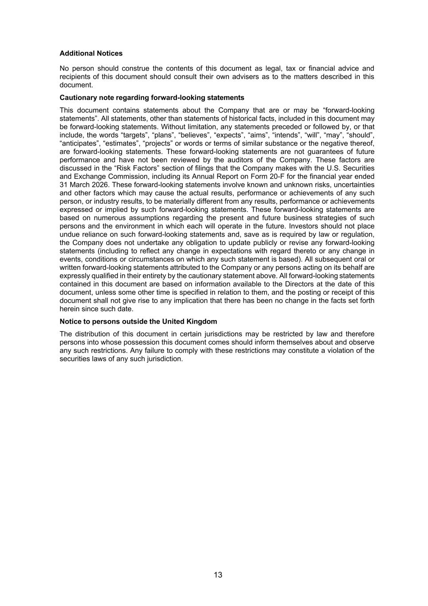
13 Additional Notices No person should construe the contents of this document as legal, tax or financial advice and recipients of this document should consult their own advisers as to the matters described in this document. Cautionary note regarding forward-looking statements This document contains statements about the Company that are or may be “forward-looking statements”. All statements, other than statements of historical facts, included in this document may be forward-looking statements. Without limitation, any statements preceded or followed by, or that include, the words “targets”, “plans”, “believes”, “expects”, “aims”, “intends”, “will”, “may”, “should”, “anticipates”, “estimates”, “projects” or words or terms of similar substance or the negative thereof, are forward-looking statements. These forward-looking statements are not guarantees of future performance and have not been reviewed by the auditors of the Company. These factors are discussed in the “Risk Factors” section of filings that the Company makes with the U.S. Securities and Exchange Commission, including its Annual Report on Form 20-F for the financial year ended 31 March 2026. These forward-looking statements involve known and unknown risks, uncertainties and other factors which may cause the actual results, performance or achievements of any such person, or industry results, to be materially different from any results, performance or achievements expressed or implied by such forward-looking statements. These forward-looking statements are based on numerous assumptions regarding the present and future business strategies of such persons and the environment in which each will operate in the future. Investors should not place undue reliance on such forward-looking statements and, save as is required by law or regulation, the Company does not undertake any obligation to update publicly or revise any forward-looking statements (including to reflect any change in expectations with regard thereto or any change in events, conditions or circumstances on which any such statement is based). All subsequent oral or written forward-looking statements attributed to the Company or any persons acting on its behalf are expressly qualified in their entirety by the cautionary statement above. All forward-looking statements contained in this document are based on information available to the Directors at the date of this document, unless some other time is specified in relation to them, and the posting or receipt of this document shall not give rise to any implication that there has been no change in the facts set forth herein since such date. Notice to persons outside the United Kingdom The distribution of this document in certain jurisdictions may be restricted by law and therefore persons into whose possession this document comes should inform themselves about and observe any such restrictions. Any failure to comply with these restrictions may constitute a violation of the securities laws of any such jurisdiction.

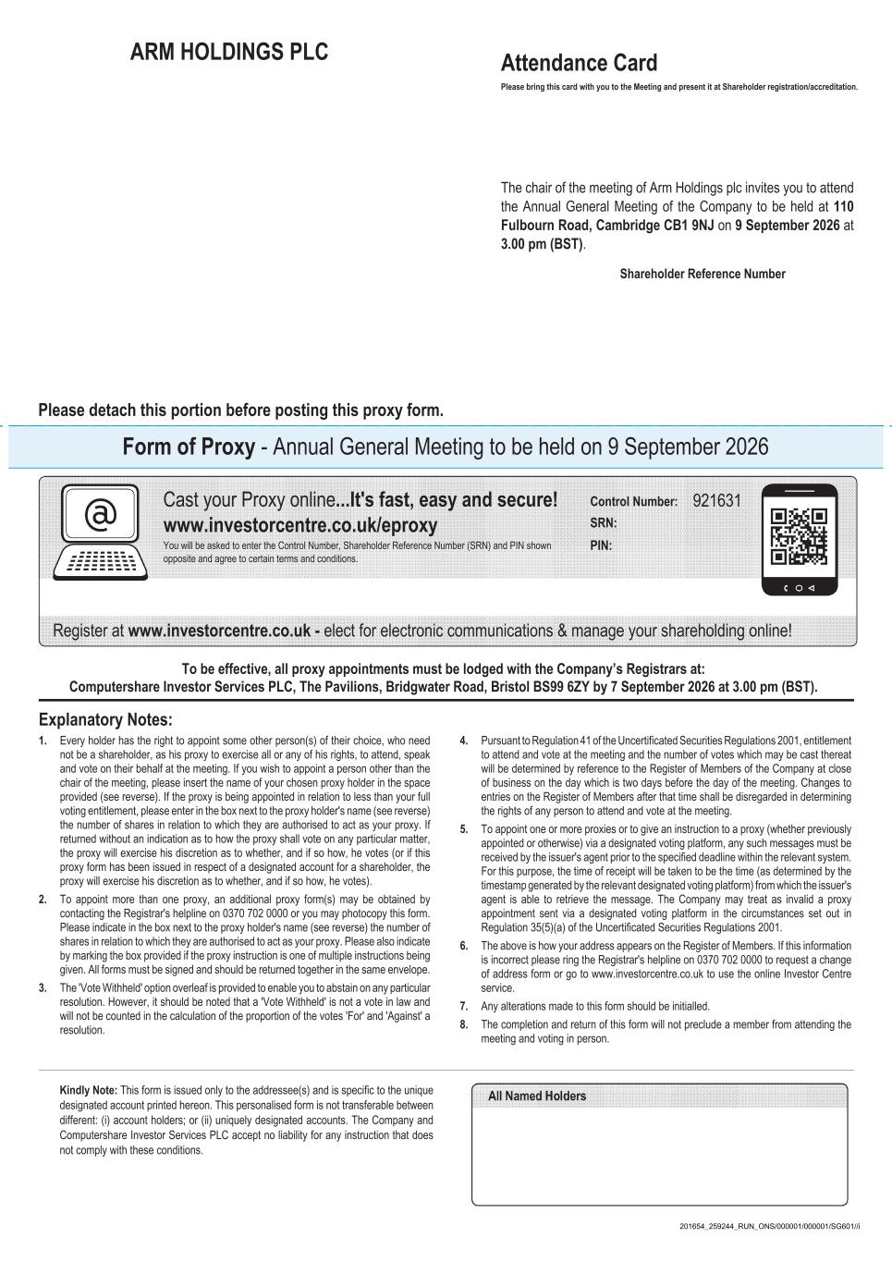
ARM HOLDINGS PLC Form of Proxy - Annual General Meeting to be held on 9 September 2026 Kindly Note: This form is issued only to the addressee(s) and is specific to the unique designated account printed hereon. This personalised form is not transferable between different: (i) account holders; or (ii) uniquely designated accounts. The Company and Computershare Investor Services PLC accept no liability for any instruction that does not comply with these conditions. Explanatory Notes: 1. Every holder has the right to appoint some other person(s) of their choice, who need not be a shareholder, as his proxy to exercise all or any of his rights, to attend, speak and vote on their behalf at the meeting. If you wish to appoint a person other than the chair of the meeting, please insert the name of your chosen proxy holder in the space provided (see reverse). If the proxy is being appointed in relation to less than your full voting entitlement, please enter in the box next to the proxy holder's name (see reverse) the number of shares in relation to which they are authorised to act as your proxy. If returned without an indication as to how the proxy shall vote on any particular matter, the proxy will exercise his discretion as to whether, and if so how, he votes (or if this proxy form has been issued in respect of a designated account for a shareholder, the proxy will exercise his discretion as to whether, and if so how, he votes). 2. To appoint more than one proxy, an additional proxy form(s) may be obtained by contacting the Registrar's helpline on 0370 702 0000 or you may photocopy this form. Please indicate in the box next to the proxy holder's name (see reverse) the number of shares in relation to which they are authorised to act as your proxy. Please also indicate by marking the box provided if the proxy instruction is one of multiple instructions being given. All forms must be signed and should be returned together in the same envelope. 3. The 'Vote Withheld' option overleaf is provided to enable you to abstain on any particular resolution. However, it should be noted that a 'Vote Withheld' is not a vote in law and will not be counted in the calculation of the proportion of the votes 'For' and 'Against' a resolution. 4. Pursuant to Regulation 41 of the Uncertificated Securities Regulations 2001, entitlement to attend and vote at the meeting and the number of votes which may be cast thereat will be determined by reference to the Register of Members of the Company at close of business on the day which is two days before the day of the meeting. Changes to entries on the Register of Members after that time shall be disregarded in determining the rights of any person to attend and vote at the meeting. 5. To appoint one or more proxies or to give an instruction to a proxy (whether previously appointed or otherwise) via a designated voting platform, any such messages must be received by the issuer's agent prior to the specified deadline within the relevant system. For this purpose, the time of receipt will be taken to be the time (as determined by the timestamp generated by the relevant designated voting platform) from which the issuer's agent is able to retrieve the message. The Company may treat as invalid a proxy appointment sent via a designated voting platform in the circumstances set out in Regulation 35(5)(a) of the Uncertificated Securities Regulations 2001. 6. The above is how your address appears on the Register of Members. If this information is incorrect please ring the Registrar's helpline on 0370 702 0000 to request a change of address form or go to www.investorcentre.co.uk to use the online Investor Centre service. 7. Any alterations made to this form should be initialled. 8. The completion and return of this form will not preclude a member from attending the meeting and voting in person. To be effective, all proxy appointments must be lodged with the Company’s Registrars at: Computershare Investor Services PLC, The Pavilions, Bridgwater Road, Bristol BS99 6ZY by 7 September 2026 at 3.00 pm (BST). Cast your Proxy online...It's fast, easy and secure! www.investorcentre.co.uk/eproxy You will be asked to enter the Control Number, Shareholder Reference Number (SRN) and PIN shown opposite and agree to certain terms and conditions. Attendance Card Please bring this card with you to the Meeting and present it at Shareholder registration/accreditation. The chair of the meeting of Arm Holdings plc invites you to attend the Annual General Meeting of the Company to be held at 110 Fulbourn Road, Cambridge CB1 9NJ on 9 September 2026 at 3.00 pm (BST). Shareholder Reference Number Please detach this portion before posting this proxy form. Register at www.investorcentre.co.uk - elect for electronic communications & manage your shareholding online! PIN: SRN: Control Number: 921631 201654_259244_RUN_ONS/000001/000001/SG601//i

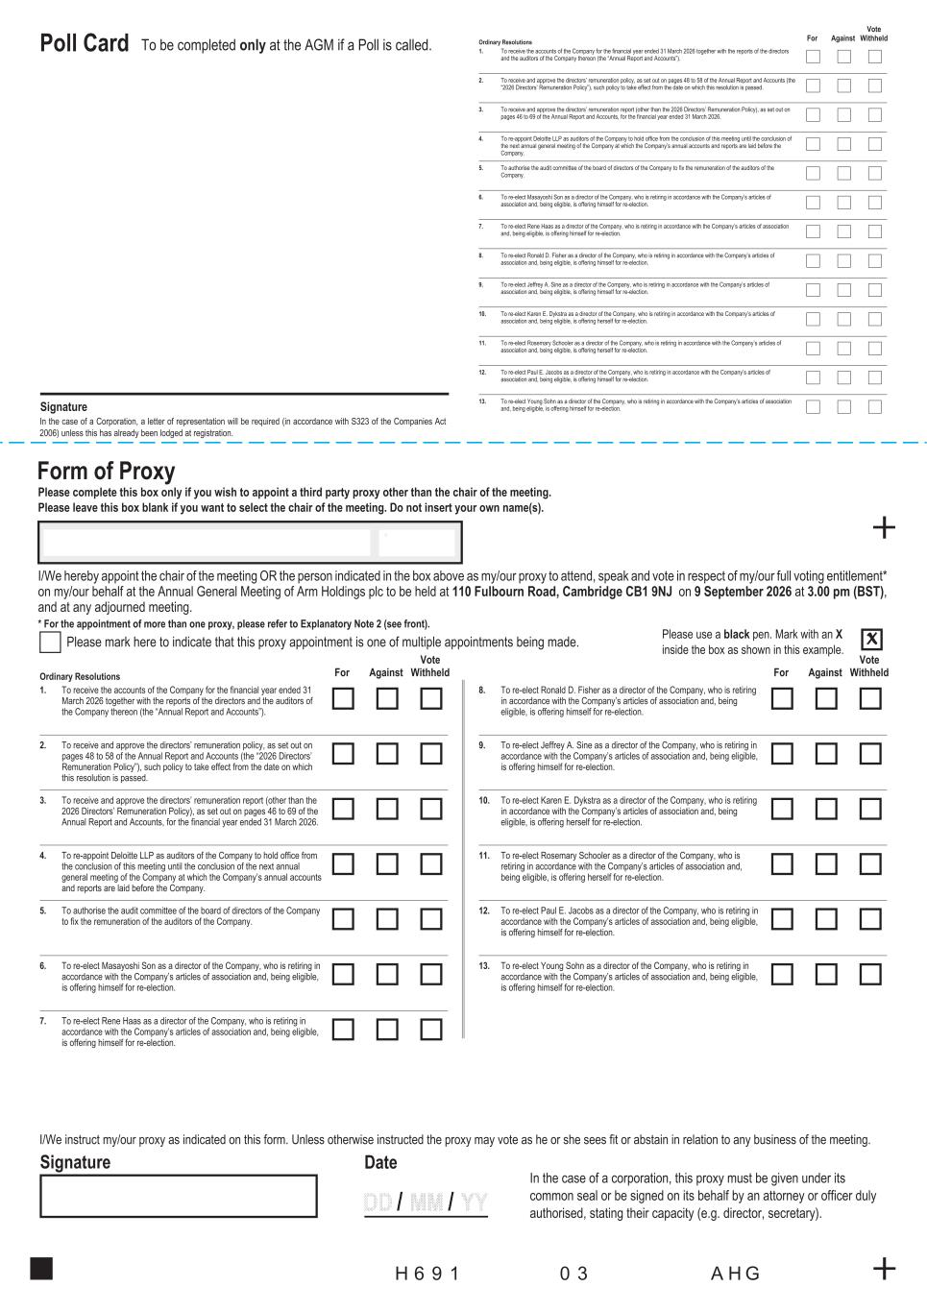
Poll Card Signature Form of Proxy Please complete this box only if you wish to appoint a third party proxy other than the chair of the meeting. Please leave this box blank if you want to select the chair of the meeting. Do not insert your own name(s). I/We hereby appoint the chair of the meeting OR the person indicated in the box above as my/our proxy to attend, speak and vote in respect of my/our full voting entitlement* on my/our behalf at the Annual General Meeting of Arm Holdings plc to be held at 110 Fulbourn Road, Cambridge CB1 9NJ on 9 September 2026 at 3.00 pm (BST), and at any adjourned meeting. * For the appointment of more than one proxy, please refer to Explanatory Note 2 (see front). Please mark here to indicate that this proxy appointment is one of multiple appointments being made. I/We instruct my/our proxy as indicated on this form. Unless otherwise instructed the proxy may vote as he or she sees fit or abstain in relation to any business of the meeting. Signature Date In the case of a corporation, this proxy must be given under its common seal or be signed on its behalf by an attorney or officer duly authorised, stating their capacity (e.g. director, secretary). Ordinary Resolutions For Against Vote Withheld 1. To receive the accounts of the Company for the financial year ended 31 March 2026 together with the reports of the directors and the auditors of the Company thereon (the “Annual Report and Accounts”). 2. To receive and approve the directors’ remuneration policy, as set out on pages 48 to 58 of the Annual Report and Accounts (the “2026 Directors’ Remuneration Policy”), such policy to take effect from the date on which this resolution is passed. 3. To receive and approve the directors’ remuneration report (other than the 2026 Directors’ Remuneration Policy), as set out on pages 46 to 69 of the Annual Report and Accounts, for the financial year ended 31 March 2026. 4. To re-appoint Deloitte LLP as auditors of the Company to hold office from the conclusion of this meeting until the conclusion of the next annual general meeting of the Company at which the Company’s annual accounts and reports are laid before the Company. 5. To authorise the audit committee of the board of directors of the Company to fix the remuneration of the auditors of the Company. 6. To re-elect Masayoshi Son as a director of the Company, who is retiring in accordance with the Company’s articles of association and, being eligible, is offering himself for re-election. 7. To re-elect Rene Haas as a director of the Company, who is retiring in accordance with the Company’s articles of association and, being eligible, is offering himself for re-election. 8. To re-elect Ronald D. Fisher as a director of the Company, who is retiring in accordance with the Company’s articles of association and, being eligible, is offering himself for re-election. 9. To re-elect Jeffrey A. Sine as a director of the Company, who is retiring in accordance with the Company’s articles of association and, being eligible, is offering himself for re-election. 10. To re-elect Karen E. Dykstra as a director of the Company, who is retiring in accordance with the Company’s articles of association and, being eligible, is offering herself for re-election. 11. To re-elect Rosemary Schooler as a director of the Company, who is retiring in accordance with the Company’s articles of association and, being eligible, is offering herself for re-election. 12. To re-elect Paul E. Jacobs as a director of the Company, who is retiring in accordance with the Company’s articles of association and, being eligible, is offering himself for re-election. 13. To re-elect Young Sohn as a director of the Company, who is retiring in accordance with the Company’s articles of association and, being eligible, is offering himself for re-election. Ordinary Resolutions For Against Vote Withheld 1. To receive the accounts of the Company for the financial year ended 31 March 2026 together with the reports of the directors and the auditors of the Company thereon (the “Annual Report and Accounts”). 2. To receive and approve the directors’ remuneration policy, as set out on pages 48 to 58 of the Annual Report and Accounts (the “2026 Directors’ Remuneration Policy”), such policy to take effect from the date on which this resolution is passed. 3. To receive and approve the directors’ remuneration report (other than the 2026 Directors’ Remuneration Policy), as set out on pages 46 to 69 of the Annual Report and Accounts, for the financial year ended 31 March 2026. 4. To re-appoint Deloitte LLP as auditors of the Company to hold office from the conclusion of this meeting until the conclusion of the next annual general meeting of the Company at which the Company’s annual accounts and reports are laid before the Company. 5. To authorise the audit committee of the board of directors of the Company to fix the remuneration of the auditors of the Company. 6. To re-elect Masayoshi Son as a director of the Company, who is retiring in accordance with the Company’s articles of association and, being eligible, is offering himself for re-election. 7. To re-elect Rene Haas as a director of the Company, who is retiring in accordance with the Company’s articles of association and, being eligible, is offering himself for re-election. For Against Vote Withheld 8. To re-elect Ronald D. Fisher as a director of the Company, who is retiring in accordance with the Company’s articles of association and, being eligible, is offering himself for re-election. 9. To re-elect Jeffrey A. Sine as a director of the Company, who is retiring in accordance with the Company’s articles of association and, being eligible, is offering himself for re-election. 10. To re-elect Karen E. Dykstra as a director of the Company, who is retiring in accordance with the Company’s articles of association and, being eligible, is offering herself for re-election. 11. To re-elect Rosemary Schooler as a director of the Company, who is retiring in accordance with the Company’s articles of association and, being eligible, is offering herself for re-election. 12. To re-elect Paul E. Jacobs as a director of the Company, who is retiring in accordance with the Company’s articles of association and, being eligible, is offering himself for re-election. 13. To re-elect Young Sohn as a director of the Company, who is retiring in accordance with the Company’s articles of association and, being eligible, is offering himself for re-election. 196H 30 GHA To be completed only at the AGM if a Poll is called. * Please use a black pen. Mark with an X inside the box as shown in this example. In the case of a Corporation, a letter of representation will be required (in accordance with S323 of the Companies Act 2006) unless this has already been lodged at registration.

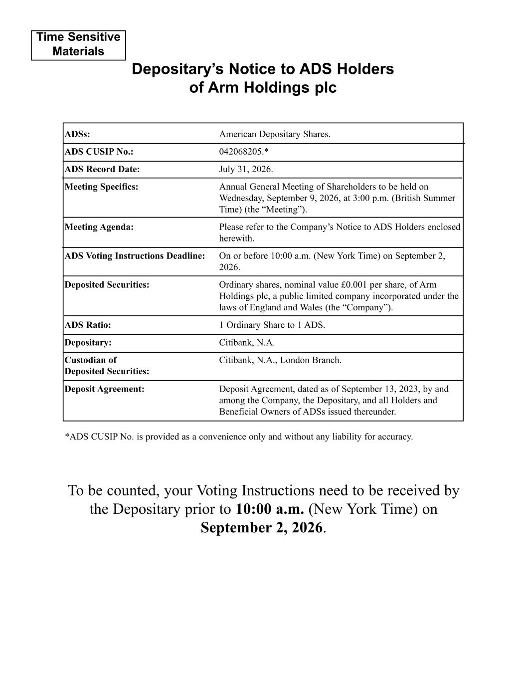
ADSs: American Depositary Shares. ADS CUSIP No.: 042068205.* ADS Record Date: July 31, 2026. Meeting Specifics: Annual General Meeting of Shareholders to be held on Wednesday, September 9, 2026, at 3:00 p.m. (British Summer Time) (the “Meeting”). Meeting Agenda: Please refer to the Company’s Notice to ADS Holders enclosed herewith. ADS Voting Instructions Deadline: On or before 10:00 a.m. (New York Time) on September 2, 2026. Deposited Securities: Ordinary shares, nominal value £0.001 per share, of Arm Holdings plc, a public limited company incorporated under the laws of England and Wales (the “Company”). ADS Ratio: 1 Ordinary Share to 1 ADS. Depositary: Citibank, N.A. Custodian of Citibank, N.A., London Branch. Deposited Securities: Deposit Agreement: Deposit Agreement, dated as of September 13, 2023, by and among the Company, the Depositary, and all Holders and Beneficial Owners of ADSs issued thereunder. *ADS CUSIP No. is provided as a convenience only and without any liability for accuracy. To be counted, your Voting Instructions need to be received by the Depositary prior to 10:00 a.m. (New York Time) on September 2, 2026. Time Sensitive Materials Depositary’s Notice to ADS Holders of Arm Holdings plc

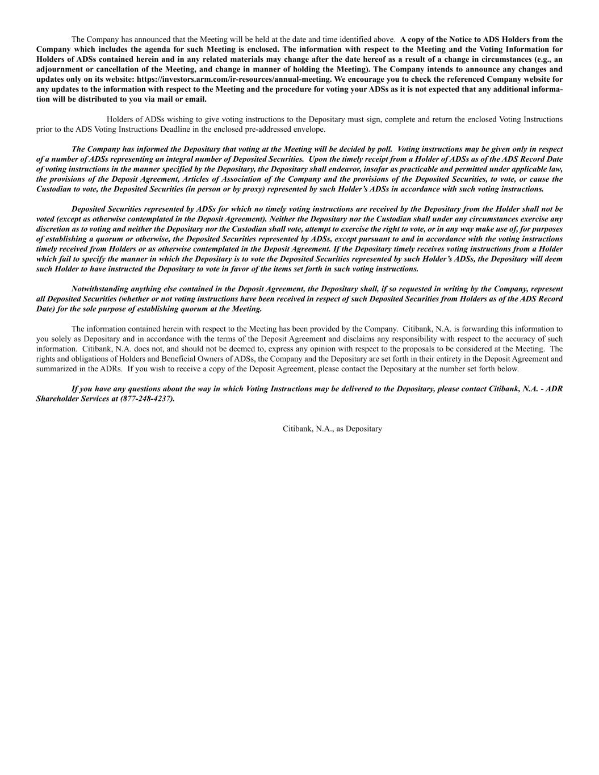
The Company has announced that the Meeting will be held at the date and time identified above. A copy of the Notice to ADS Holders from the Company which includes the agenda for such Meeting is enclosed. The information with respect to the Meeting and the Voting Information for Holders of ADSs contained herein and in any related materials may change after the date hereof as a result of a change in circumstances (e.g., an adjournment or cancellation of the Meeting, and change in manner of holding the Meeting). The Company intends to announce any changes and updates only on its website: https://investors.arm.com/ir-resources/annual-meeting. We encourage you to check the referenced Company website for any updates to the information with respect to the Meeting and the procedure for voting your ADSs as it is not expected that any additional informa- tion will be distributed to you via mail or email. Holders of ADSs wishing to give voting instructions to the Depositary must sign, complete and return the enclosed Voting Instructions prior to the ADS Voting Instructions Deadline in the enclosed pre-addressed envelope. The Company has informed the Depositary that voting at the Meeting will be decided by poll. Voting instructions may be given only in respect of a number of ADSs representing an integral number of Deposited Securities. Upon the timely receipt from a Holder of ADSs as of the ADS Record Date of voting instructions in the manner specified by the Depositary, the Depositary shall endeavor, insofar as practicable and permitted under applicable law, the provisions of the Deposit Agreement, Articles of Association of the Company and the provisions of the Deposited Securities, to vote, or cause the Custodian to vote, the Deposited Securities (in person or by proxy) represented by such Holder’s ADSs in accordance with such voting instructions. Deposited Securities represented by ADSs for which no timely voting instructions are received by the Depositary from the Holder shall not be voted (except as otherwise contemplated in the Deposit Agreement). Neither the Depositary nor the Custodian shall under any circumstances exercise any discretion as to voting and neither the Depositary nor the Custodian shall vote, attempt to exercise the right to vote, or in any way make use of, for purposes of establishing a quorum or otherwise, the Deposited Securities represented by ADSs, except pursuant to and in accordance with the voting instructions timely received from Holders or as otherwise contemplated in the Deposit Agreement. If the Depositary timely receives voting instructions from a Holder which fail to specify the manner in which the Depositary is to vote the Deposited Securities represented by such Holder’s ADSs, the Depositary will deem such Holder to have instructed the Depositary to vote in favor of the items set forth in such voting instructions. Notwithstanding anything else contained in the Deposit Agreement, the Depositary shall, if so requested in writing by the Company, represent all Deposited Securities (whether or not voting instructions have been received in respect of such Deposited Securities from Holders as of the ADS Record Date) for the sole purpose of establishing quorum at the Meeting. The information contained herein with respect to the Meeting has been provided by the Company. Citibank, N.A. is forwarding this information to you solely as Depositary and in accordance with the terms of the Deposit Agreement and disclaims any responsibility with respect to the accuracy of such information. Citibank, N.A. does not, and should not be deemed to, express any opinion with respect to the proposals to be considered at the Meeting. The rights and obligations of Holders and Beneficial Owners of ADSs, the Company and the Depositary are set forth in their entirety in the Deposit Agreement and summarized in the ADRs. If you wish to receive a copy of the Deposit Agreement, please contact the Depositary at the number set forth below. If you have any questions about the way in which Voting Instructions may be delivered to the Depositary, please contact Citibank, N.A. - ADR Shareholder Services at (877-248-4237). Citibank, N.A., as Depositary

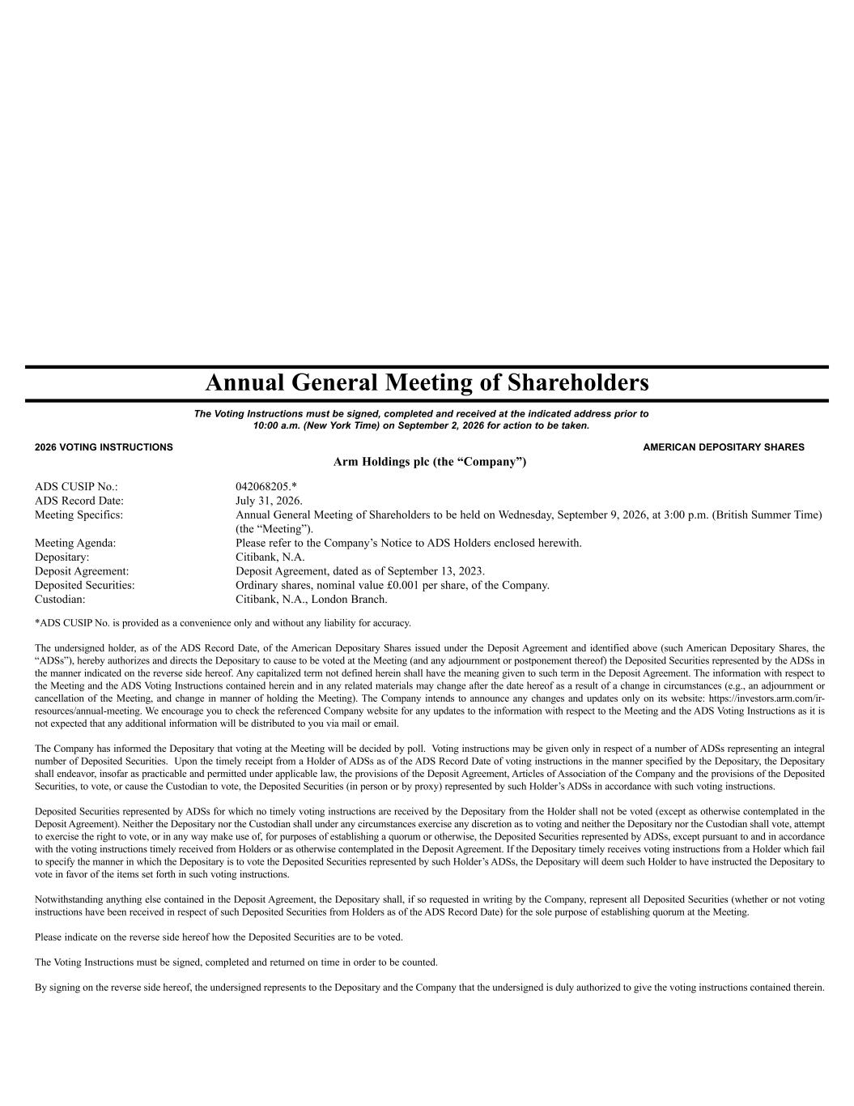
Annual General Meeting of Shareholders Arm Holdings plc (the “Company”) ADS CUSIP No.: 042068205.* ADS Record Date: July 31, 2026. Meeting Specifics: Annual General Meeting of Shareholders to be held on Wednesday, September 9, 2026, at 3:00 p.m. (British Summer Time) (the “Meeting”). Meeting Agenda: Please refer to the Company’s Notice to ADS Holders enclosed herewith. Depositary: Citibank, N.A. Deposit Agreement: Deposit Agreement, dated as of September 13, 2023. Deposited Securities: Ordinary shares, nominal value £0.001 per share, of the Company. Custodian: Citibank, N.A., London Branch. *ADS CUSIP No. is provided as a convenience only and without any liability for accuracy. The undersigned holder, as of the ADS Record Date, of the American Depositary Shares issued under the Deposit Agreement and identified above (such American Depositary Shares, the “ADSs”), hereby authorizes and directs the Depositary to cause to be voted at the Meeting (and any adjournment or postponement thereof) the Deposited Securities represented by the ADSs in the manner indicated on the reverse side hereof. Any capitalized term not defined herein shall have the meaning given to such term in the Deposit Agreement. The information with respect to the Meeting and the ADS Voting Instructions contained herein and in any related materials may change after the date hereof as a result of a change in circumstances (e.g., an adjournment or cancellation of the Meeting, and change in manner of holding the Meeting). The Company intends to announce any changes and updates only on its website: https://investors.arm.com/ir- resources/annual-meeting. We encourage you to check the referenced Company website for any updates to the information with respect to the Meeting and the ADS Voting Instructions as it is not expected that any additional information will be distributed to you via mail or email. The Company has informed the Depositary that voting at the Meeting will be decided by poll. Voting instructions may be given only in respect of a number of ADSs representing an integral number of Deposited Securities. Upon the timely receipt from a Holder of ADSs as of the ADS Record Date of voting instructions in the manner specified by the Depositary, the Depositary shall endeavor, insofar as practicable and permitted under applicable law, the provisions of the Deposit Agreement, Articles of Association of the Company and the provisions of the Deposited Securities, to vote, or cause the Custodian to vote, the Deposited Securities (in person or by proxy) represented by such Holder’s ADSs in accordance with such voting instructions. Deposited Securities represented by ADSs for which no timely voting instructions are received by the Depositary from the Holder shall not be voted (except as otherwise contemplated in the Deposit Agreement). Neither the Depositary nor the Custodian shall under any circumstances exercise any discretion as to voting and neither the Depositary nor the Custodian shall vote, attempt to exercise the right to vote, or in any way make use of, for purposes of establishing a quorum or otherwise, the Deposited Securities represented by ADSs, except pursuant to and in accordance with the voting instructions timely received from Holders or as otherwise contemplated in the Deposit Agreement. If the Depositary timely receives voting instructions from a Holder which fail to specify the manner in which the Depositary is to vote the Deposited Securities represented by such Holder’s ADSs, the Depositary will deem such Holder to have instructed the Depositary to vote in favor of the items set forth in such voting instructions. Notwithstanding anything else contained in the Deposit Agreement, the Depositary shall, if so requested in writing by the Company, represent all Deposited Securities (whether or not voting instructions have been received in respect of such Deposited Securities from Holders as of the ADS Record Date) for the sole purpose of establishing quorum at the Meeting. Please indicate on the reverse side hereof how the Deposited Securities are to be voted. The Voting Instructions must be signed, completed and returned on time in order to be counted. By signing on the reverse side hereof, the undersigned represents to the Depositary and the Company that the undersigned is duly authorized to give the voting instructions contained therein. The Voting Instructions must be signed, completed and received at the indicated address prior to 10:00 a.m. (New York Time) on September 2, 2026 for action to be taken. 2026 VOTING INSTRUCTIONS AMERICAN DEPOSITARY SHARES

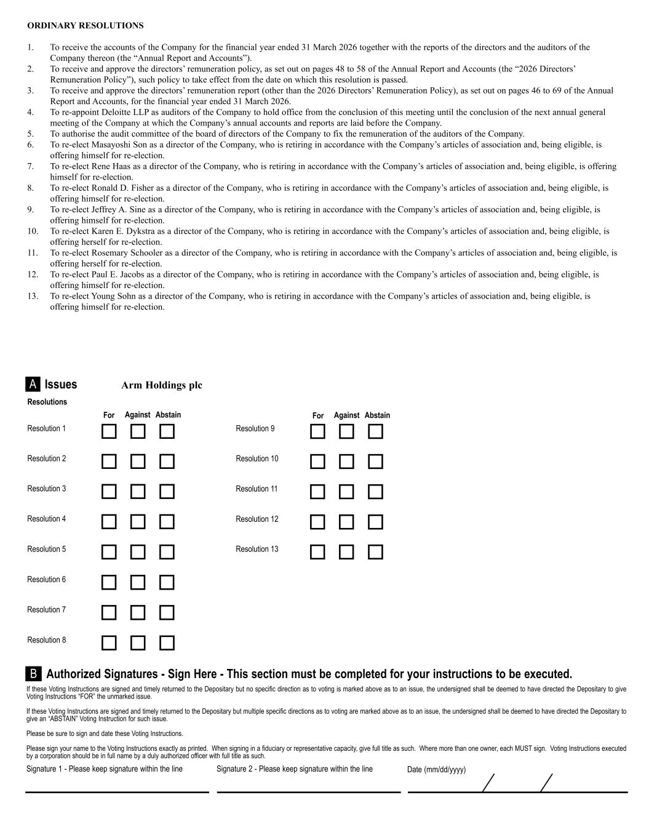
Signature 1 - Please keep signature within the line Signature 2 - Please keep signature within the line Date (mm/dd/yyyy) If these Voting Instructions are signed and timely returned to the Depositary but no specific direction as to voting is marked above as to an issue, the undersigned shall be deemed to have directed the Depositary to give Voting Instructions “FOR” the unmarked issue. If these Voting Instructions are signed and timely returned to the Depositary but multiple specific directions as to voting are marked above as to an issue, the undersigned shall be deemed to have directed the Depositary to give an “ABSTAIN” Voting Instruction for such issue. Please be sure to sign and date these Voting Instructions. Please sign your name to the Voting Instructions exactly as printed. When signing in a fiduciary or representative capacity, give full title as such. Where more than one owner, each MUST sign. Voting Instructions executed by a corporation should be in full name by a duly authorized officer with full title as such. Authorized Signatures - Sign Here - This section must be completed for your instructions to be executed.B Issues Arm Holdings plcA ORDINARY RESOLUTIONS 1. To receive the accounts of the Company for the financial year ended 31 March 2026 together with the reports of the directors and the auditors of the Company thereon (the “Annual Report and Accounts”). 2. To receive and approve the directors’ remuneration policy, as set out on pages 48 to 58 of the Annual Report and Accounts (the “2026 Directors’ Remuneration Policy”), such policy to take effect from the date on which this resolution is passed. 3. To receive and approve the directors’ remuneration report (other than the 2026 Directors’ Remuneration Policy), as set out on pages 46 to 69 of the Annual Report and Accounts, for the financial year ended 31 March 2026. 4. To re-appoint Deloitte LLP as auditors of the Company to hold office from the conclusion of this meeting until the conclusion of the next annual general meeting of the Company at which the Company’s annual accounts and reports are laid before the Company. 5. To authorise the audit committee of the board of directors of the Company to fix the remuneration of the auditors of the Company. 6. To re-elect Masayoshi Son as a director of the Company, who is retiring in accordance with the Company’s articles of association and, being eligible, is offering himself for re-election. 7. To re-elect Rene Haas as a director of the Company, who is retiring in accordance with the Company’s articles of association and, being eligible, is offering himself for re-election. 8. To re-elect Ronald D. Fisher as a director of the Company, who is retiring in accordance with the Company’s articles of association and, being eligible, is offering himself for re-election. 9. To re-elect Jeffrey A. Sine as a director of the Company, who is retiring in accordance with the Company’s articles of association and, being eligible, is offering himself for re-election. 10. To re-elect Karen E. Dykstra as a director of the Company, who is retiring in accordance with the Company’s articles of association and, being eligible, is offering herself for re-election. 11. To re-elect Rosemary Schooler as a director of the Company, who is retiring in accordance with the Company’s articles of association and, being eligible, is offering herself for re-election. 12. To re-elect Paul E. Jacobs as a director of the Company, who is retiring in accordance with the Company’s articles of association and, being eligible, is offering himself for re-election. 13. To re-elect Young Sohn as a director of the Company, who is retiring in accordance with the Company’s articles of association and, being eligible, is offering himself for re-election. Resolution 1 Resolution 2 Resolution 3 Resolution 4 Resolution 5 Resolution 6 Resolution 7 For Against Abstain Resolution 8 Resolution 9 Resolution 10 Resolution 11 Resolution 12 For Against Abstain Resolutions Resolution 13


Arm Holdings plc (incorporated and registered in England and Wales under the Companies Act 2006 with company number 11299879) Notice to ADS Holders 2026 Annual General Meeting

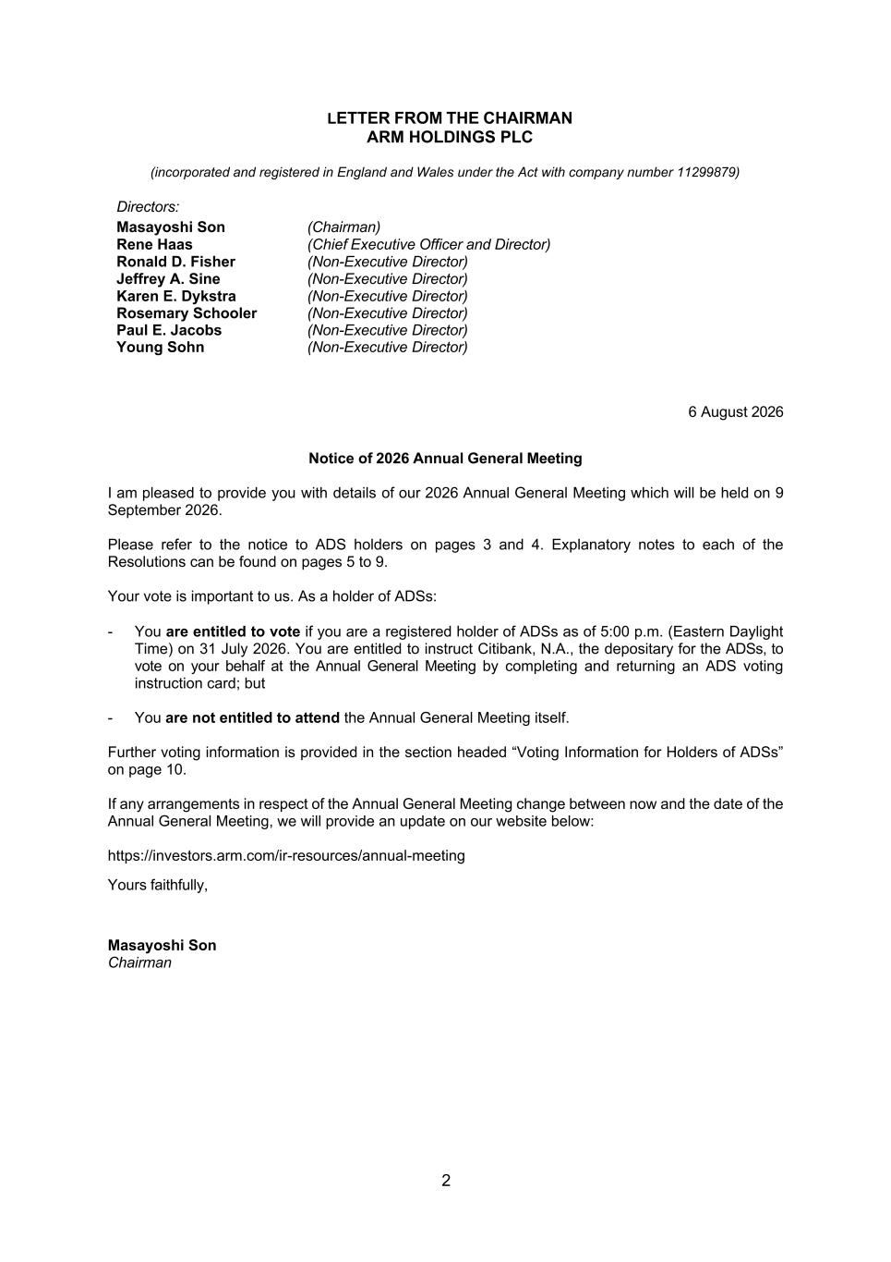
2 LETTER FROM THE CHAIRMAN ARM HOLDINGS PLC (incorporated and registered in England and Wales under the Act with company number 11299879) Directors: Masayoshi Son (Chairman) Rene Haas (Chief Executive Officer and Director) Ronald D. Fisher (Non-Executive Director) Jeffrey A. Sine (Non-Executive Director) Karen E. Dykstra (Non-Executive Director) Rosemary Schooler (Non-Executive Director) Paul E. Jacobs (Non-Executive Director) Young Sohn (Non-Executive Director) 6 August 2026 Notice of 2026 Annual General Meeting I am pleased to provide you with details of our 2026 Annual General Meeting which will be held on 9 September 2026. Please refer to the notice to ADS holders on pages 3 and 4. Explanatory notes to each of the Resolutions can be found on pages 5 to 9. Your vote is important to us. As a holder of ADSs: - You are entitled to vote if you are a registered holder of ADSs as of 5:00 p.m. (Eastern Daylight Time) on 31 July 2026. You are entitled to instruct Citibank, N.A., the depositary for the ADSs, to vote on your behalf at the Annual General Meeting by completing and returning an ADS voting instruction card; but - You are not entitled to attend the Annual General Meeting itself. Further voting information is provided in the section headed “Voting Information for Holders of ADSs” on page 10. If any arrangements in respect of the Annual General Meeting change between now and the date of the Annual General Meeting, we will provide an update on our website below: https://investors.arm.com/ir-resources/annual-meeting Yours faithfully, Masayoshi Son Chairman

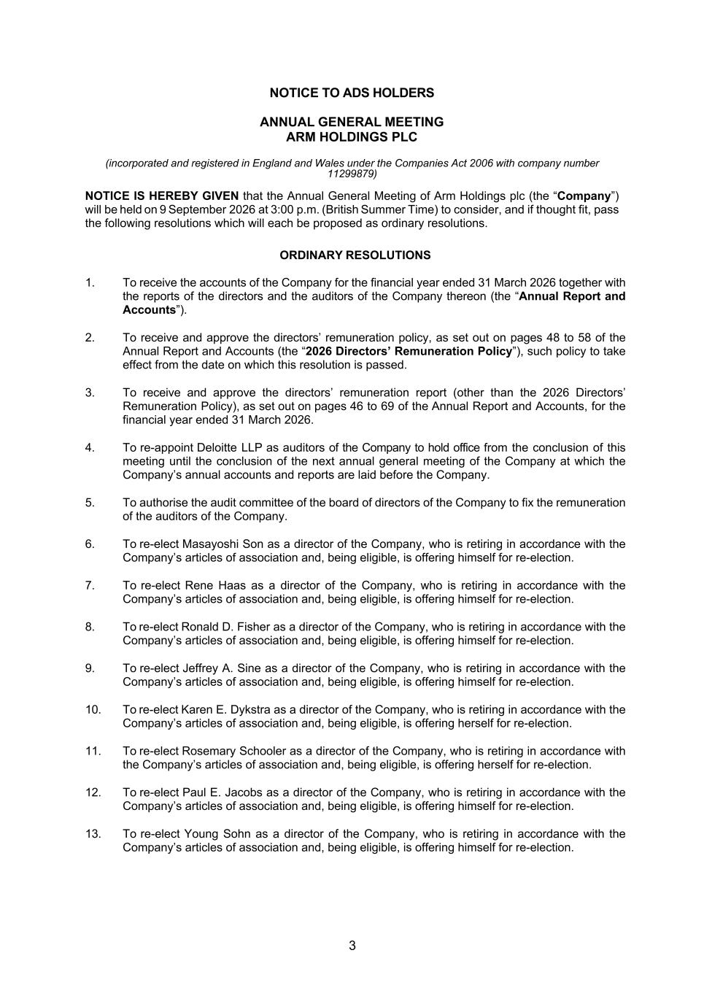
3 NOTICE TO ADS HOLDERS ANNUAL GENERAL MEETING ARM HOLDINGS PLC (incorporated and registered in England and Wales under the Companies Act 2006 with company number 11299879) NOTICE IS HEREBY GIVEN that the Annual General Meeting of Arm Holdings plc (the “Company”) will be held on 9 September 2026 at 3:00 p.m. (British Summer Time) to consider, and if thought fit, pass the following resolutions which will each be proposed as ordinary resolutions. ORDINARY RESOLUTIONS 1. To receive the accounts of the Company for the financial year ended 31 March 2026 together with the reports of the directors and the auditors of the Company thereon (the “Annual Report and Accounts”). 2. To receive and approve the directors’ remuneration policy, as set out on pages 48 to 58 of the Annual Report and Accounts (the “2026 Directors’ Remuneration Policy”), such policy to take effect from the date on which this resolution is passed. 3. To receive and approve the directors’ remuneration report (other than the 2026 Directors’ Remuneration Policy), as set out on pages 46 to 69 of the Annual Report and Accounts, for the financial year ended 31 March 2026. 4. To re-appoint Deloitte LLP as auditors of the Company to hold office from the conclusion of this meeting until the conclusion of the next annual general meeting of the Company at which the Company’s annual accounts and reports are laid before the Company. 5. To authorise the audit committee of the board of directors of the Company to fix the remuneration of the auditors of the Company. 6. To re-elect Masayoshi Son as a director of the Company, who is retiring in accordance with the Company’s articles of association and, being eligible, is offering himself for re-election. 7. To re-elect Rene Haas as a director of the Company, who is retiring in accordance with the Company’s articles of association and, being eligible, is offering himself for re-election. 8. To re-elect Ronald D. Fisher as a director of the Company, who is retiring in accordance with the Company’s articles of association and, being eligible, is offering himself for re-election. 9. To re-elect Jeffrey A. Sine as a director of the Company, who is retiring in accordance with the Company’s articles of association and, being eligible, is offering himself for re-election. 10. To re-elect Karen E. Dykstra as a director of the Company, who is retiring in accordance with the Company’s articles of association and, being eligible, is offering herself for re-election. 11. To re-elect Rosemary Schooler as a director of the Company, who is retiring in accordance with the Company’s articles of association and, being eligible, is offering herself for re-election. 12. To re-elect Paul E. Jacobs as a director of the Company, who is retiring in accordance with the Company’s articles of association and, being eligible, is offering himself for re-election. 13. To re-elect Young Sohn as a director of the Company, who is retiring in accordance with the Company’s articles of association and, being eligible, is offering himself for re-election.


4 BY ORDER OF THE BOARD /s/ Spencer Collins Spencer Collins 6 August 2026 Company Secretary

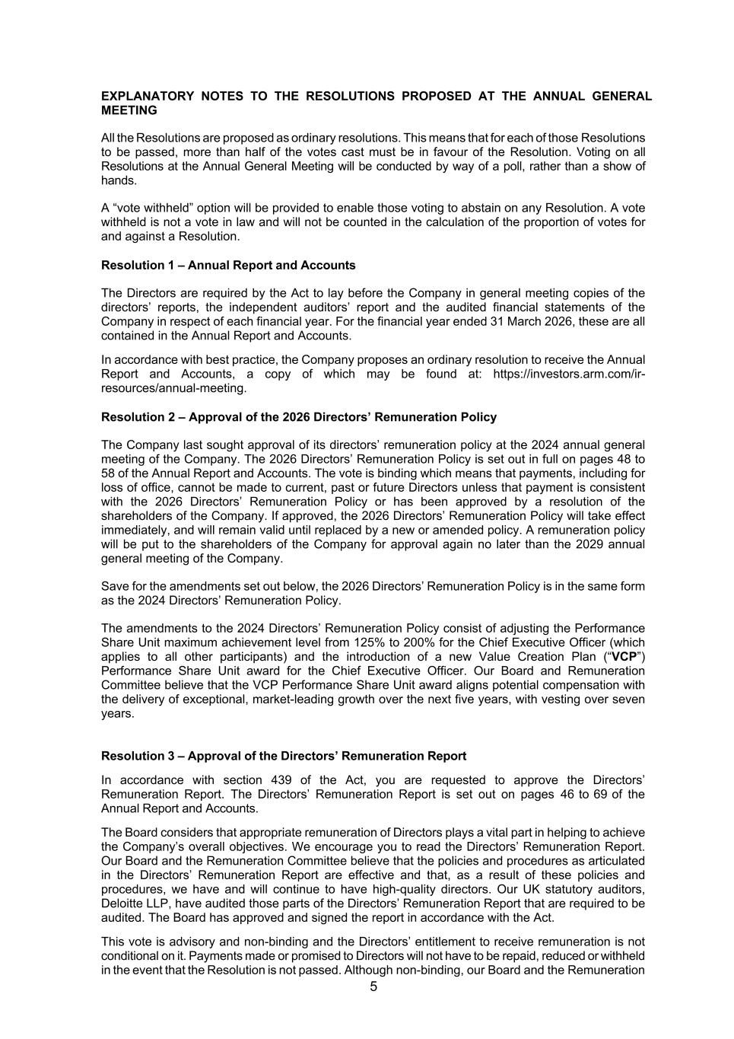
5 EXPLANATORY NOTES TO THE RESOLUTIONS PROPOSED AT THE ANNUAL GENERAL MEETING All the Resolutions are proposed as ordinary resolutions. This means that for each of those Resolutions to be passed, more than half of the votes cast must be in favour of the Resolution. Voting on all Resolutions at the Annual General Meeting will be conducted by way of a poll, rather than a show of hands. A “vote withheld” option will be provided to enable those voting to abstain on any Resolution. A vote withheld is not a vote in law and will not be counted in the calculation of the proportion of votes for and against a Resolution. Resolution 1 – Annual Report and Accounts The Directors are required by the Act to lay before the Company in general meeting copies of the directors’ reports, the independent auditors’ report and the audited financial statements of the Company in respect of each financial year. For the financial year ended 31 March 2026, these are all contained in the Annual Report and Accounts. In accordance with best practice, the Company proposes an ordinary resolution to receive the Annual Report and Accounts, a copy of which may be found at: https://investors.arm.com/ir- resources/annual-meeting. Resolution 2 – Approval of the 2026 Directors’ Remuneration Policy The Company last sought approval of its directors’ remuneration policy at the 2024 annual general meeting of the Company. The 2026 Directors’ Remuneration Policy is set out in full on pages 48 to 58 of the Annual Report and Accounts. The vote is binding which means that payments, including for loss of office, cannot be made to current, past or future Directors unless that payment is consistent with the 2026 Directors’ Remuneration Policy or has been approved by a resolution of the shareholders of the Company. If approved, the 2026 Directors’ Remuneration Policy will take effect immediately, and will remain valid until replaced by a new or amended policy. A remuneration policy will be put to the shareholders of the Company for approval again no later than the 2029 annual general meeting of the Company. Save for the amendments set out below, the 2026 Directors’ Remuneration Policy is in the same form as the 2024 Directors’ Remuneration Policy. The amendments to the 2024 Directors’ Remuneration Policy consist of adjusting the Performance Share Unit maximum achievement level from 125% to 200% for the Chief Executive Officer (which applies to all other participants) and the introduction of a new Value Creation Plan (“VCP”) Performance Share Unit award for the Chief Executive Officer. Our Board and Remuneration Committee believe that the VCP Performance Share Unit award aligns potential compensation with the delivery of exceptional, market-leading growth over the next five years, with vesting over seven years. Resolution 3 – Approval of the Directors’ Remuneration Report In accordance with section 439 of the Act, you are requested to approve the Directors’ Remuneration Report. The Directors’ Remuneration Report is set out on pages 46 to 69 of the Annual Report and Accounts. The Board considers that appropriate remuneration of Directors plays a vital part in helping to achieve the Company’s overall objectives. We encourage you to read the Directors’ Remuneration Report. Our Board and the Remuneration Committee believe that the policies and procedures as articulated in the Directors’ Remuneration Report are effective and that, as a result of these policies and procedures, we have and will continue to have high-quality directors. Our UK statutory auditors, Deloitte LLP, have audited those parts of the Directors’ Remuneration Report that are required to be audited. The Board has approved and signed the report in accordance with the Act. This vote is advisory and non-binding and the Directors’ entitlement to receive remuneration is not conditional on it. Payments made or promised to Directors will not have to be repaid, reduced or withheld in the event that the Resolution is not passed. Although non-binding, our Board and the Remuneration

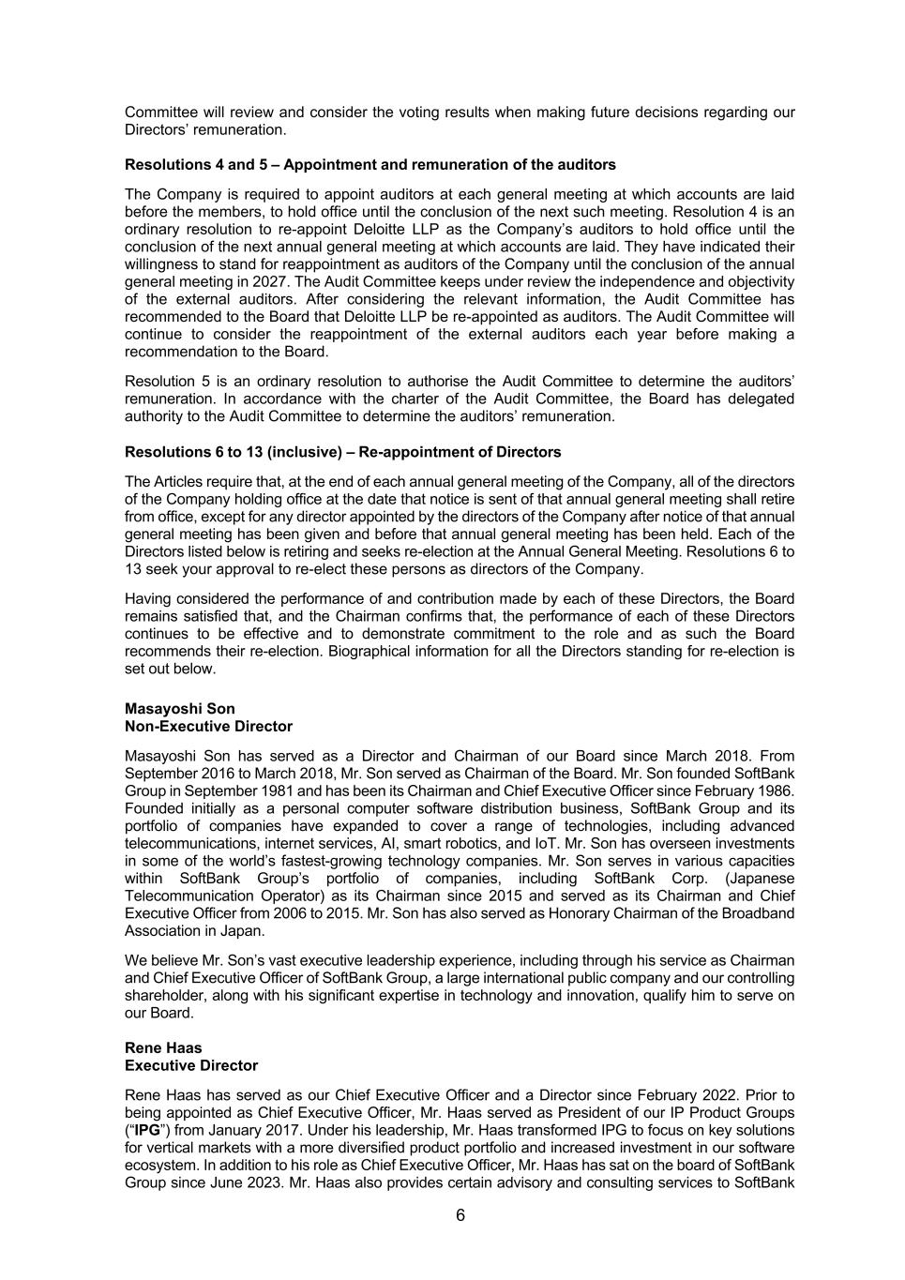
6 Committee will review and consider the voting results when making future decisions regarding our Directors’ remuneration. Resolutions 4 and 5 – Appointment and remuneration of the auditors The Company is required to appoint auditors at each general meeting at which accounts are laid before the members, to hold office until the conclusion of the next such meeting. Resolution 4 is an ordinary resolution to re-appoint Deloitte LLP as the Company’s auditors to hold office until the conclusion of the next annual general meeting at which accounts are laid. They have indicated their willingness to stand for reappointment as auditors of the Company until the conclusion of the annual general meeting in 2027. The Audit Committee keeps under review the independence and objectivity of the external auditors. After considering the relevant information, the Audit Committee has recommended to the Board that Deloitte LLP be re-appointed as auditors. The Audit Committee will continue to consider the reappointment of the external auditors each year before making a recommendation to the Board. Resolution 5 is an ordinary resolution to authorise the Audit Committee to determine the auditors’ remuneration. In accordance with the charter of the Audit Committee, the Board has delegated authority to the Audit Committee to determine the auditors’ remuneration. Resolutions 6 to 13 (inclusive) – Re-appointment of Directors The Articles require that, at the end of each annual general meeting of the Company, all of the directors of the Company holding office at the date that notice is sent of that annual general meeting shall retire from office, except for any director appointed by the directors of the Company after notice of that annual general meeting has been given and before that annual general meeting has been held. Each of the Directors listed below is retiring and seeks re-election at the Annual General Meeting. Resolutions 6 to 13 seek your approval to re-elect these persons as directors of the Company. Having considered the performance of and contribution made by each of these Directors, the Board remains satisfied that, and the Chairman confirms that, the performance of each of these Directors continues to be effective and to demonstrate commitment to the role and as such the Board recommends their re-election. Biographical information for all the Directors standing for re-election is set out below. Masayoshi Son Non-Executive Director Masayoshi Son has served as a Director and Chairman of our Board since March 2018. From September 2016 to March 2018, Mr. Son served as Chairman of the Board. Mr. Son founded SoftBank Group in September 1981 and has been its Chairman and Chief Executive Officer since February 1986. Founded initially as a personal computer software distribution business, SoftBank Group and its portfolio of companies have expanded to cover a range of technologies, including advanced telecommunications, internet services, AI, smart robotics, and IoT. Mr. Son has overseen investments in some of the world’s fastest-growing technology companies. Mr. Son serves in various capacities within SoftBank Group’s portfolio of companies, including SoftBank Corp. (Japanese Telecommunication Operator) as its Chairman since 2015 and served as its Chairman and Chief Executive Officer from 2006 to 2015. Mr. Son has also served as Honorary Chairman of the Broadband Association in Japan. We believe Mr. Son’s vast executive leadership experience, including through his service as Chairman and Chief Executive Officer of SoftBank Group, a large international public company and our controlling shareholder, along with his significant expertise in technology and innovation, qualify him to serve on our Board. Rene Haas Executive Director Rene Haas has served as our Chief Executive Officer and a Director since February 2022. Prior to being appointed as Chief Executive Officer, Mr. Haas served as President of our IP Product Groups (“IPG”) from January 2017. Under his leadership, Mr. Haas transformed IPG to focus on key solutions for vertical markets with a more diversified product portfolio and increased investment in our software ecosystem. In addition to his role as Chief Executive Officer, Mr. Haas has sat on the board of SoftBank Group since June 2023. Mr. Haas also provides certain advisory and consulting services to SoftBank

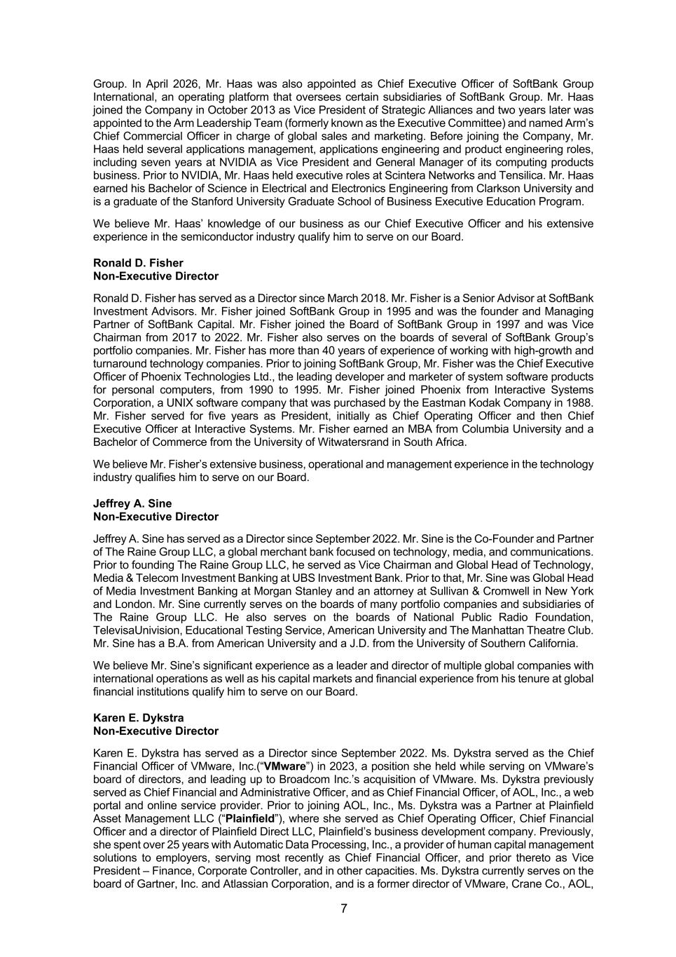
7 Group. In April 2026, Mr. Haas was also appointed as Chief Executive Officer of SoftBank Group International, an operating platform that oversees certain subsidiaries of SoftBank Group. Mr. Haas joined the Company in October 2013 as Vice President of Strategic Alliances and two years later was appointed to the Arm Leadership Team (formerly known as the Executive Committee) and named Arm’s Chief Commercial Officer in charge of global sales and marketing. Before joining the Company, Mr. Haas held several applications management, applications engineering and product engineering roles, including seven years at NVIDIA as Vice President and General Manager of its computing products business. Prior to NVIDIA, Mr. Haas held executive roles at Scintera Networks and Tensilica. Mr. Haas earned his Bachelor of Science in Electrical and Electronics Engineering from Clarkson University and is a graduate of the Stanford University Graduate School of Business Executive Education Program. We believe Mr. Haas’ knowledge of our business as our Chief Executive Officer and his extensive experience in the semiconductor industry qualify him to serve on our Board. Ronald D. Fisher Non-Executive Director Ronald D. Fisher has served as a Director since March 2018. Mr. Fisher is a Senior Advisor at SoftBank Investment Advisors. Mr. Fisher joined SoftBank Group in 1995 and was the founder and Managing Partner of SoftBank Capital. Mr. Fisher joined the Board of SoftBank Group in 1997 and was Vice Chairman from 2017 to 2022. Mr. Fisher also serves on the boards of several of SoftBank Group’s portfolio companies. Mr. Fisher has more than 40 years of experience of working with high-growth and turnaround technology companies. Prior to joining SoftBank Group, Mr. Fisher was the Chief Executive Officer of Phoenix Technologies Ltd., the leading developer and marketer of system software products for personal computers, from 1990 to 1995. Mr. Fisher joined Phoenix from Interactive Systems Corporation, a UNIX software company that was purchased by the Eastman Kodak Company in 1988. Mr. Fisher served for five years as President, initially as Chief Operating Officer and then Chief Executive Officer at Interactive Systems. Mr. Fisher earned an MBA from Columbia University and a Bachelor of Commerce from the University of Witwatersrand in South Africa. We believe Mr. Fisher’s extensive business, operational and management experience in the technology industry qualifies him to serve on our Board. Jeffrey A. Sine Non-Executive Director Jeffrey A. Sine has served as a Director since September 2022. Mr. Sine is the Co-Founder and Partner of The Raine Group LLC, a global merchant bank focused on technology, media, and communications. Prior to founding The Raine Group LLC, he served as Vice Chairman and Global Head of Technology, Media & Telecom Investment Banking at UBS Investment Bank. Prior to that, Mr. Sine was Global Head of Media Investment Banking at Morgan Stanley and an attorney at Sullivan & Cromwell in New York and London. Mr. Sine currently serves on the boards of many portfolio companies and subsidiaries of The Raine Group LLC. He also serves on the boards of National Public Radio Foundation, TelevisaUnivision, Educational Testing Service, American University and The Manhattan Theatre Club. Mr. Sine has a B.A. from American University and a J.D. from the University of Southern California. We believe Mr. Sine’s significant experience as a leader and director of multiple global companies with international operations as well as his capital markets and financial experience from his tenure at global financial institutions qualify him to serve on our Board. Karen E. Dykstra Non-Executive Director Karen E. Dykstra has served as a Director since September 2022. Ms. Dykstra served as the Chief Financial Officer of VMware, Inc.(“VMware”) in 2023, a position she held while serving on VMware’s board of directors, and leading up to Broadcom Inc.’s acquisition of VMware. Ms. Dykstra previously served as Chief Financial and Administrative Officer, and as Chief Financial Officer, of AOL, Inc., a web portal and online service provider. Prior to joining AOL, Inc., Ms. Dykstra was a Partner at Plainfield Asset Management LLC (“Plainfield”), where she served as Chief Operating Officer, Chief Financial Officer and a director of Plainfield Direct LLC, Plainfield’s business development company. Previously, she spent over 25 years with Automatic Data Processing, Inc., a provider of human capital management solutions to employers, serving most recently as Chief Financial Officer, and prior thereto as Vice President – Finance, Corporate Controller, and in other capacities. Ms. Dykstra currently serves on the board of Gartner, Inc. and Atlassian Corporation, and is a former director of VMware, Crane Co., AOL,

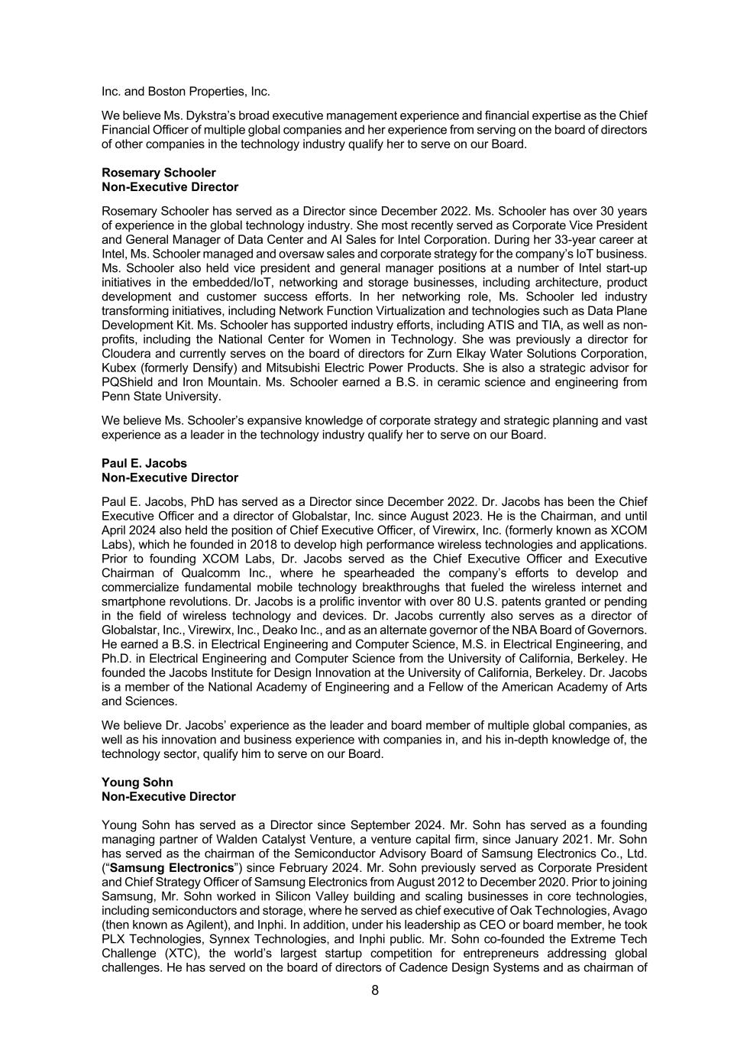
8 Inc. and Boston Properties, Inc. We believe Ms. Dykstra’s broad executive management experience and financial expertise as the Chief Financial Officer of multiple global companies and her experience from serving on the board of directors of other companies in the technology industry qualify her to serve on our Board. Rosemary Schooler Non-Executive Director Rosemary Schooler has served as a Director since December 2022. Ms. Schooler has over 30 years of experience in the global technology industry. She most recently served as Corporate Vice President and General Manager of Data Center and AI Sales for Intel Corporation. During her 33-year career at Intel, Ms. Schooler managed and oversaw sales and corporate strategy for the company’s IoT business. Ms. Schooler also held vice president and general manager positions at a number of Intel start-up initiatives in the embedded/IoT, networking and storage businesses, including architecture, product development and customer success efforts. In her networking role, Ms. Schooler led industry transforming initiatives, including Network Function Virtualization and technologies such as Data Plane Development Kit. Ms. Schooler has supported industry efforts, including ATIS and TIA, as well as non- profits, including the National Center for Women in Technology. She was previously a director for Cloudera and currently serves on the board of directors for Zurn Elkay Water Solutions Corporation, Kubex (formerly Densify) and Mitsubishi Electric Power Products. She is also a strategic advisor for PQShield and Iron Mountain. Ms. Schooler earned a B.S. in ceramic science and engineering from Penn State University. We believe Ms. Schooler’s expansive knowledge of corporate strategy and strategic planning and vast experience as a leader in the technology industry qualify her to serve on our Board. Paul E. Jacobs Non-Executive Director Paul E. Jacobs, PhD has served as a Director since December 2022. Dr. Jacobs has been the Chief Executive Officer and a director of Globalstar, Inc. since August 2023. He is the Chairman, and until April 2024 also held the position of Chief Executive Officer, of Virewirx, Inc. (formerly known as XCOM Labs), which he founded in 2018 to develop high performance wireless technologies and applications. Prior to founding XCOM Labs, Dr. Jacobs served as the Chief Executive Officer and Executive Chairman of Qualcomm Inc., where he spearheaded the company’s efforts to develop and commercialize fundamental mobile technology breakthroughs that fueled the wireless internet and smartphone revolutions. Dr. Jacobs is a prolific inventor with over 80 U.S. patents granted or pending in the field of wireless technology and devices. Dr. Jacobs currently also serves as a director of Globalstar, Inc., Virewirx, Inc., Deako Inc., and as an alternate governor of the NBA Board of Governors. He earned a B.S. in Electrical Engineering and Computer Science, M.S. in Electrical Engineering, and Ph.D. in Electrical Engineering and Computer Science from the University of California, Berkeley. He founded the Jacobs Institute for Design Innovation at the University of California, Berkeley. Dr. Jacobs is a member of the National Academy of Engineering and a Fellow of the American Academy of Arts and Sciences. We believe Dr. Jacobs’ experience as the leader and board member of multiple global companies, as well as his innovation and business experience with companies in, and his in-depth knowledge of, the technology sector, qualify him to serve on our Board. Young Sohn Non-Executive Director Young Sohn has served as a Director since September 2024. Mr. Sohn has served as a founding managing partner of Walden Catalyst Venture, a venture capital firm, since January 2021. Mr. Sohn has served as the chairman of the Semiconductor Advisory Board of Samsung Electronics Co., Ltd. (“Samsung Electronics”) since February 2024. Mr. Sohn previously served as Corporate President and Chief Strategy Officer of Samsung Electronics from August 2012 to December 2020. Prior to joining Samsung, Mr. Sohn worked in Silicon Valley building and scaling businesses in core technologies, including semiconductors and storage, where he served as chief executive of Oak Technologies, Avago (then known as Agilent), and Inphi. In addition, under his leadership as CEO or board member, he took PLX Technologies, Synnex Technologies, and Inphi public. Mr. Sohn co-founded the Extreme Tech Challenge (XTC), the world’s largest startup competition for entrepreneurs addressing global challenges. He has served on the board of directors of Cadence Design Systems and as chairman of


9 the board of HARMAN International since May 2012 and March 2017, respectively. Mr. Sohn holds a B.S. in electrical engineering from the University of Pennsylvania and an M.S. from the MIT Sloan School of Management. We believe Mr. Sohn’s extensive experience as a leader and a board member of multiple global companies and his in-depth knowledge of the technology industry qualify him to serve on our Board.

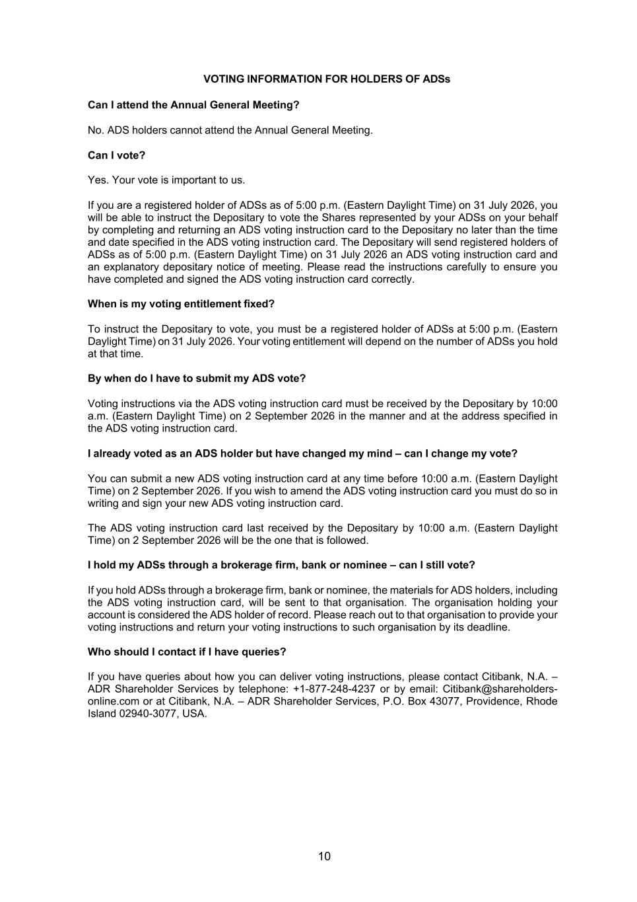
10 VOTING INFORMATION FOR HOLDERS OF ADSs Can I attend the Annual General Meeting? No. ADS holders cannot attend the Annual General Meeting. Can I vote? Yes. Your vote is important to us. If you are a registered holder of ADSs as of 5:00 p.m. (Eastern Daylight Time) on 31 July 2026, you will be able to instruct the Depositary to vote the Shares represented by your ADSs on your behalf by completing and returning an ADS voting instruction card to the Depositary no later than the time and date specified in the ADS voting instruction card. The Depositary will send registered holders of ADSs as of 5:00 p.m. (Eastern Daylight Time) on 31 July 2026 an ADS voting instruction card and an explanatory depositary notice of meeting. Please read the instructions carefully to ensure you have completed and signed the ADS voting instruction card correctly. When is my voting entitlement fixed? To instruct the Depositary to vote, you must be a registered holder of ADSs at 5:00 p.m. (Eastern Daylight Time) on 31 July 2026. Your voting entitlement will depend on the number of ADSs you hold at that time. By when do I have to submit my ADS vote? Voting instructions via the ADS voting instruction card must be received by the Depositary by 10:00 a.m. (Eastern Daylight Time) on 2 September 2026 in the manner and at the address specified in the ADS voting instruction card. I already voted as an ADS holder but have changed my mind – can I change my vote? You can submit a new ADS voting instruction card at any time before 10:00 a.m. (Eastern Daylight Time) on 2 September 2026. If you wish to amend the ADS voting instruction card you must do so in writing and sign your new ADS voting instruction card. The ADS voting instruction card last received by the Depositary by 10:00 a.m. (Eastern Daylight Time) on 2 September 2026 will be the one that is followed. I hold my ADSs through a brokerage firm, bank or nominee – can I still vote? If you hold ADSs through a brokerage firm, bank or nominee, the materials for ADS holders, including the ADS voting instruction card, will be sent to that organisation. The organisation holding your account is considered the ADS holder of record. Please reach out to that organisation to provide your voting instructions and return your voting instructions to such organisation by its deadline. Who should I contact if I have queries? If you have queries about how you can deliver voting instructions, please contact Citibank, N.A. – ADR Shareholder Services by telephone: +1-877-248-4237 or by email: Citibank@shareholders- online.com or at Citibank, N.A. – ADR Shareholder Services, P.O. Box 43077, Providence, Rhode Island 02940-3077, USA.

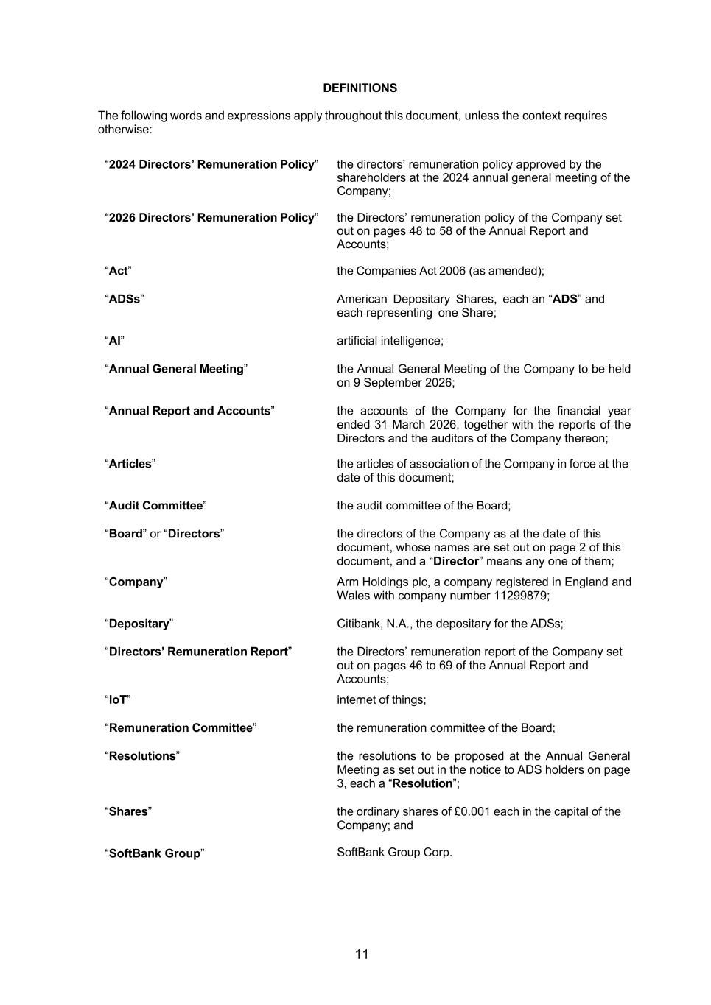
11 DEFINITIONS The following words and expressions apply throughout this document, unless the context requires otherwise: “2024 Directors’ Remuneration Policy” the directors’ remuneration policy approved by the shareholders at the 2024 annual general meeting of the Company; “2026 Directors’ Remuneration Policy” the Directors’ remuneration policy of the Company set out on pages 48 to 58 of the Annual Report and Accounts; “Act” the Companies Act 2006 (as amended); “ADSs” American Depositary Shares, each an “ADS” and each representing one Share; “AI” artificial intelligence; “Annual General Meeting” the Annual General Meeting of the Company to be held on 9 September 2026; “Annual Report and Accounts” the accounts of the Company for the financial year ended 31 March 2026, together with the reports of the Directors and the auditors of the Company thereon; “Articles” the articles of association of the Company in force at the date of this document; “Audit Committee” the audit committee of the Board; “Board” or “Directors” the directors of the Company as at the date of this document, whose names are set out on page 2 of this document, and a “Director” means any one of them; “Company” Arm Holdings plc, a company registered in England and Wales with company number 11299879; “Depositary” Citibank, N.A., the depositary for the ADSs; “Directors’ Remuneration Report” the Directors’ remuneration report of the Company set out on pages 46 to 69 of the Annual Report and Accounts; “IoT” internet of things; “Remuneration Committee” the remuneration committee of the Board; “Resolutions” the resolutions to be proposed at the Annual General Meeting as set out in the notice to ADS holders on page 3, each a “Resolution”; “Shares” the ordinary shares of £0.001 each in the capital of the Company; and “SoftBank Group” SoftBank Group Corp.

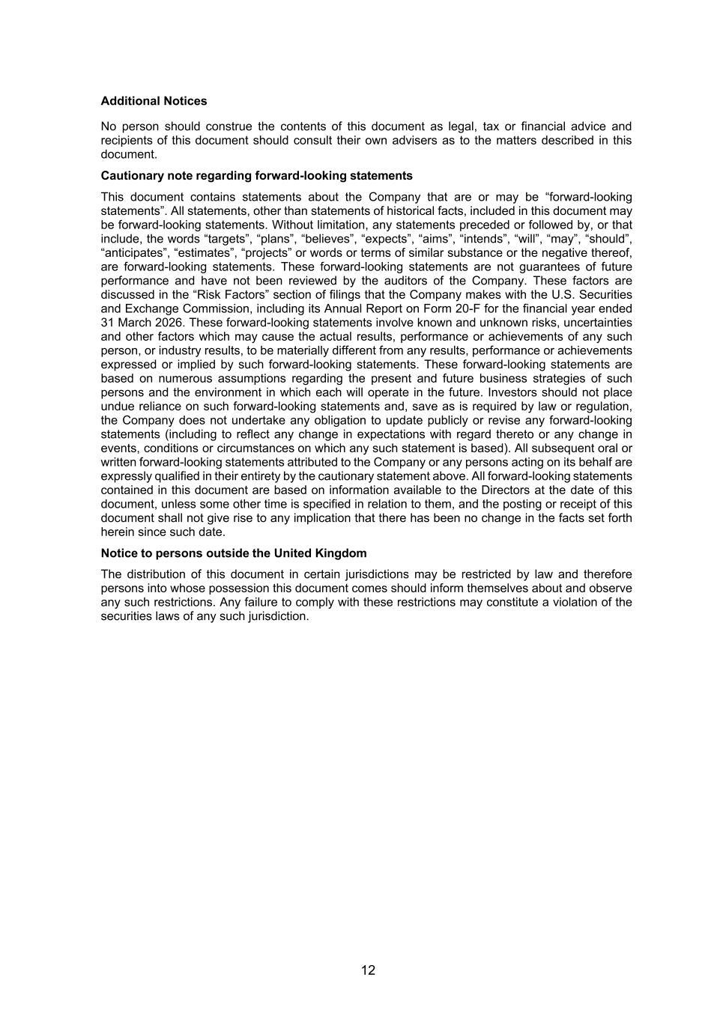
12 Additional Notices No person should construe the contents of this document as legal, tax or financial advice and recipients of this document should consult their own advisers as to the matters described in this document. Cautionary note regarding forward-looking statements This document contains statements about the Company that are or may be “forward-looking statements”. All statements, other than statements of historical facts, included in this document may be forward-looking statements. Without limitation, any statements preceded or followed by, or that include, the words “targets”, “plans”, “believes”, “expects”, “aims”, “intends”, “will”, “may”, “should”, “anticipates”, “estimates”, “projects” or words or terms of similar substance or the negative thereof, are forward-looking statements. These forward-looking statements are not guarantees of future performance and have not been reviewed by the auditors of the Company. These factors are discussed in the “Risk Factors” section of filings that the Company makes with the U.S. Securities and Exchange Commission, including its Annual Report on Form 20-F for the financial year ended 31 March 2026. These forward-looking statements involve known and unknown risks, uncertainties and other factors which may cause the actual results, performance or achievements of any such person, or industry results, to be materially different from any results, performance or achievements expressed or implied by such forward-looking statements. These forward-looking statements are based on numerous assumptions regarding the present and future business strategies of such persons and the environment in which each will operate in the future. Investors should not place undue reliance on such forward-looking statements and, save as is required by law or regulation, the Company does not undertake any obligation to update publicly or revise any forward-looking statements (including to reflect any change in expectations with regard thereto or any change in events, conditions or circumstances on which any such statement is based). All subsequent oral or written forward-looking statements attributed to the Company or any persons acting on its behalf are expressly qualified in their entirety by the cautionary statement above. All forward-looking statements contained in this document are based on information available to the Directors at the date of this document, unless some other time is specified in relation to them, and the posting or receipt of this document shall not give rise to any implication that there has been no change in the facts set forth herein since such date. Notice to persons outside the United Kingdom The distribution of this document in certain jurisdictions may be restricted by law and therefore persons into whose possession this document comes should inform themselves about and observe any such restrictions. Any failure to comply with these restrictions may constitute a violation of the securities laws of any such jurisdiction.

