As filed with the Securities and Exchange Commission on September 12, 2024

 | UNITED STATES
 | SECURITIES AND EXCHANGE COMMISSION
 | Washington, D.C. 20549
 | _______________________
 | POST-EFFECTIVE AMENDMENT NO. 1
 | TO
 | FORM S-8
 | REGISTRATION STATEMENT NO. 333-274544
 | UNDER
 | THE SECURITIES ACT OF 1933
 | _______________________
 | Arm Holdings plc
 | (Exact name of registrant as specified in its charter)
England and Wales | Not Applicable
(State or other jurisdiction of incorporation or organization) | (I.R.S. Employer
 | Identification Number)
110 Fulbourn Road
Cambridge CB1 9NJ
United Kingdom
(Address of principal executive offices)
 | Arm Holdings plc 2023 Omnibus Incentive Plan with
 | Non-Employee Sub Plan and the France and Israel Sub-Plans
 | The Arm Holdings plc RSU Award Plan with California and Israeli Sub-Plans
 | The Arm Holdings plc All-Employee Plan 2019 with California and French Sub-Plans
 | The Executive IPO Plan 2019 with California Sub-Plan
 | The Arm Non-Executive Directors RSU Award Plan with California Sub-Plan
 | Arm Holdings plc 2024 Employee Stock Purchase Plan
 | (Full title of plan)
 | Arm, Inc.
 | 120 Rose Orchard Way
 | San Jose, CA 95134
 | (Name and address of agent for service)
 | +1 (408) 576-1500
 | (Telephone number, including area code, of agent for service)
 | Copies to:
Spencer Collins | Phil Linnard
Chief Legal Officer | Slaughter and May
Arm Holdings plc | One Bunhill Row,
110 Fulbourn Road | London EC1Y 8YY
Cambridge CB1 9NJ | United Kingdom
United Kingdom | Tel: +44 (0)20 7600 1200
Tel: +44 (1223) 400 400

Indicate by check mark whether the registrant is a large accelerated filer, an accelerated filer, a non-accelerated filer, a smaller reporting company, or an emerging growth company. See the definitions of “large accelerated filer,” “accelerated filer,” “smaller reporting company,” and “emerging growth company” in Rule 12b-2 of the Exchange Act.

Large accelerated filer Smaller reporting company

☐

☐

Accelerated filer ☐ Non-accelerated filer

Emerging growth company ☐

☒

If an emerging growth company, indicate by check mark if the registrant has elected not to use the extended transition period for complying with any new or revised financial accounting standards provided pursuant to Section 7(a)(2)(B) of Securities Act. ☐

EXPLANATORY NOTE

Arm Holdings plc (the “Company” or “Registrant”) previously filed a Registration Statement on Form S-8 (File No. 333-274544) with the U.S. Securities and Exchange Commission on September 15, 2023 (the “Prior Registration Statement”) with respect to 20,500,000 of the Registrant’s ordinary shares, par value $0.001 per share and American Depositary Shares representing ordinary shares (“ADSs”), issuable under the Company’s 2023 Omnibus Incentive Plan and the sub-plans thereto (the “Existing Plans”).

On September 11, 2024, at the Company’s Annual General Meeting, the Company’s shareholders approved the Company’s 2024 Employee Stock Purchase Plan (the “ESPP”), under which the Company may also issue shares from the share pool approved for the Existing Plans.

Accordingly, the Company is filing this Post Effective Amendment No. 1 to the Prior Registration Statement to amend the Prior Registration Statement to include the ESPP to the plans that may utilize the approved share pool.

For the avoidance of doubt, the Registrant is not registering any additional shares pursuant to this Post-Effective Amendment.

PART I

INFORMATION REQUIRED IN THE SECTION 10(a) PROSPECTUS

The information specified in Item 1 and Item 2 of Part I of Form S-8 is omitted from this Registration Statement in accordance with the provisions of

Rule 428 under the Securities Act of 1933, as amended (the “Securities Act”). The documents containing the information specified in Item 1 and Item 2 of Part I of

Form S-8 will be delivered to the participants in the plan covered by this Registration Statement as specified by Rule 428(b)(1) under the Securities Act.

PART II

INFORMATION REQUIRED IN THE REGISTRATION STATEMENT

Item 3. Incorporation of Documents by Reference.

The following documents previously filed with the SEC by the Company are incorporated by reference herein and shall be deemed to be part hereof:

- The Registrant’s latest annual report on Form 20-F filed pursuant to Section 13(a) or 15(d) of the Securities Exchange Act of 1934, as amended (the “Exchange Act”) for the fiscal year ended March 31, 2024, filed May 29, 2024; and

- The descriptions of the Registrant’s American Depositary Shares and Ordinary Shares contained in the Registrant’s registration statement on Form 8-A filed on September 12, 2023 (File No. 001-41800) under the Exchange Act, including any amendment or report filed for the purpose of updating such description.

All documents and reports filed by the Registrant pursuant to Sections 13(a), 13(c), 14 and 15(d) of the Exchange Act subsequent to the date hereof and prior to the filing of a post-effective amendment indicating that all securities offered herein have been sold or which deregisters all securities then remaining unsold, including any Reports of Foreign Private Issuers on Form 6-K submitted during such period (or portion thereof) that is identified in such form as being incorporated by reference into this Registration Statement, shall be deemed to be incorporated by reference into this Registration Statement and to be a part hereof from the date of such documents and reports.

Any statement contained in a document incorporated or deemed to be incorporated by reference herein shall be deemed to be modified or superseded for purposes of this Registration Statement to the extent that a statement contained herein or in any other subsequently filed document which also is or is deemed to be incorporated by reference herein modifies or supersedes such statement. Any such statement so modified or superseded shall not be deemed, except as so modified or superseded, to constitute a part of this Registration Statement.

Item 4. Description of Securities.

Not applicable.

Item 5. Interests of Named Experts and Counsel.

Not applicable.

Item 6. Indemnification of Directors and Officers.

To the extent permitted by the U.K. Companies Act 2006, the Registrant is empowered to indemnify its directors against any liability they incur by reason of their directorship. The Registrant maintains directors’ and officers’ insurance to insure such persons against certain liabilities. The Registrant has entered into a deed of indemnity with each of its directors and executive officers.

Item 7. Exemption from Registration Claimed.

Not applicable.

Item 8. Exhibits

Exhibit |  |  |  |  |  | Description of Exhibit |  |  |  |  |  |  |  |  |  |  | Form | File No. | Exhibit | Filing Date | Filed Herewith
Number
4.1 |  |  | Articles of Association, as amended. |  |  |  |  |  |  |  |  |  |  |  |  |  | 20-F | 001-41800 | 1.1 | 05/29/2024
4.2 |  |  | Deposit Agreement, dated as of September 13, 2023, by and |  |  |  |  |  |  |  |  |  |  |  |  |  | 20-F | 001-41800 | 2.1 | 05/29/2024
 |  |  | between Arm Holdings plc and Citibank, N.A.
4.3 |  |  | Form of American Depositary Receipt (included in Exhibit
 |  | 4.2).
4.4 |  |  | Arm Holdings plc 2023 Omnibus Incentive Plan with the Non- |  |  |  |  |  |  |  |  |  |  |  |  |  |  |  |  |  | X
 |  |  | Employee Sub-Plan, the France Sub-Plan, as amended, and the
 |  |  | Israel Sub-Plan.
4.5 |  |  | The Arm Holdings plc RSU Award Plan with California and |  |  |  |  |  |  |  |  |  |  |  |  |  | S-8 | 333-274544 | 4.6 | 09/15/2023
 |  |  | Israeli Sub-Plans.
4.6 |  |  | The Arm Holdings plc All-Employee Plan 2019 with |  |  |  |  |  |  |  |  |  |  |  |  |  | S-8 | 333-274544 | 4.7 | 09/15/2023
 |  |  | California and French Sub-Plans.
4.7 |  |  | The Executive IPO Plan 2019 with California Sub-Plan. |  |  |  |  |  |  |  |  |  |  |  |  |  | S-8 | 333-274544 | 4.8 | 09/15/2023
4.8 |  |  | The Arm Non-Executive Directors RSU Award Plan with |  |  |  |  |  |  |  |  |  |  |  |  |  | S-8 | 333-274544 | 4.9 | 09/15/2023
 |  |  | California Sub-Plan.
4.9 |  |  | Arm Holdings plc 2024 Employee Stock Purchase Plan. |  |  |  |  |  |  |  |  |  |  |  |  |  |  |  |  |  | X
5.1 |  |  | Opinion of Slaughter and May. |  |  |  |  |  |  |  |  |  |  |  |  |  |  |  |  |  | X
5.2 |  |  | Opinion of Morrison & Foerster (UK) LLP. |  |  |  |  |  |  |  |  |  |  |  |  |  |  |  |  |  | X
23.1 |  |  | Consent of Deloitte & Touche LLP, the Company’s |  |  |  |  |  |  |  |  |  |  |  |  |  |  |  |  |  | X
 |  |  | independent registered public accounting firm.
23.2 |  |  | Consent of Slaughter and May (included as part of Exhibit |  |  |  |  |  |  |  |  |  |  |  |  |  |  |  |  |  | X
 |  |  | 5.1).
23.3 |  |  | Consent of Morrison & Foerster (UK) LLP (included as part |  |  |  |  |  |  |  |  |  |  |  |  |  |  |  |  |  | X
 |  |  | of Exhibit 5.2).

Item 9. Undertakings.

- The Registrant hereby undertakes:

  - To file, during any period in which offers or sales are being made, a post-effective amendment to this Registration Statement:

    - to include any prospectus required by section 10(a)(3) of the Securities Act of 1933;

    - to reflect in the prospectus any facts or events arising after the effective date of this Registration Statement (or the most recent post-effective amendment thereof) which, individually or in the aggregate, represent a fundamental change in the information set forth in this Registration Statement. Notwithstanding the foregoing, any increase or decrease in volume of securities offered (if the total dollar value of securities offered would not exceed that which was registered) and any deviation from

the low or high end of the estimated maximum offering range may be reflected in the form of prospectus filed with the Commission pursuant to Rule 424(b) if, in the aggregate, the changes in volume and price represent no more than a 20 percent change in the maximum aggregate offering price set forth in the “Calculation of Registration Fee Table” attached as Exhibit 107 to this Registration Statement; and

- to include any material information with respect to the plan of distribution not previously disclosed in the Registration Statement or any material change to such information in the Registration Statement;

provided, however, that paragraphs (a)(1)(i) and (a)(1)(ii) do not apply if the information required to be included in a post-effective amendment by those paragraphs is contained in periodic reports filed with or furnished to the Commission by the Registrant pursuant to Section 13 or Section 15(d) of the Securities Exchange Act of 1934 that are incorporated by reference in this Registration Statement.

  - That, for the purpose of determining any liability under the Securities Act of 1933, each such post-effective amendment shall be deemed to be a new registration statement relating to the securities offered therein, and the offering of such securities at that time shall be deemed to be the initial bona fide offering thereof.

  - To remove from registration by means of a post-effective amendment any of the securities being registered which remain unsold at the termination of

the offering.

- The Registrant hereby undertakes that, for purposes of determining any liability under the Securities Act of 1933, each filing of the Registrant’s annual report pursuant to Section 13(a) or Section 15(d) of the Securities Exchange Act of 1934 (and, where applicable, each filing of an employee benefit plan’s annual report pursuant to Section 15(d) of the Securities Exchange Act of 1934) that is incorporated by reference in the Registration Statement shall be deemed to be a new registration statement relating to the securities offered therein, and the offering of such securities at that time shall be deemed to be the initial bona fide offering thereof.

- Insofar as indemnification for liabilities arising under the Securities Act of 1933 may be permitted to directors, officers and controlling persons of the Registrant pursuant to the foregoing provisions, or otherwise, the Registrant has been advised that in the opinion of the Securities and Exchange Commission such indemnification is against public policy as expressed in the Act and is, therefore, unenforceable. In the event that a claim for indemnification against such liabilities (other than the payment by the Registrant of expenses incurred or paid by a director, officer or controlling person of the Registrant in the successful defense of any action, suit or proceeding) is asserted by such director, officer or controlling person in connection with the securities being registered, the Registrant will, unless in the opinion of its counsel the matter has been settled by controlling precedent, submit to a court of appropriate jurisdiction the question whether such indemnification by it is against public policy as expressed in the Securities Act of 1933 and will be governed by the final adjudication of such issue.

SIGNATURES

Pursuant to the requirements of the Securities Act of 1933, the Registrant certifies that it has reasonable grounds to believe that it meets all of the requirements for filing on Form S-8 and has duly caused this Registration Statement to be signed on its behalf by the undersigned, thereunto duly authorized, in the City of Cambridge, United Kingdom on September 12, 2024.

ARM HOLDINGS PLC

By: /s/ Jason Child

Jason Child

Chief Financial Officer

POWER OF ATTORNEY

KNOW ALL BY THESE PRESENTS, that, Young Sohn, whose signature appears below hereby constitutes and appoints Rene Haas or Jason Child and each of them, his true and lawful attorney-in-fact and agent, with full power of substitution and resubstitution, for him and in his name, place and stead, in any and all capacities, to sign any and all amendments to this Registration Statement (including post-effective amendments to the Registration Statement), and to file the same, with all exhibits thereto, and any other documents in connection therewith, granting unto said attorneys-in-fact and agents full power and authority to do and perform each and every act and thing requisite and necessary to be done in and about the premises, as fully to all intents and purposes as he might or could do in person, hereby ratifying and confirming all that said attorneys-in-fact and agents, or their substitute or substitutes, may lawfully do or cause to be done by virtue hereof.

Pursuant to the requirements of the Securities Act of 1933, this Registration Statement has been signed by the following persons in the capacities and on the dates indicated.

 |  |  |  | Signature |  |  |  |  |  | Title |  | Date
________ |  |  | /s/ Rene Haas |  |  | ________ |  |  | Chief Executive Officer and Director |  |  | September 12, 2024
 |  |  | Rene Haas |  |  |  |  |  | (Principal Executive Officer)
 |  |  |  |  |  |  |  |  | Executive Vice President and Chief Financial Officer |  |  | September 12, 2024
________/s/ Jason Child________
 |  |  | Jason Child |  |  |  |  |  | (Principal Financial Officer)
 |  |  |  |  |  |  |  |  | Chief Accounting Officer |  |  | September 12, 2024
________/s/ Laura Bartels________
 |  |  | Laura Bartels |  |  |  |  |  | (Principal Accounting Officer)

___________________________ |  |  | Director and Chairman of the Board of Directors | September 12, 2024
Masayoshi Son*
___________________________ |  |  | Director | September 12, 2024
Ronald D. Fisher*
___________________________ |  |  | Director | September 12, 2024
Jeffrey A. Sine*
___________________________ |  |  | Director | September 12, 2024
Karen E. Dykstra*
________/s/ Young Sohn________ |  |  | Director | September 12, 2024
 | Young Sohn
___________________________ |  |  | Director | September 12, 2024
Rosemary Schooler*
___________________________ |  |  | Director | September 12, 2024
Paul E. Jacobs, PhD*

*Signed by Jason Child according to the Power of Attorney in the Prior Registration Statement.

AUTHORIZED REPRESENTATIVE

Pursuant to the Securities Act of 1933, the undersigned, the duly authorized representative in the United States of Arm Holdings plc has signed this Registration Statement on September 12, 2024.

ARM, INC.

By: | /s/ Rene Haas
Name: | Rene Haas
Title: | Director

Exhibit 4.4

ARM HOLDINGS PLC

2023 OMNIBUS INCENTIVE PLAN

WITH

NON-EMPLOYEE SUB-PLAN

AND

THE FRANCE AND ISRAEL SUB-PLANS

ADOPTED BY THE BOARD OF DIRECTORS: AUGUST 24, 2023

APPROVED BY THE SHAREHOLDERS: AUGUST 25, 2023

- Purposes of the Plan. The purposes of the Plan are to provide additional incentives to enhance the Company’s and its Subsidiaries’ ability to attract, motivate and retain persons who make (or are expected to make) important contributions to the Company by providing these individuals with equity ownership and other incentive opportunities, and to promote the success of the Company.

- Definitions. The following definitions shall apply as used herein and in the individual Award Agreements, except as defined otherwise in an individual Award Agreement. If a term is separately defined in an individual Award Agreement, such definition shall supersede the definition contained in this Section 2.

  - “Administrator” means the Board or any Committee appointed to administer the Plan.

  - “ADSs” means American Depositary Shares, representing Shares on deposit with a U.S. banking institution selected by the Company and which are registered pursuant to a Form F-6.

  - “Applicable Laws” means any applicable laws, statutes, constitutions, principles of common law, resolutions, ordinances, codes, edicts, decrees, rules, listing rules, regulations, judicial decisions, rulings or requirements issued, enacted, adopted, promulgated, implemented or otherwise put into effect by or under the authority of any Governmental Body (including under the authority of any applicable self-regulating organization such as the Nasdaq Stock Market, the New York Stock Exchange, the London Stock Exchange or the Financial Industry Regulatory Authority), including without limitation: (a) the requirements relating to the administration of equity incentive plans under English, U.S. federal and state securities, tax and other applicable laws, rules and regulations, the applicable rules of any stock exchange or quotation system on which the Shares are listed or quoted and the applicable laws and rules of any other country or jurisdiction where Awards are granted; and (b) corporate, securities, tax or

other laws, statutes, rules, requirements or regulations, whether U.S. federal, state, local, applicable in the United Kingdom, United States or any other relevant jurisdiction.

- “Award” means an Option, SAR, Dividend Equivalent Right, Restricted Share, Restricted Share Unit or Other Award granted under the Plan

or a Sub-Plan.

- “Award Agreement” means the written agreement or other instrument evidencing the grant of an Award, including any amendments thereto.

- “Beneficial Ownership” has the meaning defined in Rule 13d-3 under the Exchange Act.

- “Board” means the Board of Directors of the Company.

- “Cause” means, with respect to the termination by the Company or any of its Subsidiaries of a Grantee’s Continuous Service, that such termination is for “Cause” as such term (or word of like import) is expressly defined in a then-effective written agreement between the Grantee and the Company or such Subsidiary of the Company, or in the absence of such then-effective written agreement and definition, is based on, in the determination of the Administrator, the Grantee’s: (i) failure to substantially perform the Grantee’s duties (other than a failure resulting from the Grantee’s Disability); (ii) failure to carry out, or comply with any lawful directive of the Board or the Grantee’s immediate supervisor; (iii) action or failure to act that could reasonably be expected to result in (or has resulted in) the Grantee’s conviction, plea of no contest, plea of nolo contendere, or imposition of unadjudicated probation for any felony or indictable offence or crime involving fraud, dishonesty or moral turpitude (or equivalent in any jurisdiction); (iv) unlawful use (including being under the influence) or possession of illegal drugs on the premises of the Company or any of its Subsidiaries or while performing the Grantee’s duties and responsibilities for the Company or any of its Subsidiaries; (v) the Grantee’s commission of (or attempted commission of) an act of fraud, embezzlement, misappropriation, misconduct, or breach of fiduciary duty against the Company or any of its Subsidiaries; (vi) the Grantee’s unauthorized use or disclosure of the confidential information or trade secrets of the Company or any of its Subsidiaries; or (vii) the Grantee’s material violation of any contract or agreement between the Grantee and the Company or any of its Subsidiaries or of any statutory duty owed to the Company or any of its Subsidiaries, or such Grantee’s material failure to comply with the written policies or rules of the Company or any of its Subsidiaries.

- “Change in Control” means the occurrence of any of the following events:

  - the acquisition by any Person of Beneficial Ownership of securities possessing more than 50% of the total combined voting power of the Company’s then outstanding securities; provided, however, that for purposes of this Subsection (i), the following acquisitions shall not constitute a Change in Control: (1) any acquisition by the Company; (2) any acquisition by any employee benefit plan (or related trust) sponsored or maintained by the Company or any of its Subsidiaries; or (3) any acquisition pursuant to a transaction which complies with clauses (A) and (B) of Subsection (ii) below; or

2

- consummation of a Corporate Event (as defined in Section 11(b)) unless, following such Corporate Event, (A) all or substantially all of the individuals and entities that had Beneficial Ownership of the Company’s outstanding securities immediately prior to such Corporate Event have Beneficial Ownership, directly or indirectly, of more than 50% of the value of the then outstanding equity securities and the combined voting power of the then outstanding voting securities entitled to vote generally in the election of directors of the corporation or other entity resulting from such Corporate Event (including, without limitation, a corporation which as a result of such transaction owns the Company or all or substantially all of the Company’s assets either directly or through one or more subsidiaries) in substantially the same proportions as their ownership, immediately prior to such Corporate Event, of the Company’s then outstanding equity securities and the combined voting power of the then outstanding voting securities and (B) no Person (excluding any employee benefit plan or related trust of the Company, any of its Subsidiaries or a corporation or other entity resulting from such Corporate Event) beneficially owns, directly or indirectly, 50% or more of, respectively, the then outstanding shares of the corporation resulting from such Corporate Event or the combined voting power of the then outstanding voting securities of such corporation, except to the extent that such ownership of the Company existed prior to the Corporate Event.

Notwithstanding anything to the contrary, a Permitted Change in Control shall not constitute a Change in Control. With respect to Awards that are “deferred compensation” under Section 409A of the Code, to the extent necessary to avoid incurring adverse tax consequences under Section 409A of the Code with respect to such Awards, each of the foregoing events shall only be deemed to be a Change in Control for purposes of the Plan to the extent such event qualifies as a “change in control event” for purposes of Section 409A of the Code.

- “Code” means the Internal Revenue Code of 1986.

- “Committee” means the Renumeration Committee of the Board or any other committee composed of members of the Board that is appointed by the Board or the Renumeration Committee of the Board to administer the Plan and constituted in accordance with Applicable Laws. Once appointed, the Committee shall continue to serve in its designated capacity until otherwise directed by the Board or the Committee.

- “Company” means Arm Holdings plc, a public limited company organized under the laws of England and Wales, or any successor entity that adopts the Plan in connection with a Corporate Event.

- “Consultant” means any natural person and other permitted recipients under the Applicable Laws (other than an Employee or a Director, solely with respect to rendering services in such person’s capacity as a Director) who is engaged by the Company or any of its Subsidiaries to render consulting or advisory services to the Company or such Subsidiary of the Company.

- “Continuous Service” means that the provision of services to the Company and any of its Subsidiaries in any capacity as a Service Provider is not interrupted or terminated. Continuous Service shall not be considered interrupted in the case of (i) any

3

approved leave of absence, (ii) transfers among the Company or any of its Subsidiaries in any capacity provided that the Grantee remains a Service Provider or recommences service with the Company or any of its Subsidiaries within 7 days following the cession of service with the original employing entity; or (iii) any other change in status as long as the Grantee remains a Service Provider (in each case, except as otherwise provided in the Award Agreement). Except as otherwise determined by the Administrator or as required to avoid incurring taxes, penalties or interest under Section 409A, in the event of any spin-off of a Subsidiary of the Company, the Continuous Service of the Service Providers of such spun-off Subsidiary shall be deemed terminated as of the closing of the spin off for purposes of the Plan and any Award unless the Service Provider continues to provide services as an Employee, Director or Consultant of the Company or another Subsidiary following the spin-off. An approved leave of absence shall include sick leave, military leave or any other authorized personal leave. For purposes of an Incentive Stock Option, if such leave exceeds three months, and reemployment upon expiration of such leave is not guaranteed by statute or contract, then, solely for purposes of determining whether the Option qualifies as an Incentive Stock Option, employment will be deemed terminated on the first day immediately following such three-month period and the Incentive Stock Option shall be treated as a Non-Qualified Stock Option on the date that is three months and one day following such deemed termination of employment. The Administrator will determine how any change or purported change in a Grantee’s Service Provider status (including a change which would result in a termination of Continuous Service under the Plan but not under the Non-Employee Sub-Plan or vice versa) affects and Award.

- “Director” means a member of the Board or the board of directors or board of managers of any of its Subsidiaries.

- “Disability” means such term (or word of like import) as defined under any long-term disability policy of the Company or any of its Subsidiaries to which a Grantee provides services regardless of whether the Grantee is covered by such policy. If the Company or any of its Subsidiaries to which the Grantee provides services does not have a long-term disability policy in place, “Disability” means that the Grantee is unable to carry out the responsibilities and functions of the position held by the Grantee by reason of any medically determinable physical or mental impairment for a period of not less than 90 consecutive days. A Grantee will not be considered to have incurred a Disability unless the Grantee furnishes proof of such impairment sufficient to satisfy the Administrator in its discretion.

- “Distressed Share Sale” means the realization of any Share Security in respect of Shares (or shares in a holding company of the Company) subject to such Share Security, by the sale or appropriation of such Shares for value in circumstances where the relevant Share Security has become enforceable.

- “Dividend Equivalent Right” means a right granted under the Plan entitling the Grantee to compensation measured by dividends paid to stockholders with respect to Shares.

- “Effective Date” has the meaning set forth in Section 13.

4

- “Employee” means any employee of the Company or any of its Subsidiaries.

- “Equity Restructuring” means any return of capital (including a share dividend), bonus issue of shares or other Company securities by way of capitalization of profits, share split, reverse share split, spin-off, rights offering, re-designation, redenomination, consolidation recapitalization through a large, nonrecurring cash dividend, or any similar equity restructuring transaction, that affects the number or class of Shares (or other Company securities) or the nominal value of Shares (or other Company securities) and causes a change in the per share value of the Shares underlying outstanding Awards. Notwithstanding the foregoing, the conversion of any convertible securities of the Company will not be treated as an Equity Restructuring.

- “Exchange Act” means the Securities Exchange Act of 1934.

- “Fair Market Value” means, as of any date, the value of a Share determined as follows:

  - if the Shares are listed on one or more established stock exchanges or national market systems, the closing sales price for a Share (or the closing bid, if no sales were reported) as quoted on the principal exchange or system on which the Shares are listed (as determined by the Administrator) on the date of determination (or, if no closing sales price or closing bid was reported on that date, as applicable, on the last trading date such closing sales price or closing bid was reported);

  - if the Shares are regularly quoted on an automated quotation system (including the OTC Bulletin Board) or by a recognized securities dealer, the closing sales price for a Share as quoted on such system or by such securities dealer on the date of determination, but if selling prices are not reported, the Fair Market Value shall be the mean between the high bid and low asked prices for a Share on the date of determination (or, if no such prices were reported on that date, on the last date such prices were reported); or

  - in the absence of an established market for the Shares of the type described in (i) and (ii) above, the Fair Market Value shall be determined by the Administrator in good faith and in a manner consistent with Applicable Laws.

- “France Sub-Plan” means the France Sub-Plan to the Plan, as set forth in Appendix 2 (as may be amended from time to time).

- “Governmental Body” means any: (i) nation, state, commonwealth, province, territory, county, municipality, district or other jurisdiction of any nature; (ii) United Kingdom, U.S. federal, state, local, municipal or other government; (iii) governmental or regulatory body, or quasi-governmental body of any nature (including any governmental division, department, administrative agency or bureau, commission, authority, instrumentality, official, ministry, fund, foundation, center, organization, unit, body or entity and any court or other tribunal, and for the avoidance of doubt, any tax authority) or other body exercising similar

5

powers or authority; or (iv) self-regulatory organization (including the Nasdaq Stock Market, the New York Stock Exchange, the London Stock Exchange and the Financial Industry Regulatory Authority).

- “Grantee” means a Service Provider who receives an Award under the Plan (and any permitted transferee of an Award or Shares).

- “Greater Than 10% Shareholder” means an individual then owning (within the meaning of Section 424(d) of the Code) more than 10% of the total combined voting power of all classes of equity securities of the Company or its Subsidiary corporation, as defined in Section 424 (f) of the Code.

- “Incentive Stock Option” or “ISO” means an Option intended to qualify as an incentive stock option within the meaning of Section 422 of the
Code.

- “Internal Reorganization” means a reorganization of the structure of the Company and its Subsidiaries (or all or substantially all of the business, assets and undertakings of the Company and its Subsidiaries), such that the ultimate beneficial ownership of the Company and its Subsidiaries (or all or substantially all of the business, assets and undertakings of the Company and its Subsidiaries) does not change.

- “IPO Date” means the date of the underwriting agreement between the Company and the underwriter(s) managing the initial public offering of the Company’s ADSs, pursuant to which the ADSs are priced for the initial public offering.

- “Israel Sub-Plan” means the Israel Sub-Plan to the Plan, as set forth in Appendix 3 (as may be amended from time to time).

- “Non-Employee Sub-Plan” means the Non-Employee Sub-Plan to the Plan, as set forth in Appendix 1 (as may be amended from time to time).

- “Non-Qualified Stock Option” means an Option that is not intended to, or that does not, qualify as an incentive stock option within the meaning of Section 422 of the Code.

- “Officer” means a person who is an officer of the Company or any of its Subsidiaries within the meaning of Section 16 of the Exchange Act.

- “Option” means an option to purchase Shares granted under the Plan.

- “Other Award” means awards not described in Section 6 or 7 of cash, Shares or other property, including awards valued wholly or partially by reference to, or otherwise based on or settled in, cash, Shares or other property, including awards with specified dollar values that are payable in Shares and awards providing for the appreciation in value of Shares (e.g., options or share rights with an exercise price or strike price less than 100% of the Fair Market Value at the time of grant), that may be granted either alone or in addition to Awards provided for under Section 6 and Section 7.

6

- “Permitted Change in Control” means (i) the acquisition by any Person of Beneficial Ownership of securities possessing more than 50% of the total combined voting power of SoftBank’s then outstanding securities; (ii) a Shareholder Transfer, provided that if a transferee acquires Beneficial Ownership of securities possessing more than 50% of the total combined voting power of the Company’s then outstanding securities subsequently ceases to be directly or indirectly controlled by SoftBank (including, without limitation, through ownership or control of such transferee’s manager or investment adviser), such loss of control by SoftBank shall constitute a Change in Control; (iii) any transfer of Shares by SVF to its limited partners pursuant to the terms of the limited partnership agreement constituting SVF; (iv) any Internal Reorganization; and/or (v) the grant of, or exercise of rights in relation to, any Share Security (other than a Distressed Share Sale).

- “Person” means any natural person, entity or “group” (within the meaning of Section 13(d) or 14(d) of the Exchange Act).

- “Plan” means this Arm Holdings plc 2023 Omnibus Incentive Plan, as may be amended, modified or restated from time to time.

- “Prior Plans” means (i) The Arm Limited RSU Award Plan; (ii) The Arm Non-Executive Directors RSU Award Plan; (iii) The Arm Limited All-Employee Plan 2019; and (iv) The Executive IPO Plan 2019, including the sub-plans thereto, in each case originally adopted by Arm Limited, as may be subsequently amended and/or restated from time to time and as assumed or adopted by the Company prior to the Effective Date.

- “Restricted Share” means Shares awarded to a Grantee under Section 7 subject to certain vesting conditions and other restrictions. For clarity, references to “performance shares” (or terms of similar import) means Restricted Shares with vesting or other terms conditioned upon achieving performance-based vesting conditions.

- “Restricted Share Unit” means an unfunded, unsecured right to receive, on the applicable settlement date, one Share (or, if specified in the Award Agreement, other consideration determined by the Administrator to be of equal value as of such settlement date), subject to certain vesting conditions and other restrictions provided that nothing contained in the Plan or any Award Agreement, and no action taken pursuant to its provisions, will create or be construed to create a trust of any kind or a fiduciary relationship between a Grantee and the Company or any of its Subsidiaries or any other person. For clarity, references to “performance share units” (or terms of similar import) means Restricted Share Units with vesting or other terms conditioned upon achieving performance-based vesting conditions.

- “SAR” means a share appreciation right granted under the Plan entitling the Grantee to Shares or cash or a combination thereof, as measured by appreciation in the value of a Share.

- “Section 409A” means Section 409A of the Code.

- “Securities Act” means the Securities Act of 1933.

7

- “Service Provider” means an Employee, Director or Consultant, provided that Consultants and Directors who are not Employees are only considered “Service Providers” eligible to be granted Awards under the Non-Employee Sub-Plan.

- “Share” means an ordinary share of GBP 0.001 each in the capital of the Company, or the equivalent number of ADSs equal to an ordinary

share.

- “Share Reserve” has the meaning given to it in Section 3(a).

- “Share Security” means any charge, mortgage or other security interest over Shares (or shares in a holding company of the Company) granted from time to time by the holder of such shares to any Person.

- “Shareholder Transfer” means any transfer of Shares between Kronos II LLC and SVF HoldCo (UK) Limited and/or each of such entities’ respective affiliates, provided that in the case of any transfer pursuant to which the transferee acquires Beneficial Ownership of securities possessing more than 50% of the total combined voting power of the Company’s then outstanding securities, such transferee is indirectly or directly controlled by SoftBank (including, without limitation, through ownership or control of such transferee’s manager or investment adviser).

- “SoftBank” means SoftBank Group Corp., a corporation incorporated under the laws of Japan, or any successor entity.

- “Sub-Plan” means any sub-plan established with respect to the Plan, including the Non-Employee Sub-Plan, the France Sub-Plan, and the Israel Sub-Plan, in each case, as may be amended from time to time.

- “Subsidiary” means any corporation in which the Company owns, directly or indirectly, at least 50% of the total combined voting power of all classes of stock, or any other entity (including partnerships and joint ventures) in which the Company owns, directly or indirectly, at least 50% of the combined equity thereof; provided, however, that for purposes of determining whether any individual may be a Grantee for purposes of any grant of an Incentive Stock Option, “Subsidiary” shall have the meaning ascribed to such term in Section 424(f) of the Code.

- “Substitute Awards” means Awards granted or Shares issued by the Company in assumption of, or in substitution or exchange for, awards previously granted, or the right or obligation to make future awards, in each case by a company acquired by the Company or any of its affiliates or with which the Company or any of its affiliates combines.

- “SVF” means SoftBank Vision Fund L.P. (“Vision Fund”), SoftBank Vision Fund II-2 L.P. (“Vision Fund II”) or any successor fund established in relation to Vision Fund or Vision Fund II, the general partner, advisor or manager of which is a direct or indirect Subsidiary of SoftBank (or, in each case, any of their affiliates thereof, or any alternative investment vehicle or similar entity established in relation thereto).

8

  - “Trust” means any employee share ownership trust which has been or may be established by the Company or any of its Subsidiaries to operate in conjunction with this Plan or any Award Agreement.

  - “Trustee” means the trustee or trustees for the time being of a Trust.

  - “vest” means, with respect to an Award other than an Option or SAR, that the Award (or portion thereof that is vested) is no longer subject to forfeiture. With respect to an Option or SAR, the term “vest” means either that the Option or SAR is exercisable or, if the Option or SAR is an “early exercise” Option or SAR that permits the exercise of the Option or SAR before the applicable vesting date or event has occurred, that the Shares issuable upon exercise of such Option or SAR are no longer subject to forfeiture. If vesting of an Award would result in vesting with respect to a fraction of a Share, Option, SAR or unit (as applicable), the amount that vests will be rounded down to the nearest whole Share, Option, SAR or unit (as applicable) and such fractional amount that does not vest will remain unvested until the next applicable vesting date or event (if any) upon which a whole Share, Option, SAR or unit (as applicable) can vest.

- Shares Available for Awards.

  - Number of Shares. Subject to adjustment under Section 11 and the terms of this Section 3, Awards may be made under the Plan (taking account of Awards granted under the Sub-Plans) in an aggregate amount up to 20,500,000 Shares (the “Share Reserve”). In addition, the Share Reserve will automatically increase on April 1st of each year commencing on April 1, 2024, and ending on (and including) April 1, 2028, in an amount equal to 2% of the total number of Shares outstanding on March 31st of the preceding fiscal year. Notwithstanding the foregoing, the Board (or, to the extent permitted by Applicable Law, the Committee) may act prior to April 1st of a given year to provide that there will be no April 1st increase in the Share Reserve for such year or that the increase in the Share Reserve for such year will be a lesser (but not a greater) number of Shares than would otherwise occur pursuant to the preceding sentence. For purposes of the Plan, to the extent the Administrator determines to make or satisfy an Award in ADSs in lieu of Shares, then references to Shares shall be read as including such ADSs. Subsequent to approval of the Company’s Employee Stock Purchase Plan (the “ESPP”), each share issued under the ESPP shall reduce the number of shares available for issuance under the Plan.

  - Limit Applies to Shares Issued Pursuant to Awards. For clarity, the Share Reserve is a limit on the number of Shares that may be issued pursuant to Awards and not a limit on the granting of Awards.

  - Share Recycling. Any Shares underlying an Award (or portion of an Award) that is (A) exchanged for, or settled in, cash, forfeited, canceled or expires (whether voluntarily or involuntarily) without the issuance of Shares or (B) granted as a Substitute Award in settlement or assumption of, or in substitution for, an outstanding award pursuant to Section 3(h), shall be deemed not to have been issued for purposes of determining the maximum number of Shares that may be issued under the Plan. Shares that actually have been issued under the Plan

9

pursuant to an Award shall not be returned to the Plan and shall not become available for future issuance under the Plan, except that if unvested Restricted Shares are forfeited, such Shares shall become available for future issuance under the Plan. To the extent not prohibited by Applicable Laws, any Shares underlying an Award that are surrendered or withheld (x) in payment of the Award’s exercise or purchase price (including pursuant to the “net exercise” of an Option pursuant to Section 6(e)(iv)), or (y) in satisfaction of tax withholding obligations with respect to an Award, shall be deemed not to have been issued for purposes of determining the maximum number of Shares that may be issued under the Plan, unless otherwise determined by the Administrator. SARs payable in Shares shall reduce the maximum aggregate number of Shares which may be issued under the Plan only by the net number of actual Shares issued upon exercise of the SAR.

- ISO Limitation. Subject to adjustment under Section 11 and to the overall Share Reserve, no more than 20,500,000 Shares may be issued pursuant to the exercise of ISOs.

- Deed Poll. The Administrator may grant Awards by entering into a deed poll and, as soon as practicable after the Company has executed the deed poll, the Administrator shall enter into an Award Agreement.

- Type of Shares. The Shares issuable under the Plan will be new shares, treasury shares or market purchase shares.

- ADSs. The Administrator may determine that certain Awards will be satisfied by the transfer or issue of ADSs in lieu of Shares, and references in this Plan to Shares shall be construed accordingly.¹

- Substitute Awards. In connection with an entity’s merger or consolidation with the Company or any of its Subsidiaries or the Company’s or any of its Subsidiaries’ acquisition of an entity’s property or stock, the Administrator may grant Awards in substitution for any options or other equity or equity-based awards granted before such merger or consolidation by such entity or its affiliate. Such Substitute Awards may be granted on such terms as the Administrator deems appropriate, notwithstanding limitations on Awards in the Plan. Subject to Applicable Laws, Substitute Awards will not count against the Share Reserve (nor shall Shares subject to a Substitute Award be added to the Shares available for Awards under the Plan as provided above), except that Shares acquired by exercise of substitute ISOs will count against the maximum number of Shares that may be issued pursuant to the exercise of ISOs under the Plan. Additionally, in the event that a company acquired by the Company or any of its Subsidiaries or with which the Company or any of its Subsidiaries combines has shares available under a pre-existing plan not adopted in contemplation of such acquisition or combination, then, subject to Applicable Laws, shares available for grant pursuant to the terms of such pre-existing plan (as adjusted, to the extent appropriate, using the exchange ratio or other adjustment or valuation ratio or formula used in such acquisition or combination to determine the

- Note to Grantees: As at the date of this Plan, each ADS represents one underlying ordinary share of the Company. ADSs are the securities that are publicly tradeable on Nasdaq. In some circumstances, ADSs may be evidenced in certificate form by American Depositary Receipts, however as at the date of this Plan, the Company’s ADSs are uncertificated.

10

consideration payable to the holders of ordinary shares or common stock (as applicable) of the entities party to such acquisition or combination) may be used for Awards under the Plan and shall not reduce the Shares authorized for grant under the Plan (and Shares subject to such Awards shall not be added to the Shares available for Awards under the Plan as provided above); provided that Awards using such available shares shall not be made after the date awards or grants could have been made under the terms of the pre-existing plan, absent the acquisition or combination, and shall only be made to individuals who were not Service Providers prior to such acquisition or combination.

  - Prior Plans. Upon the Effective Date, no further new awards may be granted over Shares under the Prior Plans.

- Administration of the Plan.

  - Plan Administrator. The Plan shall be administered by the Board or a Committee designated by the Board in accordance with Applicable Laws. Once appointed, such Committee shall continue to serve in its designated capacity until otherwise directed by the Board. To the extent permitted by Applicable Law, the Board or Committee may also authorize one or more Officers or Employees to administer the Plan with respect to Awards to Service Providers (and to grant such Awards) and may limit such authority as the Board or Committee, as applicable, determines from time to time; provided, that in no event may an Officer or Employee grant, or have administrative discretion with respect to, his or her own Award.

  - Powers of the Administrator. Subject to Applicable Laws and the provisions of the Plan (including any other powers given to the Administrator hereunder), and except as otherwise provided by the Board, the Administrator shall have the authority, in its discretion:

    - to select the Service Providers to whom Awards may be granted;

    - to determine whether, when and to what extent Awards are granted;

    - to determine the number of Shares or the amount of cash or other consideration underlying each Award;

    - to approve forms of Award Agreements;

    - to determine the terms and conditions of any Award, including the vesting schedule, forfeiture provisions, payment contingencies, purchase price and any performance criteria, and whether to waive or accelerate any such terms and conditions;

    - to grant Awards to Service Providers residing outside the U.S. or to otherwise adopt or administer such procedures or sub-plans on such terms and conditions different from those specified in the Plan as may, in the judgment of the Administrator, be necessary or desirable to further the purposes of the Plan or comply with Applicable Laws;

11

- to amend the terms of any outstanding Award, subject to Section 14;

- to determine whether, to what extent and under what circumstances cash, Shares, other Awards, other property and other amounts payable with respect to an Award under the Plan shall be deferred either automatically or at the election of the Grantee or of the Administrator;

- to establish one or more programs under the Plan to permit selected Grantees to exchange an Award for one or more other types of Awards on such terms and conditions as determined by the Administrator;

- to establish one or more separate programs under the Plan for the purpose of issuing particular forms of Awards to one or more classes

of Grantees;

- to construe and interpret the terms of the Plan and Awards, including any Award Agreement;

- to approve corrections in the documentation or administration of any Award;

- to delegate any or all of its powers under the Plan to the extent permitted by Applicable Laws;

- to designate whether such Awards will be satisfied by Shares or ADSs, in each case subject to the conditions and limitations in the

Plan; and

- to take such other action, not inconsistent with the terms of the Plan, as the Administrator deems appropriate.

The express grant in the Plan of any specific power to the Administrator shall not be construed as limiting any power or authority of the Administrator. Any decision or interpretation made, or action taken, by the Administrator in connection with the administration of the Plan shall be final, conclusive and binding on all Grantees.

- Eligibility. Service Providers are eligible to be granted Awards under the Plan, subject to the limitations described herein.

- Options and Share Appreciation Rights.

  - General. The Administrator may grant Options or SARs to Service Providers subject to the limitations in the Plan, including any limitations in the Plan that apply to ISOs. The Administrator will determine the number of Options and/or SARs, the exercise price of each Option and SAR and the conditions and limitations applicable to the exercise of each Option and SAR. Each Option will be designated in writing as an ISO or Non-Qualified Stock Option at the time of grant; provided, however, that if an Option is not so designated, then such Option will be a Non-Qualified Stock Option, and the Shares purchased upon exercise of each

12

type of Option will be separately accounted for. A SAR will entitle the Grantee (or other person entitled to exercise the SAR) to receive from the Company upon exercise of the exercisable portion of the SAR an amount determined by multiplying the excess, if any, of the Fair Market Value of one Share on the date of exercise over the exercise price per Share of the SAR by the number of Shares with respect to which the SAR is exercised, subject to any limitations of the Plan or that the Administrator may impose and payable in cash, Shares valued at Fair Market Value or a combination of the two as the Administrator may determine or provide in the Award Agreement. A Grantee will have no rights of a shareholder with respect to Shares subject to any Option or SAR unless and until any Shares are delivered in settlement of the Option or SAR.

- Exercise Price. The Administrator will establish each Option’s and SAR’s exercise price and specify the exercise price in the Award Agreement. Subject to Section 25, the exercise price will not be less than the nominal value of a Share and for Grantees who are subject to tax in the United States not less than 100% of the Fair Market Value on the grant date of the Option or SAR. Notwithstanding the foregoing, an Option or SAR may be granted with an exercise price lower than 100% of the Fair Market Value on the date of grant of such Award if such Award is granted pursuant to an assumption of or substitution for another option or share appreciation right pursuant to Section 3(h) and, in respect of Grantees who are subject to tax in the United States, in a manner consistent with the provisions of Sections 409A and, if applicable, 424(a) of the Code.

- Duration. Each Option or SAR will vest and be exercisable at such times and as specified in the Award Agreement, provided that the term of an Option or SAR will not exceed ten years, subject to Section 25. Notwithstanding the foregoing and unless determined otherwise by the Company, in the event that on the last business day of the term of an Option or SAR (other than an ISO) (i) the exercise of the Option or SAR is prohibited by Applicable Laws, as determined by the Company, or (ii) Shares may not be purchased or sold by the applicable Grantee due to any Company insider trading, window period and/or dealing policy (including blackout periods), the term of the Option or SAR shall be extended until the date that is 30 days after the end of the legal prohibition, black-out period, as determined by the Company; provided, however, in no event shall the extension last beyond the original term of the applicable Option or SAR. Unless otherwise provided in an Award Agreement or otherwise determined by the Administrator, if the Grantee’s Continuous Service terminates for any reason before the full vesting of the Option or SAR, the vesting of the Option or SAR shall cease immediately upon the effective date of such termination of Continuous Service and such unvested portion shall be forfeited.

- Exercise. Options and SARs may be exercised by delivering to the Company a written notice of exercise, in a form the Administrator approves (which may be electronic), signed by the person authorized to exercise the Option or SAR, together with, as applicable, payment in full (i) as specified in Section 6(e) for the number of Shares for which the Award is exercised and (ii) as specified in Section 10(b) for any applicable taxes. Unless the Administrator otherwise determines, an Option or SAR may not be exercised for a fraction of a Share. An Option or SAR shall be deemed exercised when written notice of such exercise has been given to the Company (or a broker pursuant to Section 6(e)(ii) in accordance with the terms

13

of the Award by the Grantee and, if applicable, full payment for the Shares with respect to which the Option or SAR is exercised has been made (together with applicable tax withholding)).

- Payment Upon Exercise. Subject to the Company’s or any relevant Subsidiary’s insider trading, window period and/or dealing policy (including blackout periods) and Applicable Laws, the exercise price of an Option must be paid by:

  - cash, wire transfer of immediately available funds or by cheque payable to the order of the Company, provided that the Company may limit the use of one of the foregoing payment forms if one or more of the payment forms below is permitted;

  - if there is a public market for Shares at the time of exercise, unless the Administrator otherwise determines, (A) delivery (including telephonically to the extent permitted by the Company) of an irrevocable and unconditional undertaking by a broker acceptable to the Company to deliver promptly to the Company sufficient funds to pay the exercise price, or (B) the Grantee’s delivery to the Company of a copy of irrevocable and unconditional instructions to a broker acceptable to the Company to deliver promptly to the Company cash or a cheque sufficient to pay the exercise price; provided that such amount is paid to the Company at such time as may be required by the Administrator;

  - to the extent permitted by the Administrator at the time of exercise, delivery (either by actual delivery or attestation) of Shares owned by the Grantee free and clear of any liens, claims, encumbrances or security interests, which, when valued at their Fair Market Value on the exercise date, have a value sufficient to pay the exercise price, provided that (A) at the time of exercise the Shares are publicly traded, (B) any remaining balance of the exercise price not satisfied by such delivery is paid by the Grantee in cash or other permitted form of payment, (C) such delivery would not violate any Applicable Laws or agreement restricting the redemption of the Shares, (D) if required by the Administrator, any certificated Shares are endorsed or accompanied by an executed assignment separate from certificate, and (E) such Shares have been held by the Grantee for any minimum period necessary to avoid adverse accounting treatment as a result of such delivery;

  - to the extent permitted by the Administrator at the time of exercise, by way of “net exercise” where Shares then issuable upon the Option’s exercise which, when valued at their Fair Market Value on the exercise date, have a value sufficient to pay the exercise price are withheld in satisfaction of the exercise price, provided that any remaining balance of the exercise price not satisfied by such net exercise is paid by the Grantee in cash or other permitted form of payment;

  - to the extent permitted by the Administrator at the time of exercise and by permitted Applicable Law, delivery of any other property that the Administrator determines is good and valuable consideration;

  - any other method approved by the Administrator; or

14

    - to the extent permitted by the Administrator, any combination of the above payment forms approved by the Administrator.

- Restricted Shares; Restricted Share Units.

  - General. The Administrator may grant Restricted Shares, or the right to purchase Restricted Shares, to any Service Provider, subject to the Company’s right to repurchase all or part of such Shares at their issue price or other stated or formula price from the Grantee (or to require forfeiture or compulsory transfer of such Shares in such manner as the Administrator may determine) if conditions the Administrator specifies in the Award Agreement are not satisfied before the end of the applicable restriction period or periods that the Administrator establishes for such Award. In addition, the Administrator may grant to Service Providers Restricted Share Units, which may be subject to vesting, issuance and forfeiture conditions during the applicable restriction period or periods, as set forth in an Award Agreement. The Administrator will determine and set forth in the Award Agreement the terms and conditions for each Restricted Share and Restricted Share Unit Award, subject to the conditions and limitations contained in the Plan.

  - Duration. Each Restricted Share or Restricted Share Unit will vest at such times and as specified in the Award Agreement. Unless otherwise provided in an Award Agreement or otherwise determined by the Administrator, if, prior to the vesting date of a Restricted Share or Restricted Share Unit, the Grantee’s Continuous Service terminates for any reason, including death or Disability, the vesting of the Restricted Share or Restricted Share Unit shall cease immediately upon the effective date of such termination of Continuous Service and such unvested portion shall be forfeited.

  - Dividends and Dividend Equivalent Rights. Dividends on Restricted Shares and Dividend Equivalent Rights on Restricted Share Units may be paid or credited, as applicable, with respect to any Restricted Shares or Shares subject to Restricted Share Units, as determined (and on such terms as may be determined) by the Administrator and specified in the Award Agreement.

  - Restricted Shares.

    - Form of Award. The Company may require that the Grantee deposit in escrow with the Company (or its designee) any certificates issued in respect of Restricted Shares, together with a stock transfer form endorsed in blank. Unless otherwise determined by the Administrator, a Grantee will have voting and other rights as a shareholder of the Company with respect to any Restricted Shares.

    - Consideration. Subject to Applicable Law, Restricted Shares may be granted in consideration for (A) cash or check, bank draft or money order payable to the Company, (B) past services to the Company or any of its Subsidiaries, or (C) any other form of consideration (including future services) as the Administrator may determine to be acceptable and which is permissible under Applicable Laws.

15

  - Restricted Share Units.

    - Settlement. Unless otherwise provided in an Award Agreement or otherwise determined by the Administrator (including that the settlement of Restricted Share Units will be deferred, on a mandatory basis or at the Grantee’s election), as soon as administratively feasible, but no later than 60 days following the date on which the Restricted Share Units vest (each, a “Vesting Date”), a number of Shares equal to the number of Restricted Share Units subject to the Award that vest on the applicable Vesting Date shall be issued to the Grantee, subject to any required tax or other withholding obligations. The Grantee may be required to pay the nominal value thereof.

    - Shareholder Rights. A Grantee will have no rights of a shareholder with respect to any Shares subject to any Restricted Share Unit unless and until the Shares are delivered in a settlement of the Restricted Share Unit.

    - Consideration. Unless otherwise determined by the Administrator at the time of grant, Restricted Share Units will be granted in consideration for the Grantee’s services to the Company or any of its Subsidiaries, such that the Grantee will not be required to make any payment to the Company (other than such services) with respect to the grant or vesting of the Award, or the issuance of any Shares pursuant to the Award. If the Administrator determines that any consideration must be paid by the Grantee (in a form other than the Grantee’s services to the Company or a Subsidiary of the Company) upon the issuance of any Shares in settlement of the Award, such consideration may be paid in any form of consideration as the Administrator may determine to be acceptable and which is permissible under Applicable Laws.

- Other Awards. Other Awards may be granted to Grantees, including awards entitling Grantees to receive cash or Shares to be delivered in the future (whether based on specified performance criteria, performance goals or otherwise), in each case subject to any conditions and limitations in the Plan. Such Other Awards will also be available as a payment form in the settlement of other Awards, as standalone payments and as payment in lieu of compensation to which a Grantee is otherwise entitled. Other Awards may be paid in cash, Shares or other property, as the Administrator determines. Subject to the provisions of the Plan, the Administrator will determine the terms and conditions of each Other Award, including any purchase price, performance condition, performance goal, transfer restrictions, and vesting conditions, which, to the extent applicable to the Other Award, will be set forth in the applicable Award Agreement. For clarity, Other Awards need not be subject to vesting or other conditions or restrictions.

- Conditions upon Issuance of Shares. If the Administrator determines that the delivery of Shares with respect to an Award is or may be unlawful under Applicable Laws, the vesting or right to exercise an Award or to otherwise receive Shares with respect to an Award shall be suspended until the Administrator determines that such delivery is lawful. An Incentive Stock Option may not be exercised until the Plan has been approved by the stockholders of the Company. The Company shall have no obligation to effect any registration or qualification of the Shares under Applicable Laws. A Grantee’s right to exercise an Award may be suspended for a

16

limited period of time if the Administrator determines that such suspension is administratively necessary or desirable. In no event shall the Company issue fractional Shares.

- Tax.

  - Tax Liability. The taxation, social security or similar obligations that are not imposed by Applicable Law on the Company, any Subsidiary of the Company or any Trust that arise in connection with an Award or any sale or other disposition of Shares issued pursuant to an Award are the Grantee’s personal responsibility, regardless of any action the Company, any Subsidiary of the Company or any Trust takes with respect to any tax or other withholding obligations that arise in connection with an Award. None of the Company, any Subsidiary of the Company or any Trust makes any representation or undertaking regarding the treatment of any tax withholding in connection with any aspect of the Award, or commits to structure the Award to reduce or eliminate the Grantee’s tax liability.

  - Withholding. The Grantee shall, no later than the date as of which taxes (including any income tax, employment tax and payroll tax), duties, social insurance, social security contributions (including anything in a jurisdiction outside the United Kingdom which, in the opinion of the Administrator, is reasonably comparable to social security contributions) or other amounts in respect of Awards or otherwise in connection with a person’s participation in the Plan are required by Applicable Laws to be withheld with respect to an Award (“Withholding Obligations”), pay to the Company, a Subsidiary of the Company or a Trust (as applicable), or make arrangements satisfactory to the Administrator regarding payment of, the Withholding Obligations. The obligations of the Company under the Plan shall be conditional on satisfaction of applicable Withholding Obligations with respect to the Award. None of the Company, any Subsidiary of the Company or any Trust is under any obligation to arrange for any sale of Shares to satisfy any Withholding Obligations, or for a sale to be at any particular price, and any such sale may not be sufficient to satisfy a Grantee’s Withholding Obligations. Accordingly, Grantees may be required to pay to the Company, a Subsidiary of the Company or a Trust (as applicable) at such time and in such manner as the Company, such Subsidiary or such Trust (as applicable) may specify, including by wire transfer, delivery of a certified check, additional payroll withholding or such other means as may be specified from time to time by the Company, such Subsidiary or such Trust (as applicable), any amount of the Withholding Obligations that is not satisfied by a sale of Shares. Without limiting the foregoing, subject to Applicable Laws, the Company, a Subsidiary or a Trust (as applicable) may satisfy any Withholding Obligations by offsetting any amounts payable to the Grantee by the Company, such Subsidiary or such Trust (as applicable), and the Administrator may require or may permit a Grantee to elect that the withholding requirement be satisfied in whole or in part, by having the Company, a Subsidiary of the Company or a Trust (as applicable) withhold or by selling or tendering to the Company, a Subsidiary of the Company or a Trust (as applicable), Shares having a Fair Market Value equal to the minimum statutory withholding with respect to an Award or such greater amount that is permitted by Applicable Law, provided such greater amount does not exceed the maximum statutory rates in the applicable jurisdictions or cause adverse accounting consequences for the Company, the Subsidiary of the Company or the Trust (as applicable). The Company, a Subsidiary of the Company or a Trust (as applicable) may also use any other method

17

of obtaining the necessary payment or proceeds, as permitted by Applicable Laws, to satisfy its withholding obligation with respect to an Award.

- Adjustments For Changes in Shares and Certain Other Events.

  - Equity Restructuring. In connection with any Equity Restructuring, notwithstanding anything to the contrary in this Section 11(a), the Administrator will equitably adjust (i) the type, class and maximum number of Shares subject to the Plan, (ii) the type, class and maximum number of Shares that may be issued pursuant to the exercise of ISOs under Section 3(d) and (iii) each outstanding Award as it deems appropriate to reflect the Equity Restructuring, which may include adjusting the type, class and number of securities subject to each outstanding Award and/or the Award’s exercise price or grant price (if applicable), granting new Awards to Grantees, and making a cash payment to Grantees. The adjustments provided under this Section 11(a) will be nondiscretionary and final and binding on the affected Grantee and the Company; provided that the Administrator will determine whether an adjustment is equitable.

  - Corporate Events. In the event of any reorganization, merger, consolidation, combination, amalgamation, repurchase, recapitalization, liquidation, dissolution, or sale, transfer, exchange or other disposition of all or substantially all of the assets of the Company, or sale or exchange of Shares or other securities of the Company or a Change in Control (any “Corporate Event”), the Administrator, on such terms and conditions as it deems appropriate, is hereby authorized to take any one or more of the following actions whenever the Administrator determines that such action is appropriate:

    - To provide for the cancellation of any such Award in exchange for either an amount of cash or other property with a value equal to the amount that could have been obtained upon the exercise or settlement of the vested portion of such Award or realization of the Grantee’s rights under the vested portion of such Award, as applicable; provided that, if the amount that could have been obtained upon the exercise or settlement of the vested portion of such Award or realization of the Grantee’s rights, in any case, is equal to or less than zero (as determined by the Administrator in its discretion), then the Award may be terminated without payment. In addition, such payments under this provision may, in the Administrator’s discretion, be delayed to the same extent that payment of consideration to the holders of Shares in connection with the Corporate Event is delayed as a result of escrows, earn outs, holdbacks or any other contingencies;

    - To provide that such Award shall vest and, to the extent applicable, be exercisable as to all Shares underlying such Award, notwithstanding anything to the contrary in the Plan or the provisions of such Award as of a date prior to the effective time of such Corporate Event as the Administrator determines (or, if the Administrator does not determine such a date, as of the date that is 5 days prior to the effective date of the Corporate Event), with such Award terminating if not exercised (if applicable) at or prior to the effective time of the Corporate Event; provided, however, that the Administrator may require Grantees to complete and deliver to the Company a notice of exercise before the effective date of a Corporate Event, which exercise is contingent upon the effectiveness of such Corporate Event;

18

- To provide that such Award be assumed by the successor or survivor entity, or a parent or Subsidiary thereof, or shall be substituted for by awards satisfied by equity securities of the successor or survivor entity, or a parent or Subsidiary thereof, with appropriate adjustments as to the number and kind of shares and/or applicable exercise or purchase price, in all cases, as determined by the Administrator;

- To arrange for the assignment of any reacquisition or repurchase rights held by the Company in respect of Shares issued pursuant to the Award to the surviving entity or acquiring entity (or the surviving or acquiring entity’s parent company);

- To arrange for the lapse, in whole or in part, of any reacquisition or repurchase rights held by the Company with respect to the Award;

- To replace such Award with other rights or property selected by the Administrator; and/or

- To provide that the Award will terminate and cannot vest, be exercised or become payable after the applicable transaction or event.

The Administrator need not take the same action or actions with respect to all Awards or portions thereof or with respect to all Grantees. The Administrator may take different actions with respect to the vested and unvested portions of an Award.

  - Administrative Stand Still. In the event of any pending Corporate Event or other similar transaction, for administrative convenience, the Administrator may refuse to permit the exercise of any Award for up to thirty days before or after such Corporate Event or other similar transaction.

  - General. Except as expressly provided in the Plan or the Administrator’s action under the Plan, no Grantee will have any rights due to any subdivision or consolidation of Shares of any class, dividend payment, increase or decrease in the number of Shares of any class, issue, rights issue, offer or dissolution, liquidation, merger, or consolidation of the Company or other corporation. Except as expressly provided with respect to an Equity Restructuring under Section 11(a) or the Administrator’s action under the Plan, no issuance by the Company of Shares of any class, or securities convertible into Shares of any class, will affect, and no adjustment will be made regarding, the number of Shares subject to an Award or the Award’s grant or exercise price. The existence of the Plan, any Award Agreements and the Awards granted hereunder will not affect or restrict in any way the Company’s right or power to make or authorize (i) any adjustment, recapitalization, reorganization or other change in the Company’s capital structure or its business, (ii) any Corporate Event or (iii) sale or issuance of securities, including securities with rights superior to those of the Shares or securities convertible into or exchangeable for Shares. The Administrator may treat Grantees and Awards (or portions thereof) differently under this Section 11.

- Change in Control. Subject to Section 11 and except as otherwise determined by the Administrator or provided in an Award Agreement, employment or similar agreement or in

19

the definitive Change in Control transaction agreement, in the event of a Change in Control, the Awards shall be treated as follows:

- Awards Continued or Assumed or Substituted by Surviving Entity or Acquiring Entity.

  - If the Company is the surviving entity (in which case the Awards will continue) or if the Company is not the surviving entity or is acquired by another entity, but the surviving or acquiring entity (or a parent entity thereof) assumes an Award or substitutes for an Award another award relating to the stock of such surviving or acquiring entity (or parent thereof), such awards (the “Continued, Assumed or Substituted Awards”) shall remain governed by their respective terms; provided, that if on, or within 18 months following, the date of the Change in Control, the Grantee’s Continuous Service is terminated by the Company or any of its Subsidiaries without Cause, (A) the Continued, Assumed or Substituted Awards that are subject only to service-based vesting conditions held by the Grantee that were not then vested (and, with respect to Options and SARs, exercisable) shall immediately become fully vested and, if applicable, exercisable; and (B) the Continued, Assumed or Substituted Awards that are subject to vesting conditions relating to items or events other than Continuous Service (e.g., performance-based vesting conditions) held by the Grantee that were not then vested (and, with respect to Options and SARs, exercisable) shall immediate become vested and, if applicable, exercisable, assuming such vesting conditions have been satisfied at the “target” (or term of similar import) performance level.

  - If the Company is not the surviving entity or is acquired by another entity, and the surviving or acquiring entity (or a parent entity thereof) does not assume or substitute Awards, the holders of such Awards shall be entitled to the following benefits:

    - With respect to an Award that is subject only to service-based vesting conditions, subject to the Grantee’s Continuous Service through the consummation of the Change in Control, a pro-rata portion of such Award shall become vested as of the date of the Change in Control, which pro-rata portion shall be determined on an Award-by-Award basis by multiplying (x) the total number of Shares underlying the Award that would otherwise vest on the scheduled vesting date immediately following such Change in Control, by (y) a fraction, the numerator of which is the number of days from the last vesting date immediately prior to such Change in Control (or, if no such vesting date has occurred, the vesting commencement date specified in the Award) through and including the day on which the Change in Control occurs, and the denominator of which is the total number of days from the last vesting date immediately prior to the Change in Control (or, if no such vesting date has occurred, the vesting commencement date) through the scheduled vesting date immediately following such Change in Control; and

    - with respect to an Award that is subject to vesting conditions relating to items or events other than Continuous Service (e.g., performance-based vesting conditions), all or a portion of the Award may vest as of immediately prior to the occurrence of such Change in Control, but only to the extent (if at all) determined by the Administrator in its absolute discretion; provided, that, to the extent any Award constitutes

20

deferred compensation for purposes of Section 409A, if the settlement or other payment event resulting from the vesting of such Award pursuant to this Section 12(a)

- would not be permitted by Section 409A, such Award shall vest pursuant to this Section 12(a)(ii), but the settlement or other payment event with respect to such Award shall not be accelerated and shall instead occur when it would have occurred had the Award become Continued, Assumed or Substituted Awards pursuant to Section 12(a)(i) (or on such earlier date as is permitted under Section 409A). Any portion of the outstanding Award that is not vested pursuant to Section 12(a)(ii) shall be cancelled for no consideration. The Administrator may provide that any portion of an Award that is vested (or vests) as of the Change in Control shall be canceled in exchange for a payment in an amount equal to (A) the Fair Market Value per Share subject to the Award immediately prior to the Change in Control over the exercise or base price (if any) per Share subject to the Award multiplied by (B) the number of Shares that becomes vested pursuant to Section 12(a)(ii). For avoidance of doubt, if the Fair Market Value per Share subject to an Option or SAR immediately prior to the Change in Control is less than the exercise or base price per Share of such Award, such Awards shall be cancelled for no consideration.

    - For the purposes of this Section 12, an Award shall be considered assumed or substituted for if immediately following the Change in Control the award is of substantially equal value, with the determination of such substantial equality of value being made by the Administrator before the Change in Control.

  - Effective Date and Term of Plan. The Plan was approved by the Board on August 24, 2023. The Plan shall become effective on the IPO Date (the “Effective Date”), provided the Plan is approved by the Company’s shareholders prior to the IPO Date. Unless earlier terminated by the Board, the Plan will remain in effect until the fifth anniversary of the date the Plan was approved by the Company’s shareholders, but Awards previously granted may extend beyond that date in accordance with the Plan. If the Plan is not approved by the Company’s shareholders within 12 months of the date of Board approval of the Plan, all ISOs will be treated as Non-Qualified Stock Options.

  - Amendment and Termination of the Plan and Amendment of Award Agreements. The Administrator may, at any time, amend, suspend or terminate the Plan and amend Award Agreements; provided that if the Administrator proposes an amendment that would be to the material disadvantage of any Grantees in respect of subsisting rights under the Plan or Award Agreement, then: (a) the Administrator shall invite each such disadvantaged Grantee to indicate whether or not they approve the amendment, and (b) such amendment shall only take effect if the majority (assessed by reference to the size of affected Awards) of the Grantees who respond to an invitation made in accordance with this Section 14 consent to the amendment. The Administrator shall have absolute discretion to determine which Grantees are disadvantaged by a proposed amendment. No Awards may be granted under the Plan during any suspension period or after Plan termination; however, the suspension or termination of the Plan shall not affect Awards outstanding at the time of any Plan suspension or termination. The Board will obtain shareholder approval of any Plan amendment to the extent necessary to comply with Applicable Laws.

21

- Clawback, Repayment or Recapture Policy. All Awards (including any proceeds, gains or other economic benefit the Grantee actually or constructively receives upon receipt or exercise of any Award or the receipt or resale of any Shares underlying the Award) will be subject to any Company clawback, repayment or recapture policy that may be adopted from time to time to the extent such policy applies to the relevant Grantee, including any claw-back policy adopted to comply with Applicable Laws (including the Dodd-Frank Wall Street Reform and Consumer Protection Act and any rules or regulations promulgated thereunder) as set forth in such clawback policy or the Award Agreement, to the extent applicable and permissible under Applicable Laws. No recovery of compensation under such a claw-back policy will be an event giving rise to a Grantee’s right to voluntary terminate employment upon a “constructive termination” or any similar term under any plan of or agreement with the Company or any of its Subsidiaries.

- Limitations on Liability. Notwithstanding any other provisions of the Plan, no individual acting as a Director, Officer, other Employee or agent of the Company or any of its affiliates will be liable to any Grantee, former Grantee, spouse, beneficiary, or any other person for any claim, loss, liability, or expense incurred in connection with the Plan or any Award, and such individual will not be personally liable with respect to the Plan because of any contract or other instrument executed in his or her capacity as an Administrator, Director, Officer, other employee or agent of the Company or any of its affiliates. As a condition to accepting an Award under the Plan, each Grantee (a) agrees to not make any claim against the Company, any affiliates thereof, or any of their respective Officers, Directors, Employees related to tax or social security liabilities arising from such Award or other compensation paid or payable by the Company or any of its Subsidiaries and (b) acknowledges that such Grantee was advised to consult with his or her own personal tax, financial and other legal advisors regarding the tax and social security consequences of the Award and has either done so or knowingly and voluntarily declined to do so. The Company will indemnify and hold harmless each Director, Officer, other Employee and agent of the Company or any of its affiliates that has been or will be granted or delegated any duty or power relating to the Plan’s administration or interpretation, against any cost or expense (including attorneys’ fees) or liability (including any sum paid in settlement of a claim with the Administrator’s approval) arising from any act or omission concerning this Plan unless arising from such person’s own fraud or bad faith.

- No Effect on Terms of Employment/Consulting Relationship. The Plan shall not confer upon any Grantee any right with respect to the Grantee’s Continuous Service, or alter any Grantee’s status as an at will employee (if applicable), nor shall it interfere in any way with the Grantee’s right or the right of the Company or any of its Subsidiaries to terminate the Grantee’s Continuous Service at any time, with or without Cause, and with or without notice.

- Right to Compensation. A Grantee shall have no right to compensation or damages in respect of any loss or potential loss arising from or in connection with the Plan or any Award, including in relation to (a) any loss or reduction of rights or expectations under the Plan in any circumstances including where such loss or potential loss arises (or is claimed to arise), in whole or in part, from the termination of the Grantee’s Continuous Service or notice to terminate the Grantee’s Continuous Service given by or to the Company or a Subsidiary for any

22

reason, and whether any such termination is lawful or unlawful; (b) any loss of opportunity to be granted future Awards; (c) any exercise of a discretion or a decision taken in relation to an Award or to the Plan, or any failure to exercise a discretion or take a decision; or (d) the operation, suspension, termination or amendment of the Plan.

- No Effect on Retirement and Other Benefit Plans. Except as specifically provided in a compensation or benefit plan, program or arrangement of the Company or any of its Subsidiaries, Awards shall not be deemed compensation for purposes of such plans, programs or arrangements. The Plan is not a “pension plan” or “welfare plan” under the Employee Retirement Income Security Act of 1974.

- Unfunded Obligation. Grantees shall have the status of general unsecured creditors of the Company. Any amounts payable to Grantees pursuant to the Plan or an Award shall be unfunded and unsecured obligations for all purposes, including Title I of the Employee Retirement Income Security Act of 1974, and shall not be construed as creating a trust or conferring upon any Grantee any rights with respect to any Trust or other arrangement that may be used to facilitate the issuance of Shares or other aspects of such Award. None of the Company or any of its affiliates shall be required to segregate any monies from its general funds, to create any trusts, or to establish any special accounts with respect to such obligations. The Company shall retain at all times beneficial ownership of any investments, including trust investments, that the Company may make to fulfill its payment obligations hereunder. Any investments or the creation or maintenance of any trust or any Grantee account shall not create or constitute a trust or fiduciary relationship between the Administrator, the Company or any of its affiliates and a Grantee, or otherwise create any vested or beneficial interest in any Grantee or the Grantee’s creditors in any assets of the Company or any of its affiliates or in any trust. A Grantee shall have no claim against the Company or any of its affiliates for any changes in the value of any assets that may be invested or reinvested by the Company with respect to the Plan.

- Construction. The following rules of construction shall apply to the Plan and Award Agreements. Captions and titles are for convenience only and shall not affect the meaning or interpretation of any provision of the Plan or Award Agreement. Except when otherwise indicated by the context, the singular shall include the plural and the plural shall include the singular. Use of the word “or” is not intended to be exclusive, unless the context clearly requires otherwise. The words “include,” “includes” or “including” shall be deemed to be followed by the words “without limitation,” whether or not they are in fact followed by those words or words of like import. The words “writing” and “written” and comparable words refer to printing, typing and other means of reproducing words (including electronic media) in a visible form. Any reference to any federal, state or other statute or law shall be deemed also to refer to such statute or law as amended, and to all rules and regulations promulgated thereunder. References to “stockholders” shall be deemed to refer to “shareholders” to the extent required by Applicable Laws. References to the Company or any of its Subsidiaries shall include such entity’s successors.

- Non-exclusivity of the Plan. Neither the adoption of the Plan by the Board, the submission of the Plan to the stockholders of the Company for approval nor any provision of the

23

Plan will be construed as creating any limitations on the power of the Board to adopt such additional compensation arrangements as it may deem desirable.

- Provisions for Certain Grantees.

  - Modification. The Administrator may modify Awards granted to Grantees who are nationals of, or employed in, a jurisdiction outside the United Kingdom and the United States or establish subplans or procedures under the Plan to address differences in laws, rules, regulations or customs of such international jurisdictions with respect to tax, securities, currency, employee benefit or other matters, including as may be necessary or appropriate in the Administrator’s discretion to grant Awards under any tax-favorable regime that may be available in any jurisdiction (provided that Administrator approval will not be necessary for immaterial modifications to the Plan or any Award Agreement to ensure or facilitate compliance with the laws of the relevant jurisdiction).

  - Imposition of Other Requirements. The Company reserves the right to impose requirements on the Grantee’s participation in the Plan, on Awards and on any Shares acquired under the Plan, to the extent the Company determines it is necessary or advisable in order to comply with local law or facilitate the administration of the Plan, and to require the Grantee to sign any additional agreements or undertakings that may be necessary to accomplish the foregoing.

  - Section 431 Elections. Each Grantee irrevocably agrees to enter into, in respect of any Shares the Grantee may acquire on vesting of an Award, on or before the vesting of such Award, such election(s) as the Company may specify under section 431(1) or section 431(2) of the Income Tax (Earnings and Pensions) Act 2003 (including any amendment, modification, extension, consolidation, replacement or re-enactment of such provisions).

- Section 409A. The following provisions only apply to Grantees subject to tax in the United States:

  - General. The Company intends that all Awards be structured to comply with, or be exempt from, Section 409A, such that no adverse tax consequences, interest, or penalties under Section 409A apply, and the Plan and all Award Agreements (or other agreements affecting Awards) will be interpreted accordingly. Notwithstanding anything in the Plan or any Award Agreement to the contrary, the Administrator may, without a Grantee’s consent, amend this Plan or Awards, adopt policies and procedures, or take any other actions (including amendments, policies, procedures and retroactive actions) as are necessary or appropriate to preserve the intended tax treatment of Awards, including any such actions intended to (A) exempt this Plan or any Award from Section 409A, or (B) comply with Section 409A, including regulations, guidance, compliance programs and other interpretative authority that may be issued after an Award’s grant date. The Company makes no representations or warranties as to an Award’s tax treatment under Section 409A or otherwise. The Company will have no obligation under this Section 24(a) or otherwise to avoid the taxes, penalties or interest under Section 409A with respect to any Award and will have no liability to any Grantee or any other person if any Award, compensation or other benefits under the Plan are determined to

24

constitute noncompliant “nonqualified deferred compensation” subject to taxes, penalties or interest under Section 409A.

  - Separation from Service. If an Award constitutes “nonqualified deferred compensation” under Section 409A, any payment or settlement of such Award upon a termination of a Grantee’s Service Provider relationship will, to the extent necessary to avoid taxes under Section 409A, be made only upon the Grantee’s “separation from service” (within the meaning of Section 409A), whether such “separation from service” occurs upon or after the termination of the Grantee’s Service Provider relationship. For purposes of this Plan or any Award Agreement relating to any such payments or benefits, references to a “termination,” “termination of service,” “termination of employment” or like terms means a “separation from service.”

  - Payments to Specified Employees. Notwithstanding any contrary provision in the Plan or any Award Agreement, any payment(s) of “nonqualified deferred compensation” required to be made under an Award to a “specified employee” (as defined under Section 409A and as the Administrator determines) due to his or her “separation from service” will, to the extent necessary to avoid taxes under Section 409A(a)(2)(B)(i) of the Code, be delayed for the six-month period immediately following such “separation from service” (or, if earlier, until the specified employee’s death) and will instead be paid (as set forth in the Award Agreement) on the day immediately following such six-month period or as soon as administratively practicable thereafter (without interest). Any payments of “nonqualified deferred compensation” under such Award payable more than six months following the Grantee’s “separation from service” will be paid at the time or times the payments are otherwise scheduled to be made.

- 10% Shareholders. The Administrator may grant ISOs only to Employees of the Company or any of its present or future Subsidiary corporations, as defined in Section 424 (f) of the Code, and any other entities the employees of which are eligible to receive ISOs under the Code. If an ISO is granted to a Greater Than 10% Shareholder, the exercise price will not be less than 110% of the Fair Market Value on the Option’s grant date, and the term of the Option will not exceed five years. All ISOs will be subject to and construed consistently with Section 422 of the Code. By accepting an ISO, the Grantee agrees to give prompt notice to the Company of dispositions or other transfers (other than in connection with a Change in Control) of Shares acquired under the Option made within (a) two years from the grant date of the Option or (b) one year after the transfer of such Shares to the Grantee, specifying the date of the disposition or other transfer and the amount the Grantee realized, in cash, other property, assumption of indebtedness or other consideration, in such disposition or other transfer. Neither the Company nor the Administrator will be liable to a Grantee, or any other party, if an ISO fails or ceases to qualify as an “incentive stock option” under Section 422 of the Code. Any ISO or portion thereof that fails to qualify as an “incentive stock option” under Section 422 of the Code for any reason, including becoming exercisable with respect to Shares having a fair market value exceeding the $100,000 limitation under Treasury Regulation Section 1.422-4, will be a Non-Qualified Stock Option.

25

- No Obligation to Notify or Minimize Taxes. Except as required by Applicable Laws the Company has no duty or obligation to any Grantee to advise such Grantee as to the time or manner of exercising such Award. Furthermore, the Company has no duty or obligation to warn or otherwise advise such Grantee of a pending termination or expiration of an Award or a possible period in which the Award may not be exercised. The Company has no duty or obligation to minimize the tax or social security consequences of an Award to the holder of such Award and will not be liable to any holder of an Award for any adverse tax or social security consequences to such holder in connection with an Award.

- Data Privacy.

  - As a condition for receiving any Award, each Grantee acknowledges that the Company and any of its affiliates may collect, use and transfer, in electronic or other form, personal data as described in this section by and among the Company and any of its affiliates exclusively for implementing, administering and managing the Grantee’s participation in the Plan. The Company (as above) may hold certain personal information about a Grantee, including the Grantee’s name, address and telephone number; birthdate; social security, insurance number or other identification number; salary; nationality; job title(s); any Shares held in the Company (as above); and Award details, to implement, manage and administer the Plan and Awards (the “Data”). The Company (as above) may transfer the Data amongst themselves as necessary to implement, administer and manage a Grantee’s participation in the Plan, and the Company (as above) may transfer the Data to third parties assisting the Company with Plan implementation, administration and management. These recipients may be located in the Grantee’s country, or elsewhere, and the Grantee’s country may have different data privacy laws and protections than the recipients’ country. By accepting an Award, each Grantee acknowledges that such recipients may receive, possess, use, retain and transfer the Data, in electronic or other form, to implement, administer and manage the Grantee’s participation in the Plan, including any required Data transfer to a broker or other third party with whom the Company or the Grantee may elect to deposit any Shares. The Data related to a Grantee will be held only as long as necessary to implement, administer, and manage the Grantee’s participation in the Plan. A Grantee may, at any time, view the Data that the Company holds regarding such Grantee, request additional information about the storage and processing of the Data regarding such Grantee and recommend any necessary corrections to the Data regarding the Grantee in writing, without cost, by contacting the local human resources representative.

  - For the purpose of operating the Plan in the European Union, the United Kingdom and such other jurisdictions determined by the Administrator, the Company will collect and process information relating to Grantees in accordance with the privacy notice which is provided to each Grantee.

- Transferability of Awards. Unless determined otherwise by the Administrator, Awards may not be sold, pledged, assigned, hypothecated, transferred or disposed of in any manner other than by will or by the rules of intestacy, the laws of descent and distribution or similar rules or laws applicable to the Grantee in the event of death. Unless determined otherwise by the Administrator, any attempt to sell, pledge, assign, hypothecate, transfer or dispose of an

26

Award or any rights in respect of an Award, whether voluntarily or involuntarily, shall result in the immediate forfeiture of the Award.

- Termination in Exceptional Circumstances. If a Grantee’s Continuous Service terminates due to ill-health, injury, Disability or death, in each case, evidenced to the reasonable satisfaction of the Administrator, then the Administrator may, in its absolute discretion, vest all or a portion of such Grantee’s Awards with effect from the termination date of such Grantee’s Continuous Service, or make a cash payment to such Grantee (or in the case of a deceased Grantee, such Grantee’s personal representatives), in recognition of the fact of the lapse of such Grantee’s Awards. The quantum of such vesting and/or cash payment shall be at the absolute discretion of the Administrator.

- Other Policies. All Awards (including any proceeds, gains or other economic benefit the Grantee actually or constructively receives upon receipt or exercise of any Award or the receipt or resale of any Shares underlying the Award) will be subject to any relevant policy of the Company or any of its Subsidiaries to the extent such policy applies to the relevant Grantee, including but not limited to any remuneration policy and/or share retention, ownership, or holding policy that may be adopted from time to time.

- Conformity to Applicable Laws. Grantee acknowledges that the Plan is intended to conform to the extent necessary with Applicable Laws. Notwithstanding anything herein to the contrary, the Plan and all Awards will be administered only in conformance with Applicable Laws. To the extent Applicable Laws permit, the Plan and all Award Agreements will be deemed amended as necessary to conform to Applicable Laws and may be unilaterally cancelled by the Company (with the effect that all Grantee’s rights thereunder lapse with immediate effect) if the Administrator determines in its reasonable discretion that such conformity is not possible or practicable.

- Relationship to Other Benefits. No payment under the Plan will be taken into account in determining any benefits under any pension, retirement, savings, profit sharing, group insurance, welfare or other benefit plan of the Company or any of its Subsidiaries except as expressly provided in writing in such other plan or an agreement thereunder.

- Deferrals. To the extent permitted by Applicable Laws, the Administrator, in its sole discretion, may determine that the delivery of Shares or the payment of cash, upon the exercise, vesting or settlement of all or a portion of any Award may be deferred and may also establish programs and procedures for deferral elections to be made by Grantees.

- Trust. The Company or any of its Subsidiaries may provide money to the Trustee or any other person to enable them or him/her to acquire Shares to be held for the purposes of the Plan or any Award Agreement, or enter into any guarantee or indemnity for those purposes, to the extent permitted by Chapter 2 of Part 18 of the Companies Act 2006 and any other Applicable Laws. Notwithstanding the foregoing or anything else to the contrary, (a) no Grantee shall have any interest in any Shares, cash or other assets of any Trust (or similar arrangement), until the Trustee transfers (or causes to be transferred) any Shares, cash or other Trust assets to such Grantee, (b) with respect to any Grantee who is subject to U.S. taxes, to the extent Shares,

27

cash or other assets are transferred from a Trust to such Grantee in respect of an Award, such Shares, cash or other assets shall not be acquired or otherwise held by the Trust until immediately prior to the transfer of such Shares, cash or other assets to the Grantee, and (c) in no event will Shares or other assets be set aside (directly or indirectly), acquired by, transferred to or held in, a trust (including, for clarity, any Trust or similar arrangement) located outside the United States for the purpose of paying deferred compensation or otherwise satisfying an obligation with respect to any Award that constitutes nonqualified deferred compensation plan for purpose of Section 409A if it would result in taxation under Section 409A(b)(1) of the Code.

- Documentation. Each Award will be evidenced in an Award Agreement, which may be written or electronic, as the Administrator determines. By accepting any Award the Grantee consents to receive documents by electronic delivery and to participate in the Plan through any on-line electronic system established and maintained by the Company, any of its Subsidiaries or another third party selected by the Company or any of its Subsidiaries. Each Award may contain terms and conditions in addition to (or a variation of or effecting a disapplication of) those set forth in the Plan. Any reference herein or in an Award Agreement to a “written” agreement or document will include any agreement or document delivered electronically, filed publicly at www.sec.gov (or any successor website thereto) or posted on the Company’s or any of its Subsidiaries’ intranet (or other shared electronic medium controlled by the Company or any of its Subsidiaries to which the Grantee has access). As a condition to accepting an Award under the Plan, the Grantee agrees to execute any additional documents or instruments necessary or desirable, as determined in the Administrator’s sole discretion, to carry out the purposes or intent of the Award, or facilitate compliance with securities and/or other regulatory requirements, in each case at the Administrator’s request.

- Discretion. Except as the Plan otherwise provides, each Award may be made alone or in addition or in relation to any other Award. The terms of each Award to a Grantee need not be identical, and the Administrator need not treat Grantees or Awards (or portions thereof) uniformly.

- Conditions on Delivery of Shares. The Company will not be obligated to deliver any Shares under the Plan or any Award Agreement, or remove restrictions from Shares previously delivered under the Plan or any Award Agreement, until (a) all Award conditions have been met or removed to the Company’s satisfaction, (b) as determined by the Company, all other legal matters regarding the issuance and delivery of such Shares (including payment of nominal value) have been satisfied, including any applicable securities laws and stock exchange or stock market rules and regulations, and (c) the Grantee has executed and delivered to the Company such representations or agreements as the Administrator deems necessary or appropriate to satisfy any Applicable Laws. The Company’s inability to obtain authority from any regulatory body having jurisdiction, which the Administrator determines is necessary to the lawful issuance and sale of any securities, will relieve the Company of any liability for failing to issue or sell such Shares as to which such requisite authority has not been obtained.

- Severability. If any portion of the Plan or any Award Agreement or any action taken thereunder is held illegal or invalid for any reason, the illegality or invalidity will not affect

28

the remaining parts of the Plan or such Award Agreement, and the Plan and such Award Agreement will be construed and enforced as if the illegal or invalid provisions had been excluded, and the illegal or invalid action will be null and void.

- Governing Documents. If any contradiction occurs between the Plan and any Award Agreement or other written agreement between a Grantee and the Company (or any of its Subsidiaries) that the Administrator has approved, the Plan will govern, unless it is expressly specified in such Award Agreement or other written document that a specific provision of the Plan will not apply. All Awards will be subject to Applicable Laws on insider trading and dealing and any specific insider trading, window period and/or dealing policy adopted by the Company.

- Valid Issuance. If the Company is unable to obtain the authority that counsel for the Company deems necessary or advisable for the lawful issuance and sale of Shares under the Plan, the Company will be relieved from any liability for failure to issue and sell Shares upon exercise or settlement of such Awards unless and until such authority is obtained. A Grantee is not eligible for the grant of an Award or the subsequent issuance of Shares pursuant to the Award if such grant or issuance would be in violation of any Applicable Laws.

- Governing Law and Jurisdiction. The Plan and, unless determined otherwise by the Administrator, all Awards, including any non-contractual obligations arising in connection therewith, will be governed by and interpreted in accordance with the laws of England and Wales, disregarding any jurisdiction’s choice-of-law principles requiring the application of a jurisdiction’s laws other than that of England and Wales and the courts of England and Wales shall have exclusive jurisdiction to hear any dispute.

29

APPENDIX 1

NON-EMPLOYEE SUB-PLAN

TO THE ARM HOLDINGS PLC 2023 OMNIBUS INCENTIVE PLAN

This sub-plan (the “Non-Employee Sub-Plan”) to the Arm Holdings plc 2023 Omnibus Incentive Plan (the “Plan”) governs the grant of Awards to Consultants (defined below) and Directors who are not Employees. The Non-Employee Sub-Plan incorporates all the provisions of the Plan except as modified in accordance with the provisions of this Non-Employee Sub-Plan.

Awards granted pursuant to the Non-Employee Sub-Plan are not granted pursuant to an “employees’ share scheme” for the purposes of U.K. legislation.

For the purposes of the Non-Employee Sub-Plan, the provisions of the Plan shall operate subject to the following modifications:

- Interpretation.

In the Non-Employee Sub-Plan, unless the context otherwise requires, the following words and expressions have the following meanings:

“Consultant” means any person, including any adviser, engaged by the Company or any of its Subsidiaries to render services to such entity if the consultant or adviser: (i) renders bona fide services to the Company or any of its Subsidiaries; (ii) renders services not in connection with the offer or sale of securities in a capital-raising transaction and does not directly or indirectly promote or maintain a market for the Company’s securities; and (iii) is a natural person. Notwithstanding the foregoing, a person is treated as a Consultant only if a Form S-8 Registration Statement under the Securities Act is available to register either the offer or the sale of the Company’s securities to such person.

“Service Provider” means a Consultant or Director who is not an Employee.

“Termination of Service” means, subject to Section 3 below, the date the Grantee ceases to be a Service Provider as defined in this Non-Employee Sub-Plan.

- Eligibility.

Service Providers are eligible to be granted Awards under the Non-Employee Sub-Plan.

- Service Provider status and Termination of Service.

If the Administrator so determines, a Grantee who ceases to be a Service Provider for the purposes of this Non-Employee Sub-Plan and who becomes a Service Provider as defined in the Plan immediately thereafter (provided that there is no interruption or termination of the Grantee’s

Appendix 1-1

service with the Company or a Subsidiary of the Company) may be considered to remain continuously a Service Provider for the purposes of the Non-Employee Sub-Plan.

Appendix 1-2

APPENDIX 2

FRANCE SUB-PLAN

TO THE ARM HOLDINGS PLC 2023 OMNIBUS INCENTIVE PLAN

AMENDED VERSION

- Introduction. The Company has adopted the Plan, for the benefit of certain Service Providers, including any such Service Providers of a French Subsidiary who are French Grantees. Section 23 of the Plan authorizes the Administrator to modify the Plan to obtain favorable tax treatment for Grantees. This Appendix 2 (this “French Sub-Plan”) has been produced to comply with the provisions set forth in Articles L. 225-197-1 to L. 225-197-6, L. 22-10-59 and L. 22-10-60 of the French Commercial Code for the purpose of permitting Awards to qualify for special tax and social security treatment in France (“French-Qualified Share Awards”). The French-Qualified Share Awards could be granted to all or part of the employees of a French Subsidiary. When they are granted to all the employees of a French Subsidiary, they could be granted uniformly amongst French Grantees, or proportionally to their salary income or proportionally to their period of employment or following a combination of several of the previous criteria thus meeting the conditions of Article 217 quinquies of the French Tax Code. Capitalized terms in this French Sub-Plan that are not otherwise defined shall have the meanings set forth in the Plan.

French-Qualified Share Awards granted to French Grantees under the terms of the French Sub-Plan are granted pursuant to the Plan, as approved by the remuneration committee of the board of directors on May 2, 2024, in accordance with (i) the resolution approved by the shareholders on August 25, 2023, which gives the board of directors the authority to adopt other French sub-plans, and (ii) the delegation granted by the board of directors to the remuneration committee on August 24, 2023. The terms of the Plan will, subject to the modifications in the following terms and conditions of this French Sub-Plan, be applicable to French-Qualified Share Awards. Where there is any conflict between the provisions of the Plan and this French Sub-Plan, the provisions of this French Sub-Plan shall prevail.

- Definitions.

  - “Award” means a Restricted Share Unit.

  - “Award Date” means the later of: (i) the date on which the decision to grant the relevant Award is taken by the Administrator, and (ii) the date the Award is granted as set forth in the relevant Award Agreement.

  - “Closed Period” means, in relation to French-Qualified Share Awards and as set forth in Article L. 22-10-59, II of the French Commercial

Code, as amended:

    - thirty calendar days before the announcement of an annual financial report or interim financial report that the Company is obligated to

make public; and

Appendix 2-1

- for individuals holding a corporate office (mandat social) in at least one of the Subsidiaries, or salaried employees employed under the terms and conditions of an employment contract with a Subsidiary, the period as from the date they possess inside information as defined by Article 7 of Regulation (EU) No. 596/2014 of the European Parliament and of the Council of 16 April 2014 and repealing Directive 2003/6/EC of the European Parliament and of the Council and Commission Directives 2003/124/EC, 2003/125/EC and 2004/72/EC, which has not been made public.

If French law or regulations are amended after adoption of this French Sub-Plan to modify the definition or applicability of the Closed Period to French-Qualified Share Awards, such amendment will become applicable to any French-Qualified Share Awards granted under this French Sub-Plan to the extent permitted or required by French law.

- “Disability” means disability as determined in categories 2 and 3 under Article L. 341-4 of the French Social Security Code, as amended, and subject to the fulfillment of related conditions.

- “French Commercial Code” means the French code de commerce, as amended.

- “French Grantee” means an individual who is a current salaried employee employed under the terms and conditions of an employment contract (contrat de travail) by a French Subsidiary or a corporate officer (mandataire social, i.e., président du conseil d’administration, directeur général, directeur général délégué, membre du directoire, gérant d’une société par actions, président d’une société par actions simplifiée) of a French Subsidiary, provided that such individual is resident in France for French tax purposes or subject to the French social security contribution regime.

- “French Social Security Code” means the French code de la sécurité sociale, as amended.

- “Holding Period” means a period equal to two (2) years as from the Award Date minus the relevant Vesting Period, provided that such

difference is positive.

- “Mid-Point Date” means the following dates, provided, that if any Mid-Point Date is a Saturday, Sunday or any other day on which the stock exchange on which the Shares are admitted to trading is not ordinarily open for trading, such Mid-Point Date shall be deemed to be the next day on which such stock exchange is ordinarily open for trading:

Calendar Quarter | Mid-Point Date
Q1 (ending 31 March) | 15 February
Q2 (ending 30 June) | 15 May

Appendix 2-2

Q3 (ending 30 September) | 15 August
Q4 (ending 31 December) | 15 November

- “Restricted Share Unit” means an unfunded, unsecured right to receive, on the applicable settlement date, one Share, subject to certain vesting conditions and other restrictions provided that nothing contained in the Plan or any Award Agreement, and no action taken pursuant to its provisions, will create or be construed to create a trust of any kind or a fiduciary relationship between a French Grantee and the Company or any of its Subsidiaries or any other person.

- “Subsidiary” means a Subsidiary, provided that the Company holds (directly or indirectly) at least 10% of the capital or voting rights of such

Subsidiary.

- “Vesting Period” means the following vesting periods (périodes d’acquisition):

  - with respect to annual Awards, the periods as described in Schedule 1;

  - with respect to new starter Awards, the periods as described in Schedule 2;

in both cases starting on the relevant Award Date.

- Plan Limit.

  - No French-Qualified Share Awards may be granted to any French Grantee holding more than ten per cent (10%) of the share capital of the Company at the Award Date, or to any French Grantee who would come to hold more than ten per cent (10%) of the share capital of the Company as a result of being granted a French-Qualified Share Award, taking into account, as the case may be, in each case, the French-Qualified Share Awards granted to, and/or acquired by, the relevant French Grantee.

  - The aggregate number of French-Qualified Share Awards granted (together with any other awards granted by the Company for no consideration other than the nominal value referred to in the last sentence of Section 7(e)(i) of the Plan (where a French Grantee may be required to pay the nominal value of the shares underlying the Award if required by Applicable Laws) or the consideration referred to in the first sentence of Section 7(e)(iii) of the Plan) shall not exceed ten per cent (10%) of the share capital of the Company at the relevant Award Date (excluding Shares not delivered to the relevant French Grantee at the expiry of the Vesting Period in respect of lapsed French-Qualified Share Awards and Shares no longer subject to any Holding Period). No French-Qualified Share Awards shall be granted to any French Grantee whatsoever if, as a result of such granting, this condition would no longer be met.

Appendix 2-3

- No Consideration. Subject to the last sentence of Section 7(e)(i) of the Plan (where a French Grantee may be required to pay the nominal value of the shares underlying the Award if required by Applicable Laws) and the first sentence of Section 7(e)(iii) of the Plan, the grant of any Award to the French Grantee is free (attribution gratuite). As such, subject to the last sentence of Section 7(e)(i) of the Plan and the first sentence of Section 7(e)(iii) of the Plan, the French Grantee shall not in any way be required to pay, contribute, or participate to any form of consideration or payment with respect to the grant of any Award.

- Vesting.

  - Subject to paragraph (d) of this Clause 5, Shares underlying the Awards will not be issued or otherwise transferred to the French Grantees before the relevant Vesting Period has expired.

  - A French Grantee may not transfer, assign, or otherwise dispose of a French-Qualified Share Award or any rights in respect thereof until the expiry of the Vesting Period.

  - A French Grantee will not be entitled to vote or receive dividends, and will not be entitled to any Dividend Equivalent Rights or any rights of a shareholder in respect to any Shares subject to any French-Qualified Share Award (but a conditional right to the vesting of the relevant French-Qualified Share Award to his/her benefit) unless and until the Shares are delivered in settlement of the relevant French-Qualified Share Award.

  - Notwithstanding anything to the contrary in this Clause 5, if a French Grantee’s Continuous Service terminates because of death before such French Grantee’s French-Qualified Share Awards vest, the deceased French Grantee’s heirs may request, within six (6) months from the French Grantee’s date of death as evidenced by the death certificate of the French Grantee, the definitive allocation of the Shares in settlement of the relevant French-Qualified Share Awards, in accordance with Article L. 225-197-3, para. 2 of the French Commercial Code. The Company shall have no obligation to inform the heirs of the deceased French Grantee of the possibility for them to request the definitive allocation of the Shares. The definitive allocation of such Shares to the heirs will take place as soon as possible. In the absence of a request sent to the Company in accordance with the terms of this paragraph, the deceased French Grantee’s heirs will lose all rights with respect to such Shares, which will lapse, and the Company will be released from any commitment or obligation towards the deceased French Grantee’s heirs in this respect. The French-Qualified Share Awards allocated to the deceased French Grantee’s heirs shall not be subject to any Holding Period. However, any transfer will be subject to the prior and unconditional adherence of the concerned deceased French Grantee’s heirs to any extra statutory undertaking to which the relevant French Grantee was a party; any transfer will also be subject to the provisions of the Company’s articles of association and the French Sub-Plan.

- Holding of Shares.

Appendix 2-4

  - During the Holding Period, a French Grantee may not transfer, assign, or otherwise dispose of any of the Shares delivered in settlement of the relevant French-Qualified Share Award.

  - The Shares delivered in settlement of any French-Qualified Share Award may not be transferred, assigned, or otherwise disposed of during any applicable Closed Period.

  - With respect to Shares delivered in settlement of any French-Qualified Share Awards to individuals holding both a corporate office (mandat social) in at least one of the Subsidiaries and a corporate office at the Company, the Administrator shall either decide that such Shares may not be disposed of by such individuals before the termination of their corporate office, or set the amount of such Shares that they are required to hold in registered form until the termination of their corporate office.

  - If, during the Holding Period, a French Grantee is affected by a Disability, the French Grantee’s Shares cease to be subject to the Holding Period, in accordance with Article L. 225-197-1, I-para. 7 of the French Commercial Code.

- Lapse. Except in the case of death, a French Grantee’s Award lapses on the date on which he or she ceases to be a French Grantee for any reason whatsoever (and shall not be entitled to any form of indemnification); provided that, for the purposes of this Clause 7, a French Grantee shall not be treated as ceasing to be a French Grantee in the case of (i) any approved leave or absence; (ii) transfers among the Company or any of its Subsidiaries in any capacity provided that such French Grantee remains to be an employee or corporate officer of the Company or any of its Subsidiaries or recommences as an employee or corporate officer of the Company or any of its Subsidiaries within 7 days following the cessation as an employee or corporate officer of the original employing entity; or (iii) any other change in status as long as such French Grantee remains to be an employee or corporate officer of the Company or any of its Subsidiaries (in each case, except as otherwise provided in the Award Agreement).

- Other Capital Transactions. If there is an event having an effect on: (i) the share capital of the Company; or (ii) the value of the Shares subject to French-Qualified Share Awards before the expiry of the Vesting Period (notably a merger, demerger or one of the operations enumerated in Article L. 225-181 of the French Commercial Code), the Administrator may adjust the number and/or class of Shares subject to French-Qualified Share Awards as it considers appropriate, but must take all necessary steps to limit the impact of such adjustments, if any, on the tax and social security treatment applicable to the French-Qualified Share Awards, in particular by satisfying, if possible, the four cumulative conditions provided for by the French tax authorities’ administrative guidelines published under the reference BOI-RSA-ES-20-20-10-20-24/07/2017, no. 240. For the avoidance of doubt, Article L. 225-197-1 of the French Commercial Code and all the conditions set out in the Plan (and the French Sub-Plan), including the Vesting Period and the Holding Period, remain applicable.

- Miscellaneous.

Appendix 2-5

  - Each French Grantee acknowledges and agrees that he/she is responsible for obtaining advice on the tax, social security, and regulatory treatment applicable to the French-Qualified Share Awards and the related Shares from his/her own independent advisor. The obligation applies from the Award Date to the date of the subsequent transfer, assignment, or disposal of such Shares.

  - Any information relating to the tax and social security treatment applicable to any French Grantee that may be contained in this French Sub-Plan or received by any French Grantee is of a general nature only for information purposes and shall not be considered as complete or specific. Such information does not deal with the specific situation of any French Grantee.

  - Each French Grantee is fully responsible for the declarations, filings, and returns that must be made by him/her to the tax and social security authorities of: (i) the country of which he/she is a tax resident; and (ii) any other country where he/she would be subject to reporting obligations.

  - Each French Grantee is personally liable for the payment, discharge or satisfaction of all his/her social security, regulatory, and tax liabilities applicable to him/her and is solely responsible for the payment, discharge or satisfaction of such liabilities to the competent authorities and without having any recourse against the Company, any parent company or Subsidiary of the Company or any other Grantee, whether or not this person is the person responsible for any withholding or deduction in respect of such liabilities.

- Plan Administrator. The French Sub-Plan shall only be administered by the Administrator, to the exclusion of any other officers or employees.

- Interpretation.

  - The French-Qualified Share Awards granted under this French-Sub Plan are intended to qualify for special tax and social security treatment applicable to shares granted for no consideration under Articles L. 225-197-1 to L. 225-197-6 of the French Commercial Code, and in accordance with the relevant provisions set forth by French tax and social security laws, but the Company does not undertake to maintain this status.

  - The terms of this French Sub-Plan will be interpreted accordingly and in accordance with the relevant provisions set forth by French tax and social security laws and relevant guidelines published by French tax, social security, or other regulatory authorities, and reporting obligations, to the extent applicable. In the event of any conflict between the provisions of this French Sub-Plan on the one hand and the Plan and/or any Award Agreement on the other hand, the provisions of this French Sub-Plan will control for any grants of Shares made hereunder to French Grantees.

Appendix 2-6

Schedule 1

Vesting Period for Annual Awards

- 35% of the Award shall vest on the Mid-Point Date of the earliest calendar quarter starting more than one (1) year after the Award Date; and

- 6.5% of the Award shall vest respectively on the Mid-Point Date of each calendar quarter thereafter.

Appendix 2-7

Schedule 2

Vesting Period for New Starter Awards

- 48% of the Award shall vest on the Mid-Point Date of the earliest calendar quarter starting more than one (1) year after the Award Date;

- 6% of the Award shall vest respectively on the Mid-Point Date of each of the six calendar quarters thereafter; and

- 4% of the Award shall vest respectively on the Mid-Point Date of each of the four calendar quarters thereafter.

Appendix 2-8

APPENDIX 3

ISRAEL SUB-PLAN

TO THE ARM HOLDINGS PLC 2023 OMNIBUS INCENTIVE PLAN

- GENERAL

1.1 This sub-plan (the “Israel Sub-Plan”) to the Arm Holdings Plc 2023 Omnibus Incentive Plan shall apply only to Grantees who are tax residents of the State of Israel on the date of the grant of the Award, as defined below in Section 2, and are engaged by an Israeli resident Subsidiary of the Company (collectively, “Israeli Grantees”). The provisions specified hereunder shall form an integral part of the Arm Holdings Plc 2023 Omnibus Incentive Plan (hereinafter the “Plan”).

1.2 The Israel Sub-Plan is adopted pursuant to the authority of the Administrator under Section 4(b)(vi) of the Plan. The Israel Sub-Plan is to be read as a continuation of the Plan and applies to Awards granted to Israeli Grantees only to the extent necessary to comply with the requirements set by Israeli law, and in particular, with the provisions of the Ordinance. The Israel Sub-Plan does not add to or modify the Plan in respect of any other category of Grantees.

1.3 The Plan and the Israel Sub-Plan are complimentary to each other and shall be deemed as one. In the event of any conflict, whether explicit or implied, between the provisions of the Israel Sub-Plan and the Plan, the provisions set out in the Israel Sub-Plan shall prevail to the extent necessary to comply with the requirements set by Israeli law in general, and in particular, with the provisions of the Ordinance.

1.4 Any capitalized term not specifically defined in the Israel Sub-Plan shall be construed according to the interpretation given to it in the Plan.

1.5 For purposes of the Israel Sub-Plan, to the extent the Administrator determines to make or satisfy an Award in ADSs in lieu of Shares, then references to Shares shall be read as including such ADSs.

- DEFINITIONS

2.1 “102 Award” means any Award intended to qualify (as determined by the Administrator and/or the Israeli Award Agreement and/or a tax ruling from the ITA) and which qualifies as an award under Section 102, issued to an Approved Israeli Grantee.

2.2 “Approved Israeli Grantee” means an Israeli Grantee who is an employee (whether contracted to work full time or part-time) or director (excluding non-executive directors) of an Employer, excluding any Controlling Share Holder of the Company.

2.3 “Award” means any Award granted under the Plan which is settled in Shares and which will not be capable of being settled in cash.

Appendix 3-1

2.4 “Capital Gain Award” means a Trustee 102 Award elected and designated by the Company to qualify under the capital gain tax treatment in accordance with the provisions of Section 102(b)(2) and Section 102(b)(3) of the Ordinance.

2.5 “Controlling Share Holder” shall have the meaning ascribed to it in Section 32(9) of the Ordinance.

2.6 “Employer” means an Israeli resident Subsidiary of the Company which is an “employing company” within the meaning and subject to the conditions of Section 102(a) of the Ordinance.

2.7 “Israeli Award Agreement” means the Award Agreement between the Company and an Israeli Grantee that sets out the terms and conditions of an Award.

2.8 “ITA” means the Israeli Tax Authority.

2.9 “Non-Trustee 102 Award” means a 102 Award granted pursuant to Section 102(c) of the Ordinance and not held in trust by a Trustee.

2.10 “Ordinance” means the Israeli Income Tax Ordinance [New Version] – 1961, as now in effect or as hereafter may be amended or replaced from time to time.

2.11 “Ordinary Income Award” means a Trustee 102 Award elected and designated by the Company to qualify under the ordinary income tax treatment in accordance with the provisions of Section 102(b)(1) of the Ordinance.

2.12 “Rules” means the Income Tax Rules (Tax Benefits in Stock Issuance to Employees) 5763-2003.

2.13 “Section 102” means Section 102 of the Ordinance and any regulations, rules, orders or procedures promulgated thereunder as now in effect or as hereafter may be amended or replaced from time to time.

2.14 “Tax” means any applicable tax and other compulsory payments, such as any social security and health tax contributions under any Applicable Laws.

2.15 “Trust Agreement” means the agreement to be signed between the Company, an Employer and the Trustee for the purposes of Section 102.

2.16 “Trustee” means any person or entity appointed by the Company to serve as a trustee and approved by the ITA, all in accordance with the provisions of Section 102(a) of the Ordinance, as may be replaced from time to time.

2.17 “Trustee 102 Award” means a 102 Award granted to an Approved Israeli Grantee pursuant to Section 102(b) of the Ordinance and held in trust by a Trustee for the benefit of such Approved Israeli Grantee.

Appendix 3-2

2.18 “Unapproved Israeli Grantee” means an Israeli Grantee who is not an Approved Israeli Grantee, including a consultant, service provider or a Controlling Share Holder of the Company.

- ISSUANCE OF AWARDS

3.1 The persons eligible for participation in the Plan as Israeli Grantees shall include Approved Israeli Grantees and Unapproved Israeli Grantees, provided, however, that only Approved Israeli Grantees may be granted 102 Awards.

3.2 The Administrator may designate Awards granted to Approved Israeli Grantees pursuant to Section 102 as Trustee 102 Awards or Non-Trustee 102 Awards.

3.3 The grant of Trustee 102 Awards shall be subject to the Israel Sub-Plan and shall not become effective prior to the lapse of 30 days from the date the Plan and the Israel Sub-Plan have been submitted for approval by the ITA and shall be conditioned upon the approval of the Plan and the Israel Sub-Plan by the ITA.

3.4 Trustee 102 Awards may either be classified as Capital Gain Awards or Ordinary Income Awards.

3.5 No Trustee 102 Award may be granted under the Israel Sub-Plan to any Approved Israeli Grantee, unless and until the Company has filed with the ITA its election regarding the type of Trustee 102 Awards, whether Capital Gain Awards or Ordinary Income Awards, that will be granted under the Plan and the Israel Sub-Plan (the “Election”). Such Election shall become effective beginning the first date of grant of a Trustee 102 Award under the Israel Sub-Plan and shall remain in effect at least until the end of the year following the year during which the Company first granted Trustee 102 Awards. The Election shall obligate the Company to grant only the type of Trustee 102 Award it has elected, and shall apply to all Israeli Grantees who are granted Trustee 102 Awards during the period indicated herein, all in accordance with the provisions of Section 102(g) of the Ordinance. For the avoidance of doubt, the Election shall not prevent the Company from granting Non-Trustee 102 Awards simultaneously.

3.6 All Trustee 102 Awards must be held in trust by, or subject to the approval of the ITA, under the control or supervision of a Trustee, as described in Section 5 below.

3.7 The designation of Non-Trustee 102 Awards and Trustee 102 Awards shall be subject to the terms and conditions set forth in Section 102.

3.8 Awards granted to Unapproved Israeli Grantees shall be subject to Tax according to the provisions of the Ordinance and shall not be subject to the Trustee arrangement detailed herein.

Appendix 3-3

3.9 Dividend Equivalent Rights granted under the Plan and credited in Shares may be treated as separate awards. Dividend Equivalent Rights granted under the Plan and credited in cash will be treated as a cash bonus for Tax purposes.

3.10 Despite the provisions of Section 3 of the Plan, Trustee 102 Awards shall be satisfied with newly issued Shares or treasury Shares provided that such treasury Shares were held by the Company for at least 18 months. Section 34 of the Plan shall not apply to any Trustee 102 Award.

- 102 AWARD GRANT DATE

Each 102 Award will be deemed granted on the date determined by the Administrator, subject to the provisions of the Plan and the Israel Sub-Plan, and subject further to (i) the Israeli Grantee having signed all documents required by the Company or Applicable Laws, and (ii) with respect to any Trustee 102 Award, the Company having provided all applicable documents to the Trustee in accordance with the guidelines published by the ITA, such that if not all applicable documents are provided to the Trustee in accordance with the guidelines, such Award will be considered as granted on the date determined by the Administrator as a Non-Trustee 102 Award.

- TRUSTEE

5.1 Trustee 102 Awards which shall be granted under the Israel Sub-Plan and/or any Shares allocated or issued upon the grant, vesting or exercise of a Trustee 102 Award and/or other Shares received following any realization of rights under the Plan, shall be allocated or issued to the Trustee or controlled by the Trustee, for the benefit of the Approved Israeli Grantees, in accordance with the provisions of Section 102. In the event the requirements for Trustee 102 Awards are not met, the Trustee 102 Awards may be regarded as Non-Trustee 102 Awards or as Awards which are not subject to Section 102, all in accordance with the provisions of Section 102.

5.2 With respect to any Trustee 102 Award, subject to the provisions of Section 102, an Approved Israeli Grantee shall not sell or release from trust any Shares received upon the grant, vesting or exercise of a Trustee 102 Award and/or any Shares received following any realization of rights, including, without limitation, stock dividends, under the Plan at least until the lapse of the period of time required under Section 102 or any shorter period of time determined by the ITA (the “Holding Period”). Notwithstanding the foregoing, if any such sale or release occurs during the Holding Period, the sanctions under Section 102 shall apply to and shall be borne by such Approved Israeli Grantee.

5.3 Notwithstanding anything to the contrary, the Trustee shall not release or sell any Shares allocated or issued upon the grant, vesting or exercise of a Trustee 102 Award unless the Company, the Employer and the Trustee are satisfied that the full amounts of any Tax due have been paid or will be paid.

Appendix 3-4

5.4 Upon receipt of any Trustee 102 Award, the Approved Israeli Grantee will consent to the grant of such Award under Section 102 and undertake to comply with the terms of Section 102 and the trust arrangement between the Company and the Trustee.

5.5 Any Award classified as a Capital Gain Award is meant to comply with the terms and conditions of Section 102 and the requirements of the ITA, therefore it is clarified that at all times the Plan and the Israel Sub-Plan are to be read such that they comply with the requirements of Section 102 and as a consequence, should any provision in the Plan or the Israel Sub-Plan disqualify the Plan, the Israel Sub-Plan and/or the Awards granted thereunder from beneficial Tax treatment pursuant to the provisions of Section 102, such provision shall be considered invalid either permanently or until the ITA provides approval of compliance with Section 102.

6. WRITTEN GRANTEE UNDERTAKING

With respect to any Trustee 102 Award, as required by Section 102 and the Rules, by virtue of the receipt of such Award, the Israeli Grantee is deemed to have provided, undertaken and confirmed the following written undertaking (and such undertaking is deemed incorporated into any documents entered into by the Israeli Grantee in connection with the grant of such Award), and which undertaking shall be deemed to apply and relate to all Trustee 102 Awards granted to the Israeli Grantee, whether under the Plan and the Israel Sub-Plan or other plans maintained by the Company, and whether prior to or after the date hereof:

6.1 the Israeli Grantee shall comply with all terms and conditions set forth in Section 102 with regard to the Capital Gain Awards or Ordinary Income Awards, as applicable, and the applicable rules and regulations promulgated thereunder, as amended from time to time;

6.2 the Israeli Grantee is familiar with, and understands the provisions of, Section 102 in general, and the Tax arrangement under the Capital Gain Awards or Ordinary Income Awards in particular, and its tax consequences; the Israeli Grantee agrees that the Trustee 102 Awards and any Shares that may be issued upon vesting or (if applicable) exercise of the Trustee 102 Awards (or otherwise in relation to such Awards), will be held by a Trustee appointed pursuant to Section 102 for at least the duration of the Holding Period under the Capital Gain Awards or Ordinary Income Awards, as applicable. The Israeli Grantee understands that any release of such Trustee 102 Awards or Shares from trust, or any sale of the Shares prior to the termination of the Holding Period, will result in taxation at the marginal Tax rate, in addition to deductions of any appropriate income Tax, social security, health Tax contributions or other compulsory payments; and

6.3 the Israeli Grantee agrees to the Trust Agreement entered into by and between the Company, the Employer and the Trustee appointed pursuant to Section 102.

Appendix 3-5

- THE AWARDS

The terms and conditions upon which an Award shall be granted, issued, vested or exercised under the Israel Sub-Plan, shall be specified in the relevant Israeli Award Agreement for such Award to be executed pursuant to the Plan and to the Israel Sub-Plan. Each Israeli Award Agreement shall provide, inter alia, the number of Shares to which the Award relates, the type of Award granted thereunder (i.e., a Capital Gain Award, Ordinary Income Award, Non-Trustee 102 Award or an Award granted to Unapproved Israeli Grantee), and any applicable vesting provisions and/or exercise price that may be payable. For the avoidance of doubt, it is clarified that there is no obligation for uniformity of treatment of Israeli Grantees and that the terms and conditions of Awards granted to Israeli Grantees need not be the same with respect to each Israeli Grantee (whether or not such Israeli Grantees are similarly situated). The grant, vesting and exercise of Awards granted to Israeli Grantees shall be subject to the terms and conditions and, with respect to exercise, the method, as may be determined by the Administrator (including the provisions of the Plan and the Israel Sub-Plan) and, when applicable, by the Trustee, in accordance with the requirements of Section 102.

SSIGNABILITY, DESIGNATION AND SALE OF AWARDS

8.1 Notwithstanding any provision of the Plan, no Award subject to the Israel Sub-Plan or any right with respect thereto, whether fully paid or not, shall be assignable, transferable or given as collateral, and no right with respect to any such Award shall be given to any third party whatsoever, and during the lifetime of the Israeli Grantee, each and all of such Israeli Grantee’s rights with respect to an Award shall belong only to the Israeli Grantee. Any such action made, directly or indirectly, for an immediate or future validation, shall be void.

8.2 As long as Awards and/or Shares issued or purchased hereunder are held by the Trustee on behalf of the Israeli Grantee, all rights of the Israeli Grantee over the Award and Shares cannot be transferred, assigned, pledged or mortgaged.

NTEGRATION OF SECTION 102 AND TAX ASSESSING OFFICER’S APPROVAL

9.1. With regard to Trustee 102 Awards, the provisions of the Plan, the Israel Sub-Plan and the Israeli Award Agreements shall be subject to the provisions of Section 102 and any approval issued by the ITA and the said provisions shall be deemed an integral part of the Plan, the Israel Sub-Plan and the Israeli Award Agreements.

9.2. Any provision of Section 102 and/or said approval issued by the ITA, which must be complied with in order to receive and/or to maintain any Tax treatment with respect to an Award pursuant to Section 102, which is not expressly specified in the Plan, the Israel Sub-Plan or the Israeli Award Agreements, shall be considered binding upon the Company, any Employer and the Israeli Grantees. Furthermore, if any provision of the Plan or Israel Sub-Plan disqualifies Awards that are intended to qualify as 102 Awards from the beneficial Tax treatment pursuant to Section 102, such provision shall not apply to the 102 Awards.

Appendix 3-6

9.3 The exercise of options which are Trustee 102 Awards by means of “net settlement” in accordance with Section 6(e)(iv) of the Plan shall be subject to the receipt of a Tax ruling from the ITA and executed in accordance with the terms of such ruling.

TAX CONSEQUENCES; DISCLAIMER

10.1 Any tax consequences arising from the grant, purchase, exercise, vesting or sale of any Award issued hereunder, from the payment for or sale of Shares covered thereby or from any other event or act (of the Company, its Subsidiaries (including the Employer), the Trustee and/or the Israeli Grantee), hereunder, shall be borne solely by the Israeli Grantee. The Company, its Subsidiaries (including the Employer) and/or the Trustee shall withhold Tax according to the requirements of Applicable Laws, rules, and regulations, including withholding taxes at source. Furthermore, the Israeli Grantee agrees to indemnify the Company, its Subsidiaries (including the Employer) and/or the Trustee and hold them harmless against and from any and all liability for any such Tax or interest or penalty thereon, including without limitation, liabilities relating to the necessity to withhold, or to have withheld, any such Tax from any payment made to the Israeli Grantee.

10.2 The Company and/or, when applicable, the Trustee shall not be required to release any Award or Shares to an Israeli Grantee until all required Tax payments have been fully made.

10.3 Awards that do not comply with the requirements of Section 102 shall be subject to tax under Section 3(i) or 2 of the Ordinance.

10.4 With respect to Non-Trustee 102 Awards, if the Israeli Grantee ceases to be employed by the Company, or any Subsidiary (including the Employer), or otherwise if so requested by the Company and/or its Subsidiaries (including the Employer), the Israeli Grantee shall extend to the Company and/or its Subsidiaries (including the Employer) a security or guarantee for the payment of Tax due at the time of the sale of Shares, in accordance with the provisions of Section 102.

10.5 TAX TREATMENT. NOTWITHSTANDING SECTION 5.5 ABOVE, IT IS CLARIFIED THAT THE COMPANY AND ITS SUBSIDIARIES (INCLUDING THE EMPLOYER) DO NOT UNDERTAKE OR ASSUME ANY LIABILITY OR RESPONSIBILITY TO THE EFFECT THAT ANY AWARD SHALL QUALIFY WITH ANY PARTICULAR TAX REGIME OR RULES APPLYING TO PARTICULAR TAX TREATMENT, OR BENEFIT FROM ANY PARTICULAR TAX TREATMENT OR TAX ADVANTAGE OF ANY TYPE AND THE COMPANY AND ITS SUBSIDIARIES (INCLUDING THE EMPLOYER) SHALL BEAR NO LIABILITY IN CONNECTION WITH THE MANNER IN WHICH ANY AWARD IS EVENTUALLY TREATED FOR TAX PURPOSES, REGARDLESS OF WHETHER THE AWARD WAS GRANTED OR WAS INTENDED TO QUALIFY UNDER ANY PARTICULAR TAX REGIME OR TREATMENT. THIS PROVISION SHALL SUPERSEDE ANY DESIGNATION OF AWARDS OR TAX QUALIFICATION

Appendix 3-7

INDICATED IN ANY CORPORATE RESOLUTION OR AWARD AGREEMENT, WHICH SHALL AT ALL TIMES BE SUBJECT TO THE REQUIREMENTS OF APPLICABLE LAWS. THE COMPANY AND ITS SUBSIDIARIES (INCLUDING THE EMPLOYER) DO NOT UNDERTAKE AND SHALL NOT BE REQUIRED TO TAKE ANY ACTION IN ORDER TO QUALIFY ANY AWARD WITH THE REQUIREMENTS OF ANY PARTICULAR TAX TREATMENT AND NO INDICATION IN ANY DOCUMENT TO THE EFFECT THAT ANY AWARD IS INTENDED TO QUALIFY FOR ANY TAX TREATMENT SHALL IMPLY SUCH AN UNDERTAKING. NO ASSURANCE IS MADE BY THE COMPANY AND ANY OF ITS SUBSIDIARIES (INCLUDING THE EMPLOYER) THAT ANY PARTICULAR TAX TREATMENT ON THE DATE OF GRANT WILL CONTINUE TO EXIST OR THAT THE AWARD WILL QUALIFY AT THE TIME OF VESTING, EXERCISE OR DISPOSITION THEREOF WITH ANY PARTICULAR TAX TREATMENT. THE COMPANY AND ITS SUBSIDIARIES (INCLUDING THE EMPLOYER) SHALL NOT HAVE ANY LIABILITY OR OBLIGATION OF ANY NATURE IN THE EVENT THAT AN AWARD DOES NOT QUALIFY FOR ANY PARTICULAR TAX TREATMENT, REGARDLESS OF WHETHER THE COMPANY OR ITS SUBSIDIARIES (INCLUDING THE EMPLOYER) COULD HAVE TAKEN ANY ACTION TO CAUSE SUCH QUALIFICATION TO BE MET AND SUCH QUALIFICATION REMAINS AT ALL TIMES AND UNDER ALL CIRCUMSTANCES AT THE RISK OF THE ISRAELI GRANTEE. THE COMPANY AND ITS SUBSIDIARIES (INCLUDING THE EMPLOYER) DO NOT UNDERTAKE OR ASSUME ANY LIABILITY TO CONTEST A DETERMINATION OR INTERPRETATION (WHETHER WRITTEN OR UNWRITTEN) OF ANY TAX AUTHORITY, INCLUDING IN RESPECT OF THE QUALIFICATION UNDER ANY PARTICULAR TAX REGIME OR RULES APPLYING TO PARTICULAR TAX TREATMENT. AWARDS THAT DO NOT QUALIFY UNDER ANY PARTICULAR TAX TREATMENT COULD RESULT IN ADVERSE TAX CONSEQUENCES TO THE ISRAELI GRANTEE.

ONE TIME BENEFIT

The Awards granted hereunder are extraordinary, one-time Awards granted to the Israeli Grantees, and are not and shall not be deemed a salary component for any purpose whatsoever, including but not limited to, in connection with calculating severance compensation under Applicable Laws, nor shall receipt of an Award entitle an Israeli Grantee to any future Awards.

TERM OF PLAN AND ISRAEL SUB-PLAN

Notwithstanding anything to the contrary in the Plan and in addition thereto, the Company shall obtain all approvals for the adoption of the Israel Sub-Plan or for any amendment to the Israel Sub-Plan as are necessary to comply with any Applicable Laws, applicable to Awards granted to Israeli Grantees under the Israel Sub-Plan or with the Company’s incorporation documents. Any amendment of the Israel Sub-Plan shall be in accordance with Section 14 of the Plan.

Appendix 3-8

GOVERNING LAW

Solely for the purpose of determining the Israeli tax treatment of Awards granted pursuant to the Israel Sub-Plan, the Israel Sub-Plan shall be governed by, construed and enforced in accordance with the laws of the State of Israel, without reference to conflicts of law principles.

* * * * *

Appendix 3-9

Exhibit 4.9

ARM HOLDINGS PLC

RULES

OF THE

ARM HOLDINGS PLC

EMPLOYEE STOCK PURCHASE PLAN

Directors’ Adoption: | 7 August 2024
Shareholders’ Approval | 11 September 2024
Expiry Date: | 11 September 2034

1

 |  | Contents
1. | Meaning of words used |  | 3
2. | Purpose |  | 7
3. | Administration |  | 8
4. | Shares |  | 8
5. | Offerings |  | 8
6. | Eligibility |  | 8
7. | Participation |  | 9
8. | Employee Contributions |  | 9
9. | Deductions Changes |  | 10
10. | Withdrawal |  | 10
11. | Grant of Options |  | 10
12. | Exercise of Option and Purchase of Shares |  | 11
13. | Alternative Settlement on Exercise |  | 11
14. | Rights on Death or Other Termination of Employment |  | 13
15. | Issues or Transfers of Shares |  | 13
16. | Rights Not Transferable |  | 15
17. | Application of Funds |  | 15
18. | Corporate Events |  | 15
19. | Tax Withholding and Tax Liability |  | 17
20. | Notification upon Sale of Shares |  | 18
21. | Amendment of the Plan |  | 18
22. | Insufficient Shares |  | 18
23. | Relationship with Contract of Employment |  | 19
24. | Data Protection |  | 20
25. | Notices |  | 20
26. | Stamp Duty |  | 21
27. | Currency Conversion and Transfer |  | 21
28. | Third Party Rights |  | 21
29. | Provisions of the Plan |  | 22
30. | Termination of the Plan |  | 22
31. | Governing Law |  | 22
32. | Effective Date and Approval of Shareholders |  | 22
Schedule: |  | International section of the ARM Holdings plc Employee Stock Purchase Plan (Sub-plan) | 24
1. | Application |  | 24
2. | Meaning of terms used |  | 24
3. | Eligibility |  | 25
4. | Employee contributions |  | 25
5. | Grant of Options |  | 25
6. | Phantom Options |  | 26
7. | Corporate Events |  | 26
8. | Notification upon Sale of Shares |  | 26
9. | References to the Code that do not apply |  | 26
10. | Terms and conditions |  | 26
11. | US Section 409A |  | 27

2

ARM Holdings plc Employee Stock Purchase Plan Rules

- Meaning of words used

1.1 In these Rules:

"Acquiring Company" means a person who obtains or has obtained Control of the Parent;

"ADS" means an American Depositary Share representing Shares;

"Beneficial Ownership" has the meaning defined in Rule 13d-3 under the Securities Exchange Act of 1934;

"Board of Directors" means the Board of Directors of the Parent (or a duly authorised committee);

"Cash Equivalent" means the amount, if any, by which the Fair Market Value on the date of exercise exceeds the Option Price, multiplied by the number of Shares in respect of which the Option is duly exercised on that occasion;

"Change in Control" means the acquisition by any person of Beneficial Ownership of securities possessing more than 50% of the total combined voting power of the

Parent's then outstanding securities, excluding:

- any acquisition by the Parent;

- any acquisition by any employee benefit plan (or related trust) sponsored or maintained by the Parent or any of its Subsidiaries;

- the acquisition of Beneficial Ownership of securities possessing more than 50% of the total combined voting power of Softbank's then outstanding securities;

- a Shareholder Transfer, provided that if a transferee acquires Beneficial Ownership of securities possessing more than 50% of the total combined voting power of the Parent's then outstanding securities subsequently ceases to be directly or indirectly controlled by SoftBank (including, without limitation, through ownership or control of such transferee's manager or investment adviser), such loss of control of SoftBank shall not constitute a Change in Control;

- any transfer of Shares by SVF to its limited partners pursuant to the terms of the limited partnership agreement constituting SVF; and

- any charge, mortgage or other security interest over Shares (or shares in a holding company of the Parent) granted from time to time by the holder of such shares to any

3

person, other than by the sale of appropriation of such Shares for value in circumstances where the relevant charge, mortgage or other security interest has become enforceable;

"Code" means the US Internal Revenue Code of 1986, as amended;

"Committee" means the Remuneration Committee of the Board of Directors, or a sub-committee of it, or another committee or body authorised to operate the Plan as may be appointed by the Board of Directors;

"Compensation" means the amount of gross base pay, prior to salary reduction pursuant to either Section 125 or 401(k) of the Code, but excluding overtime, commissions, incentive or bonus awards, company pension contributions, allowances and reimbursements for expenses such as relocation allowances or travel expenses, income or gains from stock options or awards and similar items payable to that person by any member of the Group;

"Dealing Day" means any business day on which the NASDAQ stock exchange (or, if relevant and the Committee so determines, any stock exchange nominated by the Committee on which the Shares or ADSs, as appropriate, are traded) is open for trading;

"Designated Subsidiary" means any present or future Subsidiary that is designated from time to time, whether before or after the Plan is approved by shareholders, to participate in the Plan by the Board of Directors or by the Committee;

"Exchange Rate" means the exchange rate designated by the Committee from time to time for the purpose of converting US dollars into British pounds or British pounds into US dollars, as appropriate;

"Exercise Date" means, in relation to an Option, the last day of the Offering Period for that Option;

"Fair Market Value" means an amount equal to:

- the closing price of a Share quoted on the NASDAQ stock exchange for the preceding Dealing Day; or

- where relevant, the closing price of an ADS quoted on the NASDAQ stock exchange for the preceding Dealing Day,

or, if the Shares or ADSs, as appropriate, are not traded on such exchange, the market value of a Share or ADS, as appropriate, as determined in good faith by the Committee PROVIDED THAT such amount or value is not less than the fair market value of a Share or ADS for the purpose of the Code;

4

"Group" means the Parent and any Subsidiary and the expression "Group Company" shall be construed accordingly;

"New Option" means a new option to acquire shares in an Acquiring Company (or another body corporate determined by the Acquiring Company), granted in consideration for the release of a subsisting Option, which:

- is equivalent in all material respects with the corresponding released Option (as determined by the Committee);

- is treated as having been acquired at the same time as the corresponding released Option; and

- is governed by the Plan as if references to Shares were references to the shares over which the New Option is granted and, except in relation to the definition of "Committee" for the purposes of Rules 18.1.1, 18.1.5 and this definition of "New Option", references to the Parent were references to the Acquiring Company (or the body corporate determined by the Acquiring Company, as appropriate);

"Offering" means an offering under Rule 5;

"Offering Date" means the commencement date of the relevant Offering Period;

"Offering Period" means the period, as determined by the Committee in accordance with Rule 5, over which employees agree to payroll deductions in connection with the Plan;

“Omnibus Plan” means the Arm Holdings plc 2023 Omnibus Incentive Plan with Non-Employee Sub-Plan and the France and Israel Sub-Plans;

"Option" means a right to acquire Shares under the Plan;

"Option Price" means the purchase price for each Share which may be purchased under an Option, as determined by the Committee on the Offering Date, and which may be determined:

- as a proportion (to be not less than eight five percent (85%)) of the Fair Market Value on the Offering Date;

- as a proportion (to be not less than eighty five percent (85%)) of the Fair Market Value on the Exercise Date (or exercise date under Rule 18); or

- as the lower of the amounts in (i) and (ii),

5

PROVIDED THAT, in the case of an Option to subscribe, the purchase price for each Share is not less than the nominal value of a Share unless (and to the extent that) the Board of Directors gives an Undertaking;

"Parent" means ARM Holdings plc, registered in England and Wales under number 11299879;

"parent corporation" means a "parent corporation", as defined in Section 424(e) of the Code, with respect to the Parent;

"Participant" means a person to whom an Option has been granted or, if that person has died and where the context requires, their designated beneficiary (as described in Rule 14.2);

"Plan" means the ARM Holdings plc Employee Stock Purchase Plan as set out in these Rules (including any schedules), as amended from time to time;

"Service Requirement" means any period of employment within the Group as the Committee in its absolute discretion may determine is required and, unless otherwise determined, no such period of employment shall be required;

"Share" means an ordinary share in the capital of the Parent and, where the context requires, includes an ADS representing Shares;

"Shareholder Transfer" means any transfer of Shares between Kronos II LLC and SVF HoldCo (UK) Limited and/or each of such entities' respective affiliates, provided that in the case of any transfer pursuant to which the transferee acquires Beneficial Ownership of securities possessing more than 50% of the total combined voting power of the Parent's then outstanding securities, such transferee is indirectly or directly controlled by SoftBank (including, without limitation, through ownership or control of such transferee's manager or investment adviser);

"SoftBank" means SoftBank Group Corp., a corporation incorporated under the laws of Japan, or any successor entity;

"Sub-plan" means any sub-plan set out in a schedule to this Plan that is not intended to qualify under Section 423 of the Code and that provides for the grant of rights to acquire Shares (or cash) in accordance with rules set out in that schedule;

"Subsidiary" means a "subsidiary corporation", as defined in Section 424(f) of the Code, with respect to the Parent;

"SVF" means SoftBank Vision Fund L.P. ("Vision Fund"), SoftBank Vision Fund II-2 L.P. ("Vision Fund II") or any successor fund established in relation to Vision Fund or Vision Fund II, the general partner, advisor or manager of which is a direct or indirect subsidiary of

6

SoftBank (or, in each case, any of their affiliates thereof, or any alternative investment vehicle or similar entity established in relation thereto);

"Tax Liability" means a liability of any Group Company (or former Group Company) to account for any taxes, duties, levies, employee's social security contributions or other amounts (wherever arising) in respect of an Option (including the grant, vesting, exercise, assignment or release of the Option) or the acquisition of Shares or of any interest in Shares or the payment of any cash amounts in connection with the Plan or otherwise in connection with a Participant's participation in the Plan. References to social security contributions include anything which, in the opinion of the Parent, is reasonably comparable to social security contributions;

"Treasury Shares" means Shares in the Parent as referred to in section 724 of the UK Companies Act 2006;

"UK" means the United Kingdom;

"Undertaking" means, in relation to an Option, an undertaking that upon the exercise of such Option, arrangements will be made for the capitalisation of undistributed profits or reserves of the Parent of an amount equal to the amount by which the aggregate Option Price is less than the aggregate nominal value of the Shares to be issued upon such exercise; and

"US" means the United States of America.

1.2 In the Plan, except insofar as the context otherwise requires:

1.2.1 words denoting the singular shall include the plural and vice versa;

1.2.2 words importing a gender shall include every gender and references to a person shall include bodies corporate and unincorporated and vice versa;

1.2.3 references to any enactment or statutory requirement, shall be construed as a reference to that enactment or requirement as from time to time amended, modified, extended or re-enacted and shall include any orders, regulations, instruments or other sub-ordinate legislation made under it; and

1.2.4 headings are provided for reference only and shall not be considered as part of the Plan.

- Purpose

The purpose of the Plan is to provide employees of Parent or Designated Subsidiaries with the opportunity to purchase Shares through voluntary payroll deductions. The Plan (but without any of its Schedules) is intended to constitute an "employee stock purchase plan"

7

within the meaning of Section 423 of the Code and, where relevant, shall be interpreted in accordance with that intent. Participation may also be offered under a Sub-plan.

- Administration

3.1 The Plan will be administered by the Committee. The Committee has authority to make rules and regulations for the administration of the Plan. The Committee may delegate its administrative responsibilities under the Plan to the extent permissible under applicable law.

3.2 If any question or dispute arises as to the interpretation of the Plan or any rules, regulations or procedures relating to it, the decision of the Committee shall be final and conclusive. No member of the Committee shall be liable for any action or determination made in good faith with respect to the Plan, including any Option.

3.3 The cost of establishing and operating the Plan shall be borne by the Parent and/or any Designated Subsidiary in such proportions as the Committee shall determine.

- Shares

4.1 Number of Shares available under this Plan and for each Offering

4.1.1 The number of Shares that may be granted under this Plan shall be equal to the number of shares available pursuant to the Omnibus Plan (and any subsequently adopted and shareholder approved successor plans) and each Share issued hereunder shall reduce the number of shares available under the Omnibus Plan or its successor plans. For the avoidance of doubt, if Options granted under this Plan lapse, the Shares that were subject to those Options may be used again for the purposes of this limit.

4.1.2 Subject to the limits contained in Rules 4.1.1, 8 and 11, the maximum number of Shares that may be awarded to a Participant in any Offering Period shall not exceed a number of Shares determined by the Committee in advance of any such Offering.

- Offerings

The Parent will make one or more Offerings to eligible employees to purchase Shares under the Plan. Each Offering will be for any period of between six (6) and twenty four (24) calendar months as determined by the Committee from time to time.

- Eligibility

All permanent employees (including employees who are also directors) of Parent or any Designated Subsidiary whose employees are intended to be offered the opportunity to be

8

granted Options that are qualifying under Section 423 of the Code are eligible to participate in any one or more of the Offerings under the Plan, except where prohibited by law PROVIDED THAT as of the Offering Date they have completed any Service Requirement. For the avoidance of doubt, interns and contractors are not eligible to participate.

- Participation

7.1 An employee who is eligible pursuant to Rule 6 as of any Offering Date may participate in such Offering by submitting an enrolment form (which may be in writing or electronic form) to their appropriate payroll location (or such other person as the Parent may direct) at least ten (10) business days before the Offering Date (or by such other deadline as shall be established for the Offering Period). The form will (a) state a whole percentage to be deducted from their Compensation for each pay period during the Offering Period in accordance with Rule 8.1, (b) authorize the purchase of Shares for them in the Offering in accordance with the terms of the Plan and the Offering, and (c) specify the exact name in which Shares purchased for them are to be registered. An employee who does not enrol in accordance with these procedures will be deemed to have waived their right to participate. Notwithstanding the foregoing, participation in the Plan will neither be permitted nor be denied contrary to the requirements of the Code.

7.2 Unless the Committee determines otherwise, and subject to a Participant's right to withdraw under Rule 10, an eligible employee's enrolment form submitted in accordance with Rule 7.1 shall remain effective for and applicable to subsequent Offerings.

7.3 By participating in the Plan, a Participant agrees to be bound by the terms and conditions set out in the Rules to the Plan.

- Employee Contributions

8.1 Each eligible employee may authorize payroll deductions at any whole percentage, not less than 1% and up to a maximum of ten percent (10%) of their Compensation for each pay period (or such lower maximum percentage figure as may be specified by the Committee in relation an Offering), subject to the aggregate dollar limit specified in Rule 11.2 for a given Offering Period. The Parent and/or each Designated Subsidiary will maintain book accounts showing the amount of payroll deductions made by each Participant for each Offering Period. No interest will accrue or be paid on payroll deductions.

8.2 If, in any of their pay periods, a Participant's net pay is insufficient to allow for the deduction in full of their payroll deduction amount (in consequence of absence from work on parental or other temporary leave), the Committee may allow the Participant to make other arrangements (as agreed by the Committee) for paying the full amount required for that pay period and, in those cases, references in the Plan to payroll deductions shall be read and construed

9

accordingly for the Offering Period. This Rule shall be applied by the Committee in a manner that is fair and reasonable.

8.3 Subject to Rule 8.2, Participants may not make additional payments in connection with the Plan during or at the end of an Offering Period (including top-ups).

- Deductions Changes

A Participant may not increase their payroll deduction during any Offering. A Participant may decrease their payroll deduction during an Offering with the consent of the Committee. A Participant may terminate their payroll deduction for the remainder of the Offering and withdraw from the Offering under Rule 10.

- Withdrawal

10.1 A Participant may withdraw from participation in an Offering by delivering a notice of withdrawal (in such form as specified by the Parent) to their appropriate payroll location (or such other person as the Parent may direct). The Participant's Option will lapse on the date the notice is received and their payroll deductions will cease as soon as practicable. Following a Participant's withdrawal, the Parent or Designated Subsidiary will refund to them their entire account balance under the Offering (plus any amount rolled over from previous Offerings), without interest, as soon as practicable. Partial withdrawals are not permitted. The Participant may not begin participation again during the remainder of the Offering Period, but may enrol in a subsequent Offering in accordance with Rule 7.

10.2 Any notice of withdrawal received within the period of one month before the Exercise Date will not be effective in respect of the then current Offering Period but will, unless expressed to the contrary, be taken as a notice of withdrawal in respect of the next Offering Period where the Plan is being operated on an evergreen basis (such that a new Offering Period begins as soon as the previous one ends).

- Grant of Options

11.1 On each Offering Date, subject to Rule 11.2 and the limits in Rule 4, the Parent will grant to each eligible employee who has submitted an enrolment form in accordance with Rule 7.1 an Option to purchase, on the Exercise Date (or exercise date under Rule 18, if earlier), such number of Shares as could be purchased at the Option Price using the employee's accumulated payroll deductions for that Offering (plus any amount rolled over from one or more previous Offerings).

11.2 No employee may be granted an Option if, immediately after the Option was granted, such employee would be treated as owning stock possessing five percent (5%) or more of the total combined voting power or value of all classes of stock of the Parent or any parent corporation

10

or Subsidiary. For the purposes of the preceding sentence, the attribution rules of Section 424(d) of the Code shall apply in determining the stock ownership of an employee, and all stock which the employee has a contractual right to purchase shall be treated as stock owned by the employee. In addition, no employee may be granted an Option which permits their rights to purchase Shares under the Plan, and any other employee stock purchase plan of the Parent and any parent corporations and Subsidiaries, to accrue at a rate which exceeds $25,000 (or such other limit specified in Section 423(8) of the Code), calculated using the Fair Market Value (determined on the Offering Date), for each calendar year in which the Option is outstanding at any time. The purpose of the limitation in the preceding sentence is to comply with Section 423(b)(8) of the Code and shall be calculated and construed accordingly.

- Exercise of Option and Purchase of Shares

12.1 Subject to Rule 12.2, each Participant who continues to be an employee within the Group on the Exercise Date shall be deemed to have automatically exercised their Option on such date.

12.2 If the Fair Market Value at the Exercise Date is less than or equal to the Option Price, the Option shall lapse and the Participant's accumulated payroll deductions for that Offering shall be refunded, without interest, to the Participant as soon as practicable.

12.3 When a Participant exercises an Option pursuant to any Rule of this Plan, the Option shall be exercised so as to deliver the maximum number of whole Shares subject to the Option as can be purchased at the Option Price using the Participant's accumulated payroll deductions at that time rounded down to the nearest whole number, subject to any other limitations contained in the Plan. To the extent an Option is not so exercised, it shall lapse.

12.4 Subject to Rule 12.2, the Committee may exercise its discretion, where it considers that it is necessary or desirable to do so, to provide that any amount remaining in a Participant's account at the end of an Offering Period will be rolled over to the next Offering or refunded, without interest, to the Participant as soon as practicable.

- Alternative Settlement on Exercise

13.1 Where an Option has been duly exercised in respect of any number of Shares and those Shares have not yet been issued or transferred, the Committee may determine that either:

13.1.1 a Group Company shall procure the sale on behalf of the Participant of such Shares and pay to the Participant the net proceeds of sale; or

13.1.2 in substitution for (and satisfaction of) their right to acquire such number of Shares, the Participant shall be paid a sum equal to the Cash Equivalent of that number of Shares.

11

13.2 As soon as reasonably practicable after:

13.2.1 the Shares are sold pursuant to Rule 13.1.1; and/or

13.2.2 a determination has been made under Rule 13.1.2 that a Participant shall be paid a Cash Equivalent in substitution for (and satisfaction of) their right to acquire Shares,

the relevant Group Company shall pay to the Participant or procure the payment to the Participant of that sum in cash (converted using the Exchange Rate in effect at that time, where relevant, and subject to Rule 19) and shall ensure that the Participant's payroll deductions (or the Participant's payroll deductions equal to the aggregate Option Price payable in relation to the exercise of the Participant's Option) are refunded to the Participant, without interest, as soon as practicable, with any balance being rolled over or refunded in accordance with Rule 12.4.

13.3 Where the Committee makes a determination under Rule 13.1.2:

13.3.1 subject to Rule 13.3.2, the Participant will not be required to pay any cash amount in respect of the Option Price otherwise payable for the exercise of the Option on that occasion; and

13.3.2 in relation to an Option to subscribe, unless (and to the extent that) the Board of Directors gives an Undertaking, the Participant will be required to pay the aggregate nominal value of any Shares acquired by them, in which case the Parent shall specify the arrangements for collecting such nominal value from the Participant, which may include it being taken into consideration in the application of this Rule 13.

13.4 In relation to any Option, the Committee may determine, in its discretion, that the number of Shares subject to such Option shall be reduced (on such basis as it determines appropriate) to take account of the aggregate Option Price payable and/or any Tax Liability which may arise, in which case the value of the number of Shares by which the Option is reduced in order to reflect the Tax Liability which may arise (as determined by the Committee based on the Fair Market Value at that time) shall be paid in cash (converted using the Exchange Rate in effect at that time, where relevant) to the Participant as soon as reasonably practicable, subject to any relevant deductions in accordance with Rule 19.1.2.

13.5 If the Shares subject to an Option are (or are to be) reduced under Rule 13.4 to take account of the aggregate Option Price payable:

13.5.1 subject to Rule 13.5.3, the Participant will not be required to pay any cash amount in respect of the Option Price otherwise payable for the exercise of the Option on that occasion;

12

13.5.2 the relevant Group Company shall ensure that the Participant's payroll deductions (or the Participant's payroll deductions equal to the aggregate Option Price payable in relation to the exercise of the Participant's Option, as appropriate) are refunded to the Participant, without interest, as soon as practicable, with any balance being rolled over or refunded in accordance with Rule 12.4; and

13.5.3 in relation to an Option to subscribe, unless (and to the extent that) the Board of Directors gives an Undertaking, the Participant will be required to pay the aggregate nominal value of any Shares acquired by them, in which case the Parent shall specify the arrangements for collecting such nominal value from the Participant, which may include it being taken into consideration in the application of this Rule 13.

13.6 The Committee may determine, in its discretion, that it shall settle the exercise of an Option, in whole or in part, by using any combination of the methods set out in this Rule

13.

- Rights on Death or Other Termination of Employment

14.1 If a Participant's employment terminates before the Exercise Date for any Offering Period for any reason other than death, no further payroll deductions will be taken from any pay due and owing to the Participant, their Option will lapse and the balance in their account will be paid to them as if they had validly withdrawn from the Plan under Rule 10. For the purposes of this Rule 14, a Participant's employment shall be treated as terminating on the date the Participant ceases to be employed by a Group Company without immediately commencing employment with another Group Company.

14.2 If a Participant dies whilst in employment within the Group before the Exercise Date for an Offering, no further payroll deductions will be taken from any pay due and owing to the Participant and their designated beneficiary shall have the right to elect either to exercise the Participant's Option on the Exercise Date for the Offering (or exercise date under Rule 18) or to withdraw from the Offering. Such election shall be made by notice to the Parent (or such other person as the Parent shall direct) in the form determined by the Parent, delivered prior to the Exercise Date (or exercise date under Rule 18, as appropriate) and not later than sixty (60) days (or such other period as the Committee may determine) after the Participant's death. If the designated beneficiary elects to withdraw, or makes no election within the applicable time period, the Option will lapse and the balance of the Participant's account will be paid to their designated beneficiary as if the Participant had validly withdrawn from the Plan under Rule

10. Beneficiaries shall be designated in the manner provided by the Parent.

- Issues or Transfers of Shares

15.1 The Parent shall issue or transfer or procure the issue or transfer of the number of Shares in respect of which an Option is duly exercised to, or to the order of, a Participant as soon as practicable following the exercise of their Option (subject to Rule 19).

13

15.2 For the purposes of the Plan, Shares delivered following exercise of an Option may be newly issued Shares, Treasury Shares or Shares transferred by a third party.

15.3 Neither the granting of an Option to a Participant nor the deductions from their pay shall constitute such Participant a shareholder of the Shares subject to that Option until such Shares have been purchased by the Participant and issued or transferred to them.

15.4 If a Participant requests, some or all of the Shares the Participant acquires on exercise of their Option may be issued or transferred to a nominee of the Participant, provided that beneficial ownership of the Shares vests in the Participant.

15.5 Certificates (or other evidence of ownership) representing Shares purchased under the Plan may be issued only in the name of the Participant or in the name of a nominee authorized by that Participant.

15.6 All allotments, issues, transfers and sales of Shares will be subject to the Parent's Articles of Association and all applicable rules of any securities exchange on which Shares are listed or traded and any necessary consents or governmental approvals under any relevant enactments or regulations for the time being in force in the UK, the US or elsewhere. A Participant will be responsible for complying with any requirements the Participant needs to fulfil in order to obtain or avoid the necessity for any such consent or approval.

15.7 The Parent may require, as a condition of exercise of any Option, that such exercise be permissible under all applicable laws, including without limitation under the US Securities Act of 1933, as amended, and comply with the requirements of any exchange on which the Shares are then admitted to trading. In connection therewith, the Parent may require, as a condition of the effectiveness of the exercise of any Option, that the Participant shall have made such representations, in a manner satisfactory to the Parent, and agreed to such transfer limitations, as the Committee shall reasonably require.

15.8 All Shares issued or transferred pursuant to the Plan shall rank equally in all respects with the Shares then in issue except that:

15.8.1 Shares issued pursuant to the Plan will not have any rights attaching to Shares by reference to a record date preceding the date of allotment; and

15.8.2 in respect of Shares transferred (including a transfer of Treasury Shares) pursuant to the Plan, a Participant will be entitled only to those rights attaching to Shares by reference to a record date on or after the transfer date.

14

- Rights Not Transferable

16.1 Rights under the Plan are not transferable by a Participant other than by will or the laws of descent and distribution, and Options are exercisable only by the Participant.

16.2 An Option shall lapse immediately if the Participant, whether voluntarily or involuntarily, transfers or assigns it (or any rights in respect of it) or mortgages, charges or otherwise disposes of it or of any rights in respect of it (except as provided in Rule 16.1) or, to the extent permitted by applicable law, is adjudicated bankrupt.

- Application of Funds

All funds received or held by the Parent or any Designated Subsidiary under the Plan may be combined with other corporate funds and may be used for any corporate purpose.

- Corporate Events

18.1 Change in Control, reconstructions and option exchanges

18.1.1 In the event of a Change in Control, if the Acquiring Company (or another body corporate determined by the Acquiring Company) does not makes an offer to exchange all subsisting Options for the grant of New Options within 30 days of the date of the Change in Control, any subsisting Options may be exercised for a period of 30 days from the date of the Change in Control and, at the end of this 30-day period, any unexercised Options shall lapse.

Where an Acquiring Company (or another body corporate determined by the Acquiring Company) does offer to exchange all subsisting Options under this Rule 18.1.1, unless the Committee determines otherwise (in which case it shall determine whether Options shall lapse to the extent not exchanged), each Participant shall be deemed to accept the New Option that corresponds to their subsisting Option.

Winding-up

18.1.2 If notice is duly given of a general meeting at which a resolution will be proposed for the voluntary winding-up of the Parent, then the Parent shall notify all Participants as soon as is practicable and any subsisting Options shall be exercisable (but so that any exercise shall be conditional upon such resolution being passed) from the date of receipt of such notification until the resolution is duly passed or defeated or the general meeting is concluded or adjourned, whichever shall first occur. Subject to Rule 18.1.4, immediately after such a resolution is passed, any unexercised Options shall lapse.

15

General

18.1.3 In the event of a Change in Control, the Committee shall be entitled at any time to specify that all subsisting Options shall lapse and cease to be exercisable at the end of a period of not less than 30 days by notice to the Participants to this effect. At the end of the period so specified, any unexercised Options shall lapse and cease to be exercisable.

18.1.4 An Option, whether or not exercisable prior to or as a result of the occurrence of a Change in Control or an event specified in Rule 18.1.2, shall, if a Change in Control or an event so specified in Rule 18.1.2 occurs, lapse in accordance with the relevant sub-rule of Rule 18.1 or, if earlier, as determined by any other provision of these Rules dealing with the time of lapse. Where prior to the date an Option lapses there occurs a further Change in Control or event specified in Rule 18.1.2, an Option shall lapse on the earlier of the date determined by the preceding part of this Rule 18.1.4 and the date of lapse relevant to the further Change in Control or event specified in Rule 18.1.2.

18.1.5 A New Option shall not be exercisable by virtue of the event pursuant to which it was granted. A New Option granted in consideration of the release of a subsisting Option shall be evidenced by an Option document which shall import the relevant provisions of these Rules, subject only to such amendments as the Committee considers are necessary or appropriate to reflect the change in identity of the company over whose shares the New Option subsists and similar consequential changes.

18.1.6 No Option shall be exercised pursuant to this Rule 18.1 on a date later than the Exercise Date for such Offering Period. If any condition on exercise of an Option that arises under this Rule 18.1 has not been satisfied by the Exercise Date, unless the Committee determines that Rule 12.1 shall apply instead, such condition shall be deemed not satisfied and such Option shall lapse on that date.

18.1.7 Any amount remaining in a Participant's account following the application of this Rule 18.1, shall be refunded, without interest, to the Participant as soon as practicable (except where an Option is to be released in consideration of the grant of a New Option).

18.1.8 An Option shall be exercised under this Rule 18 by notice given by the Participant in such form and to such person as determined by the Parent.

18.2 Variation of Share Capital

18.2.1 In the event of any variation of the share capital of the Parent, including, but without prejudice to the generality of the preceding words, any capitalisation, rights issue,

16

open offer, consolidation, sub-division, reduction of capital, and/or in the event of a special dividend or distribution in specie (including a demerger in the form of a distribution in specie) or other demerger in whatever form the number of Shares subject to any Option and the Option Price may be adjusted by the Committee in such manner as is, in its opinion, fair and reasonable PROVIDED THAT such variation does not amount to a modification of the Option for the purposes of Section 424(h) of the Code and that the Option Price for a Share subject to an Option to subscribe is not reduced below its nominal value unless (and to the extent that) the Board of Directors gives an Undertaking.

18.2.2 A variation pursuant to Rule 18.2.1 shall be deemed to be effective from the record date at which the respective variation applied to other shares of the same class as the Shares. Any Options exercised within the period from the record date to the date when the Options are adjusted shall be treated as exercised with the benefit of the variation.

18.2.3 The Parent shall take such steps as the Committee considers necessary to notify Participants of any adjustment made under Rule 18.2.1.

18.3 Other changes affecting the Shares

In the event of any other change affecting the Shares, such adjustment may be made as shall be deemed equitable by the Committee to give proper effect to such event PROVIDED THAT it does not amount to a modification of the Option for the purposes of Section 424(h) of the Code.

- Tax Withholding and Tax Liability

19.1 By participating in the Plan, each Participant:

19.1.1 agrees that the Participant shall be responsible for and shall bear any Tax Liability that may arise and shall reimburse the relevant Group Company (or former Group Company) for any Tax Liability that arises;

19.1.2 agrees that the relevant Group Company (or former Group Company) shall have the right to deduct any amount representing any Tax Liability that arises from any payment of any kind otherwise due to the Participant, including a refund of payroll deductions under the Plan, or to make any other arrangements necessary for the Group Company (or former Group Company) to satisfy the Tax Liability; and

19.1.3 authorises any Group Company:

17

  - to sell or procure the sale on the Participant's behalf of such number of the Shares the Participant acquires on exercise as the Parent deems appropriate to realise net proceeds sufficient to meet any Tax Liability that arises; and

  - to procure payment to the relevant Group Company (or former Group Company) out of the net proceeds of sale of such Shares as mentioned in (i) above (after deduction of all fees, commissions and expenses incurred in relation to such sale) of monies to satisfy any Tax Liability that arises.

- Notification upon Sale of Shares

Each Participant agrees, by participating in the Plan, that if the Participant holds Shares acquired on exercise of an Option outside of the Parent's or relevant Group Company's corporate nominee facility, the Participant will give the Parent prompt notice of any disposition of Shares purchased under the Plan where such disposition occurs within one year after the date of exercise or within two years after the Offering Date for the Offering in which such Shares were purchased.

- Amendment of the Plan

21.1 Amendment to Plan Rules except Rule 4.1

The Board of Directors or the Committee may at any time, and from time to time, amend the Plan except that, without the prior approval of the shareholders of the Parent, no amendment (save as noted in Rule 21.2) shall be made that increases the number of Shares approved for the Plan, or would require shareholder approval in order for the Plan, as amended, to qualify as an "employee stock purchase plan" under Section 423(b) of the Code or under the rules or regulations of the NASDAQ stock exchange or other applicable exchange on which the Shares are listed.

21.2 Amendment to Rule 4.1

In the case of an amendment to Rule 4.1, the Board of Directors or the Committee may make such amendment subject to obtaining approval, within twelve months of such Board of Directors or Committee amendment, by the holders of a majority of the Shares present or represented and entitled to vote at a meeting of the shareholders.

- Insufficient Shares

If the total number of Shares that would otherwise be purchased on any Exercise Date (or exercise date under Rule 18) for a particular Offering Period plus the number of Shares purchased under previous Offerings under the Plan exceeds the maximum number of Shares issuable under the Plan, the Shares then available shall be apportioned among Participants in

18

proportion to the amount of payroll deductions accumulated on behalf of each Participant that would otherwise be used to purchase Shares on such Exercise Date (or exercise date under Rule 18).

- Relationship with Contract of Employment

23.1 This Rule 23 applies during a Participant's employment and after the termination of a Participant's employment, whether or not the termination is lawful.

23.2 Nothing in the Rules or the operation of the Plan forms part of the contract of employment of a Participant as an employee (or former employee). The rights and obligations arising from the employment relationship between the Participant as an employee (or former employee) and the relevant Group Company (or former Group Company) are separate from, and are not affected by, the Plan. Participation in the Plan does not create any right to, or expectation of, continued employment and is not a pensionable benefit.

23.3 No person has a right to participate in the Plan. The existence of a contract of employment with any Group Company (or former Group Company) does not give an employee (or former employee) any right or entitlement to participate on a particular basis or at all. Participation in the Plan or the grant of Options on a particular basis in any year does not create any right to or expectation of participation in the Plan or the grant of Options on the same basis, or at all, in any future year. Even repeated participation in the Plan shall not create future entitlements to participate at all.

23.4 The terms of the Plan do not entitle an employee (or former employee) to the exercise of any discretion in their favour.

23.5 An employee (or former employee) will have no claim or right of action in respect of any decision, omission or discretion, which may operate to the disadvantage of the employee (or former employee) even if it is unreasonable, irrational or might otherwise be regarded as being in breach of the duty of trust and confidence (and/or any other implied duty) between the employee (or former employee) and their employer (or former employer).

23.6 No employee (or former employee) has any right (or additional right) to compensation or damages for any loss or potential loss in relation to the Plan, including any loss in relation to:

23.6.1 any loss or reduction of rights or expectations under the Plan in any circumstances (including lawful or unlawful termination of employment);

23.6.2 any exercise of discretion or a decision taken in relation to an Option, Offering Period or to the Plan, or any failure to exercise a discretion or take a decision by Parent, the Committee or Board of Directors, as applicable; and/or

19

23.6.3 the operation, suspension, termination or amendment of the Plan.

23.7 By participating in the Plan, each Participant waives any and all rights to compensation and damages in connection with the Plan (including, in particular, those described in Rule 23.6) in consideration for, and as a condition of, the grant of an Option under the Plan.

- Data Protection

24.1 During the Participant's participation in the Plan, the Company will have access to and process, or authorise the processing of, personal data (as defined in the Data Protection Act 2018, the EU General Data Protection Regulation 5419/16 in such form as incorporated into the law of the United Kingdom by virtue of the European Union (Withdrawal) Act 2018 (as amended) and any regulations thereunder and/or any implementing legislation (together, the "Data Protection Laws")) held and controlled by any Group Member and relating to employees or customers of any Group Member, or other individuals. Each Group Member will comply with the terms of the Data Protection Laws, and the Company's data protection policies issued from time to time, in relation to such data.

24.2 Any Group Member and its employees and agents may, from time to time, hold, process and disclose Participants' personal data in accordance with the terms of the Company's employee privacy notice and data protection policy in force from time to time.

- Notices

25.1 Except as otherwise provided in this Plan, any notice or other communication under or in connection with the Plan may be given by any person to an employee or Participant personally or sent by post to the employee's or Participant's work or home address (as last known by the sender to be the employee's or Participant's address) or given electronically and, subject to Rule 25.4, any notice or other communication given in accordance with this Rule 25.1 shall be deemed to have been given:

25.1.1 upon delivery if given personally;

25.1.2 after 48 hours if sent by post (72 hours if overseas); or

25.1.3 at the time of transmission if given electronically.

25.2 Any notice or other communication sent to an employee or Participant shall be deemed to have been duly given notwithstanding that such employee or Participant is then deceased (and whether or not any Group Company has notice of the Participant's death) except where the employee's or Participant's designated beneficiary has established their entitlement to the satisfaction of the Parent and supplied to the Parent an alternative address to which documents are to be sent.

20

25.3 Any notice or other communication to be given under or in connection with the Plan may be given to the Parent or another Group Company (as appropriate) or other such person as may be nominated from time to time by the Parent or relevant Group Company (as appropriate) personally or sent by post or facsimile transmission or given electronically but shall not in any event be duly given unless it is in the form specified and actually received (or, in the case of an email, opened) by the secretary of the Parent or Group Company (as appropriate) or such other person as may be nominated by them from time to time.

25.4 For the purposes of the Plan, an email shall be treated as not having been duly sent or received if the recipient of the email notifies the sender that it has not been opened because it contains, or is accompanied by a warning or caution that it could contain or be subject to, a virus or software which could alter, damage or interfere with any computer software or email.

25.5 References in these Rules to notices or other communications being given electronically include those:

25.5.1 sent by SMS text message (to the telephone number last known by the sender to be the person's telephone number);

25.5.2 sent by email (to the address last known by the sender to be the person's email address); and

25.5.3 posted on an internal/external portal to which the employee or Participant has access.

- Stamp Duty

Any UK stamp duty or stamp duty reserve tax payable in respect of a transfer of Shares to, or to the order of a Participant, pursuant to the Plan (other than stamp duty or stamp duty reserve tax payable on a sale of Shares at the direction of the Participant or pursuant to Rule 19) shall be paid by the Parent or another Group Company.

- Currency Conversion and Transfer

No member of the Group shall be liable for any loss suffered by a Participant due to movements in currency exchange rates or due to any charges imposed by a bank in relation to the conversion or transfer of monies.

- Third Party Rights

Except as otherwise expressly stated, neither the Plan nor the grant of any Option nor the UK Contracts (Rights of Third Parties) Act 1999, nor any equivalent statutory provision of the US or any other relevant jurisdiction, shall give any third party any rights under the Plan or any

21

Option and that Act (and any such equivalent provision) shall not apply to this Plan or to the terms of any Option granted under it.

- Provisions of the Plan

29.1 Unless the Committee determines otherwise, if any provision of the Plan is held invalid, illegal or unenforceable for any reason by any court of competent jurisdiction, for the purposes of that jurisdiction:

29.1.1 such provision shall be considered severed; and

29.1.2 the remainder of the provisions of the Plan shall continue in full force and effect as if the Plan had been established with the invalid, illegal or unenforceable provision eliminated.

- Termination of the Plan

No Option may be granted after the tenth anniversary of the approval of the Plan by shareholders of the Parent but the Plan may be terminated at any earlier time by the Board or the Committee. If the Plan is terminated, unless otherwise determined by the Committee, any Options and rights of Participants then subsisting shall remain in force and the Participant's accumulated payroll deductions for incomplete Offering Periods (that have not been used to purchase Shares) shall be refunded, without interest, to the Participant as soon as practicable.

- Governing Law

31.1 The Plan and any Option shall be governed by and construed in all respects in accordance with the laws of England and Wales.

31.2 The courts of England and Wales shall have jurisdiction in respect of any claims, disputes or differences arising under or in connection with the Plan or any Option.

31.3 In relation to the Plan and any documentation relating to or concerning it, the English language versions of the documents will prevail, so that if there is any conflict between the terms or provisions of a document in English and the same document in another language, the document in English will take precedence.

- Effective Date and Approval of Shareholders

The Plan shall take effect on the date stated on the front page of this Plan, being the later of its adoption by the Board of Directors and its approval by the holders of a majority of the Shares present or represented and entitled to vote at a meeting of shareholders, which

22

approval occurred within twelve (12) months of the adoption of the Plan by the Board of Directors.

23

Schedule: International section of the ARM Holdings plc Employee Stock Purchase Plan (Sub-plan)

- Application

1.1 This Schedule specifies the terms on which the Plan is modified in its application to any Option granted or to be granted to a non-US resident (person residing outside the US or within the US, where the Committee determines it to be appropriate), where the Option is not intended to qualify under Section 423 of the Code.

1.2 The Rules of the Plan apply except as, and to the extent, modified in accordance with the terms of this Schedule.

- Meaning of terms used

2.1 Terms defined in Rule 1 of the Plan have the same meanings except as provided otherwise below.

2.2 The definitions below shall apply to Options granted under this Schedule:

"Compensation" means the amount of gross basic pay excluding overtime, commissions, incentive or bonus awards, company pension contributions, allowances and reimbursements for expenses such as relocation allowances or travel expenses, income or gains from share options or awards and similar items payable to that person by any member of the Group;

"Exchange Rate" means the exchange rate designated by the Committee from time to time for the purpose of converting local currency other than US dollars into US dollars or British pounds or US dollars or British pounds into local currency other than US dollars, as appropriate;

"Fair Market Value" means, unless the Committee determines otherwise, an amount equal to:

- the closing price of a Share of common stock quoted on the NASDAQ stock exchange for the preceding Dealing Day; or

- where relevant, the closing price of an ADS quoted on the NASDAQ stock exchange for the preceding Dealing Day,

or, if the Shares or ADSs, as appropriate, are not traded on such exchange, the market value of a Share or ADS, as appropriate, as determined in good faith by the Committee; and

"Phantom Option" means a contingent right to receive, under the Plan, on exercise:

24

  - a cash sum equal to the amount, if any, by which the Fair Market Value at that time exceeds the Option Price, multiplied by a number of notional Shares, such number of notional Shares (or the formula by which such number will be calculated) to be specified at the Offering Date in connection with the level of contribution the employee agrees to make pursuant to the Offering; and

  - a refund of any payroll deductions (or payroll deductions equal to the aggregate Option Price payable in relation to that exercise) taken from the Participant, with any remaining balance to be rolled over or refunded in accordance with Rule 12.4 of the Plan.

- Eligibility

The Committee may from time to time determine that some or all of the employees (including employees who are also directors) of one or more Designated Subsidiaries may be offered an opportunity to participate in the Plan (as modified by this Schedule) PROVIDED THAT as of the Offering Date they have completed any Service Requirement. Rule 6 of the Plan shall be modified accordingly.

- Employee contributions

4.1 Each eligible employee may authorize payroll deductions at any whole percentage figure, subject to any minimum or maximum as may be specified by the Committee in relation to an Offering Period. The Committee may determine that such payroll deductions will be subject to the aggregate dollar limit specified in Rule 11.2 for a given Offering Period. The Parent and/or each Designated Subsidiary will maintain book accounts showing the amount of payroll deductions made by each Participant for each Offering Period. The Committee may specify a different maximum for eligible employees of different Designated Subsidiaries. No interest will accrue or be paid on payroll deductions.

4.2 The Committee may determine, in relation to any eligible employee, that contributions to the Plan may be made otherwise than by payroll deduction, in which case the Committee will specify the alternative arrangements for paying the amounts required under the Plan and, in such cases, the Rules of the Plan referring to payroll deductions will be read and construed accordingly.

4.3 For the avoidance of doubt, this paragraph 4 is subject to the limits contained in Rule 4 of the Plan.

- Grant of Options

5.1 Rule 11.2 of the Plan shall be replaced with the following provision:

25

"No employee may be granted an Option which permits their rights to purchase Shares under the Plan, and any other employee stock purchase plan of the Parent and any parent corporations and Subsidiaries, to accrue at a rate which exceeds $25,000 (or such other limit specified in Section 423(8) of the Code), calculated using the Fair Market Value (determined on the Offering Date), for each calendar year in which the Option is outstanding at any time, if the Board of Directors so determines before the grant of that Option."

- Phantom Options

6.1 The Committee may exercise its discretion, where it considers that it is necessary or desirable to do so, to provide that specified employees (including employees who are also directors) of one or more Designated Subsidiaries who, as of the Offering Date, have completed any Service Requirement, shall receive Phantom Options on substantially the same terms as Options granted under this Schedule (save that there shall be an entitlement to receive cash rather than Shares at exercise).

6.2 Following exercise of a Phantom Option, the Parent or any other Group Company shall pay the Participant the cash sum due and refund any relevant payroll deductions, without interest, as soon as practicable, subject to Rule 19 of the Plan.

6.3 References to Options in the Plan (including this Schedule) shall be interpreted to include references to Phantom Options where appropriate in the context of a Phantom Option (modified as necessary to take account of the entitlement to cash rather than Shares).

- Corporate Events

The provisions of Rule 18 of the Plan shall apply except and to the extent otherwise specified by the Committee at the Offering Date.

- Notification upon Sale of Shares

The provisions of Rule 20 of the Plan shall not apply.

- References to the Code that do not apply

9.1 The last sentence of Rule 7.1 of the Plan shall not apply.

9.2 Rules 18.2.1 and 18.3 of the Plan shall have effect so that the requirement for the variation or adjustment not to be a modification of an Option under the Code does not apply.

9.3 Rule 21.1 of the Plan shall have effect without the reference to the shareholder approval requirement in the Code.

- Terms and conditions

26

The Committee may impose other terms and/or conditions additional to the Plan on Offerings made in jurisdictions outside of the US if the Committee considers that such conditions are necessary or desirable to obtain or maintain favorable tax treatment for Participants in that jurisdiction.

- US Section 409A

11.1 Notwithstanding Rule 21.1 of the Plan, the Committee shall have authority to amend the terms of any Option granted under this Schedule without the consent of the Participant in any manner whatsoever to the extent that it deems it necessary or desirable to procure or attempt to procure that the Option is not and/or does not become subject to any additional excise tax, interest and/or penalties under Section 409A of the Code.

11.2 If any provision of the Plan, as modified by this Schedule and/or the terms of any Option, or prospective Option granted or proposed to be granted to an employee who is subject to taxation under the Code or is likely to become so, would or might contravene any US regulations or US treasury guidance promulgated under or in relation to Section 409A of the Code, or would or might cause such Option or prospective Option to be subject to the additional excise tax, interest and/or penalties under Section 409A of the Code, such provisions of the Plan applicable to the affected Option and/or the terms of a subsisting Option and/or the terms of a prospective Option which it is considered may be or may become subject to taxation under the Code shall be automatically modified (in the case of a subsisting Option) or shall be modified, in each case, in order to maintain to the maximum extent practicable, the original intention of the Plan and/or the terms of the subsisting or other Option without violating the provisions of Section 409A of the Code PROVIDED that such modifications would not themselves cause a breach of the Code.

27

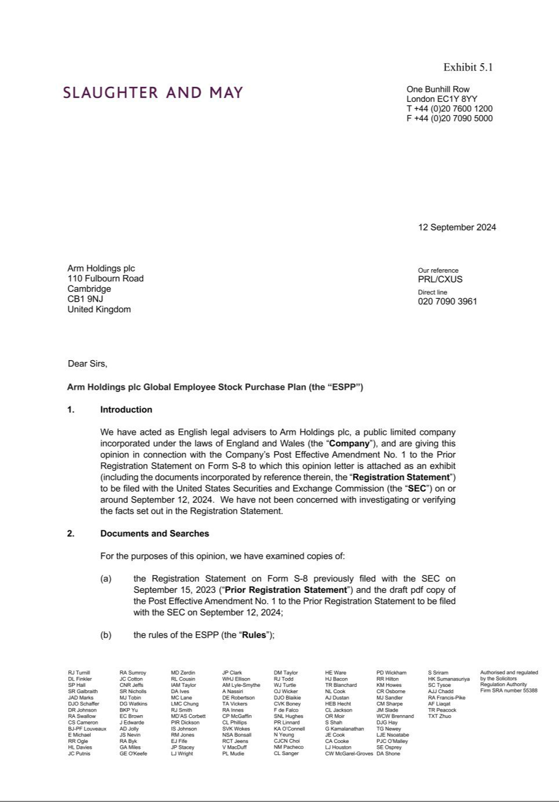

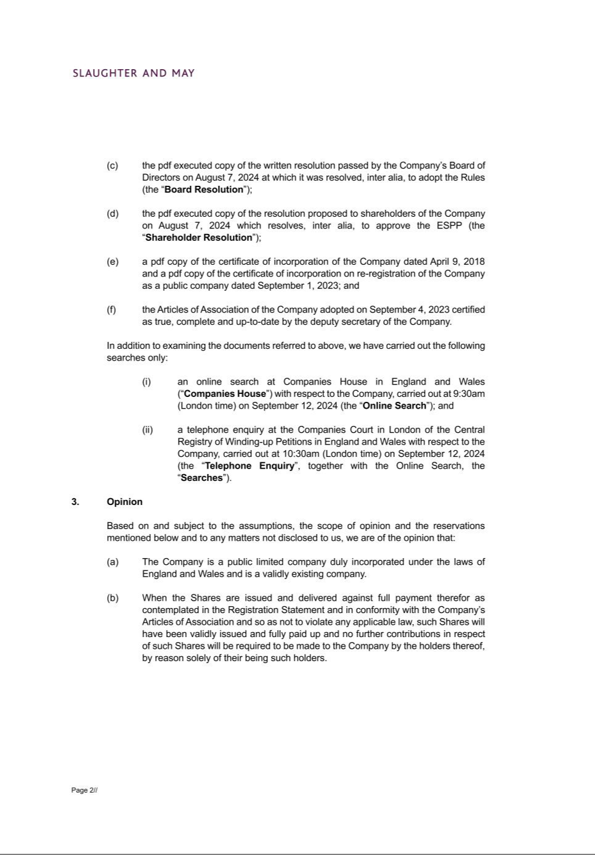

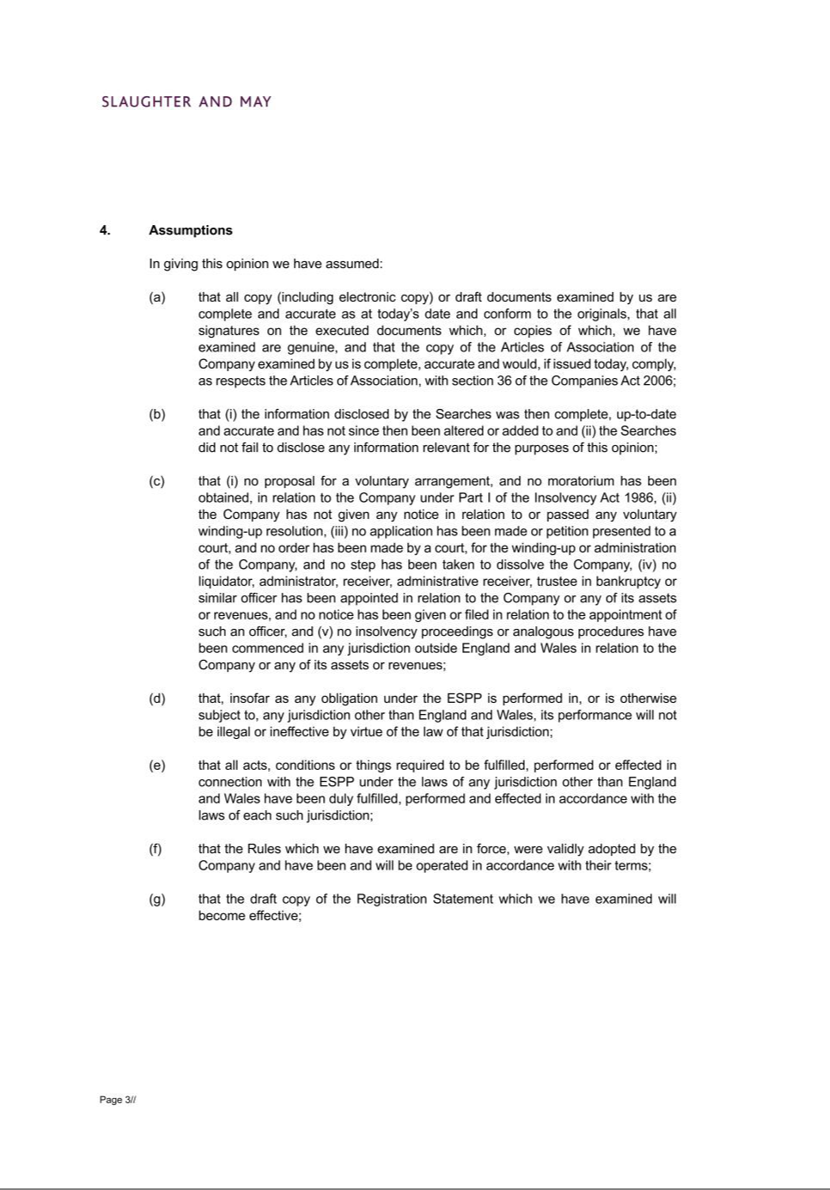

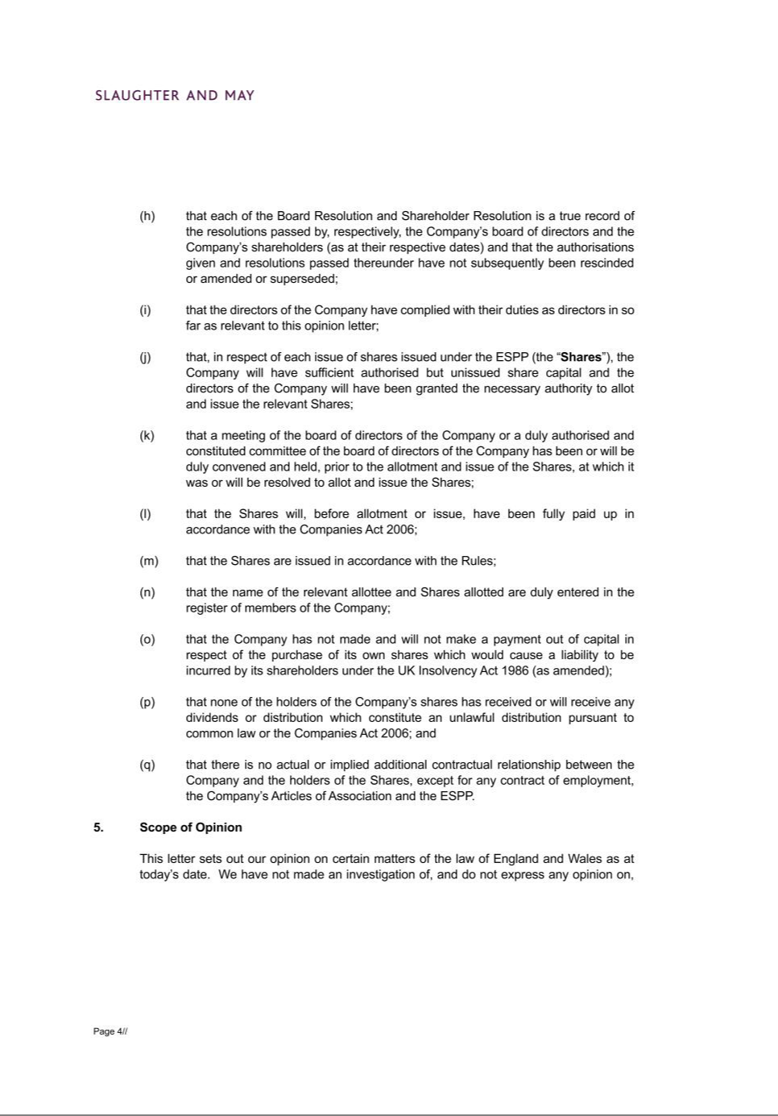

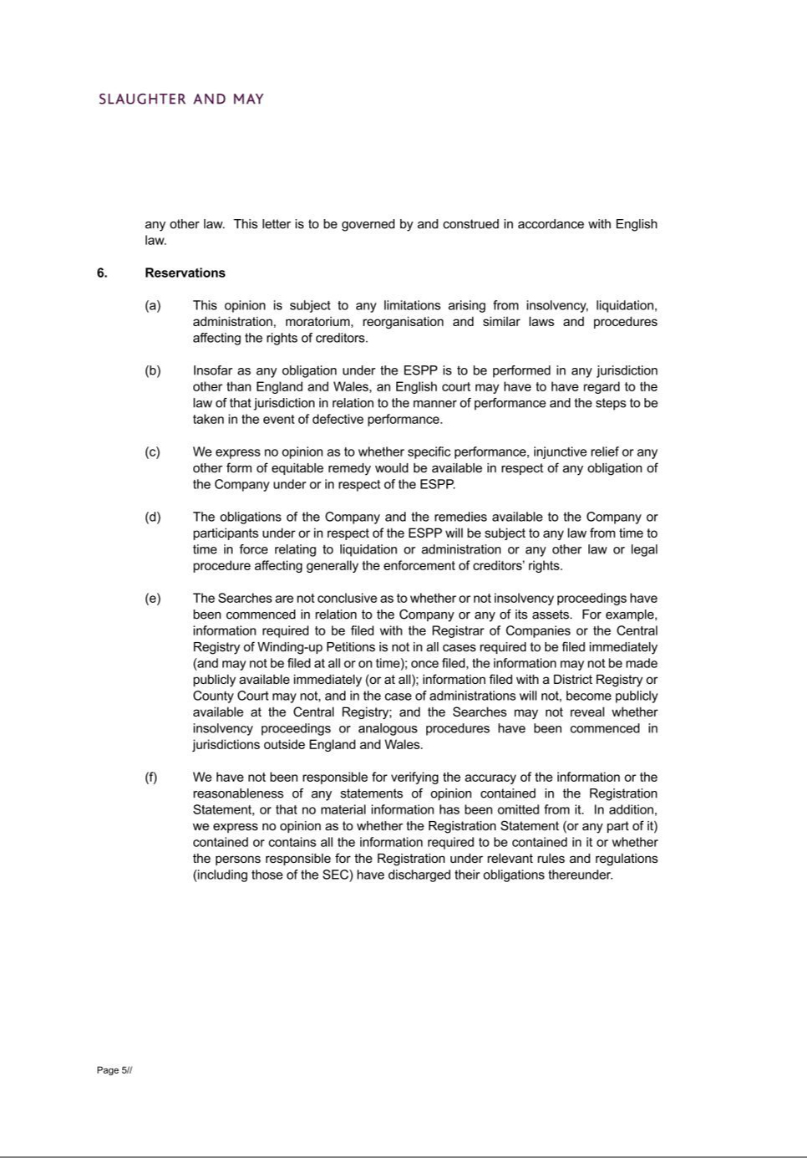

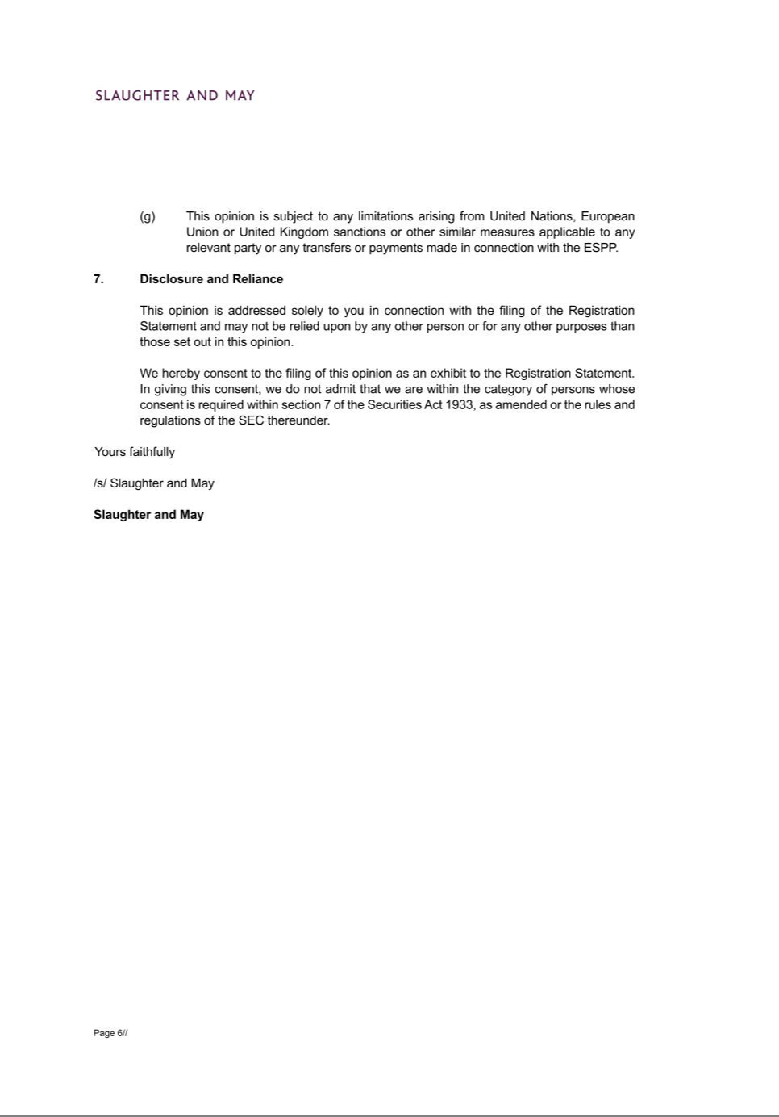

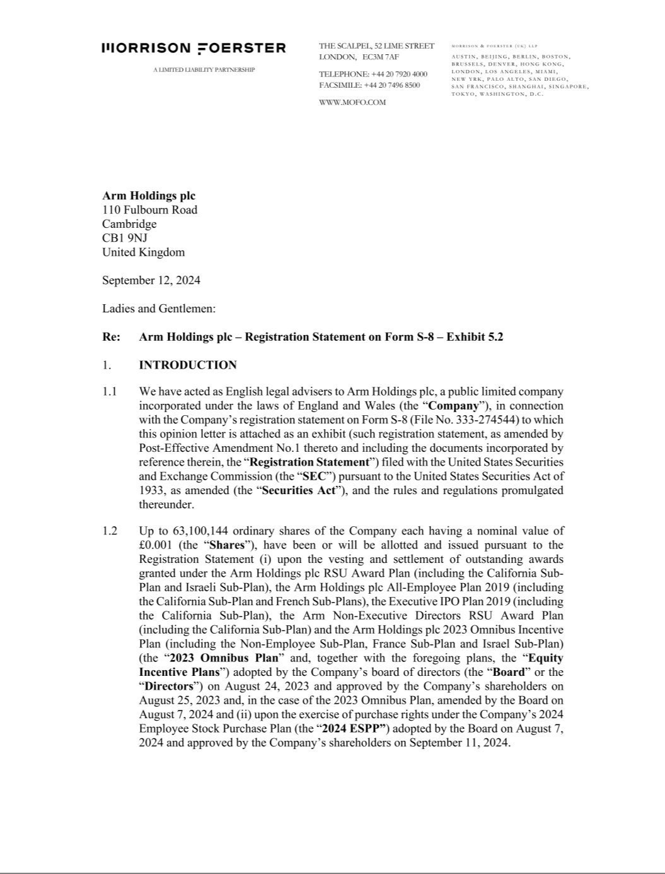

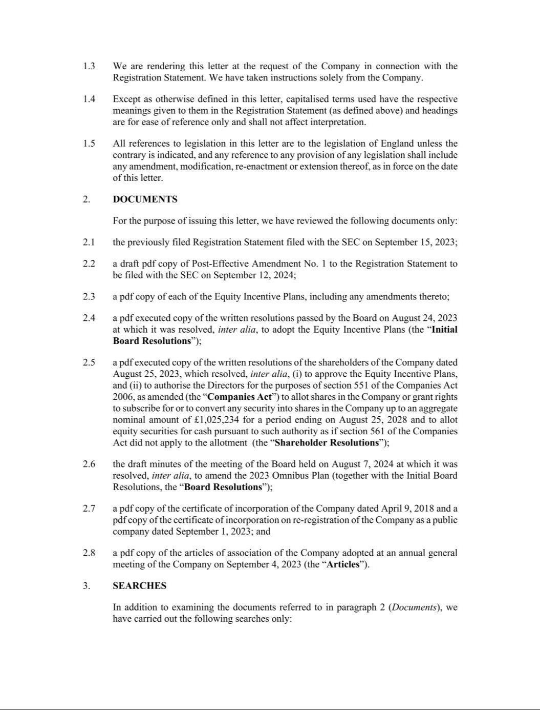

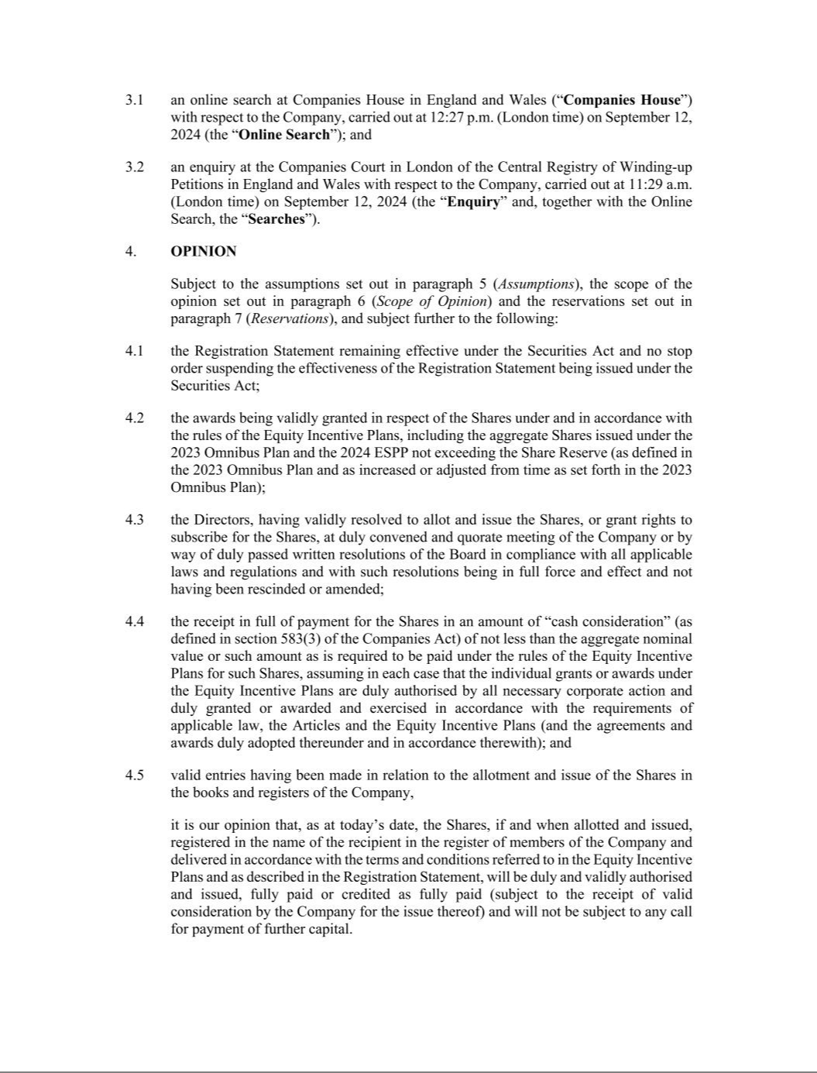

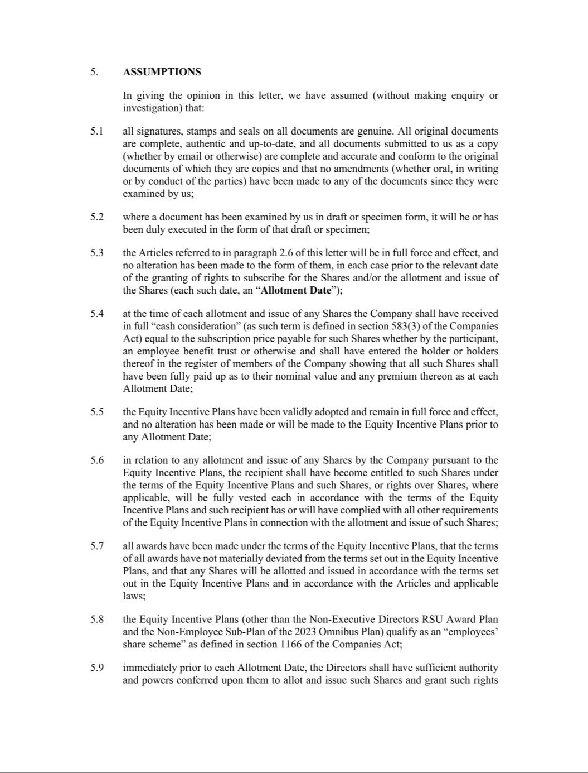

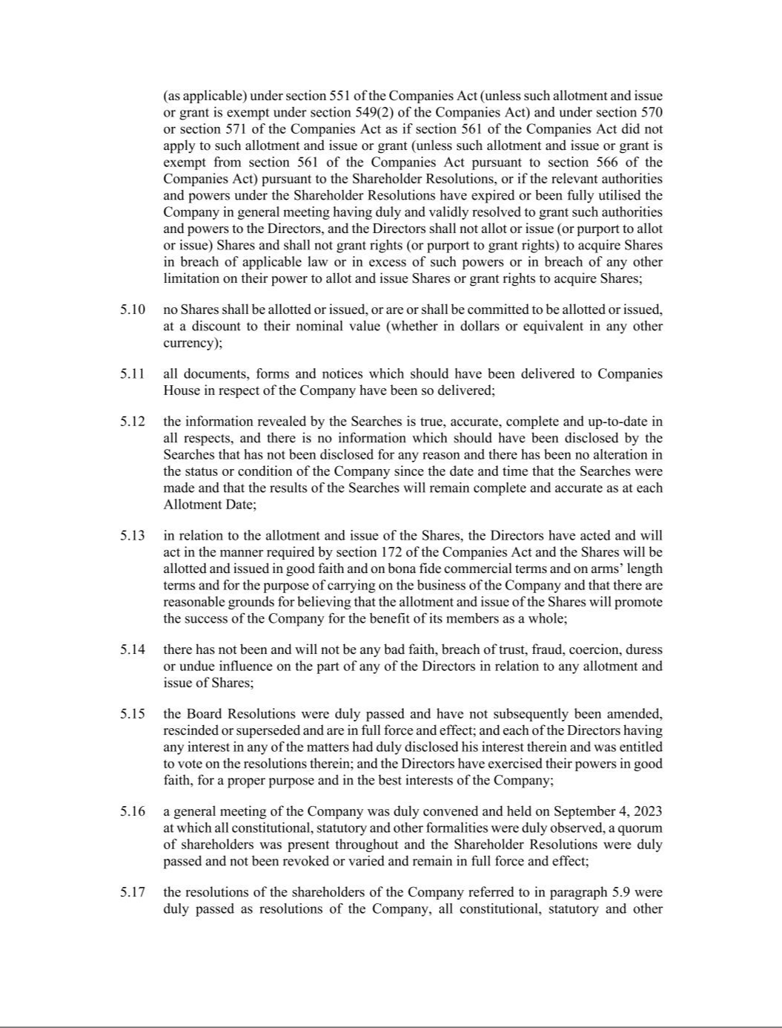

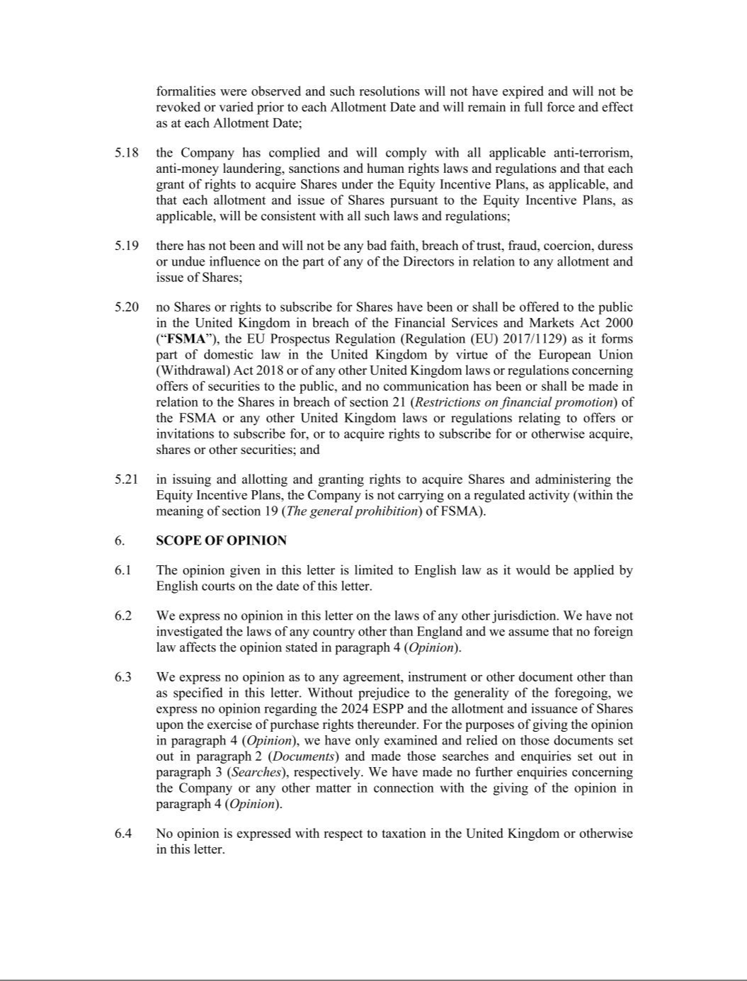

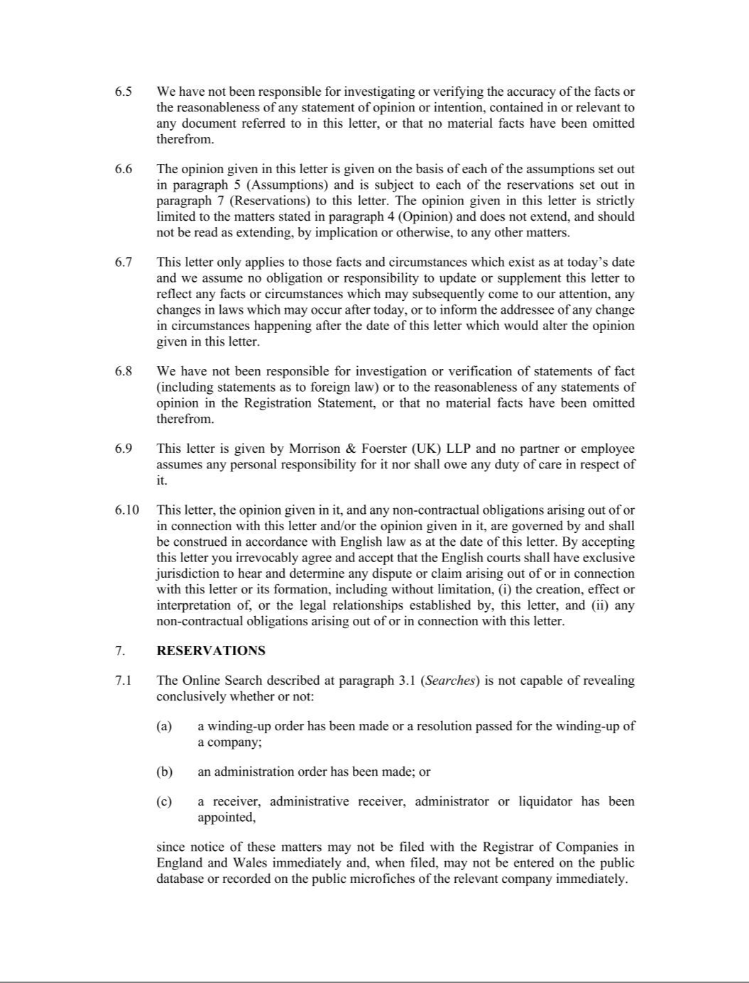

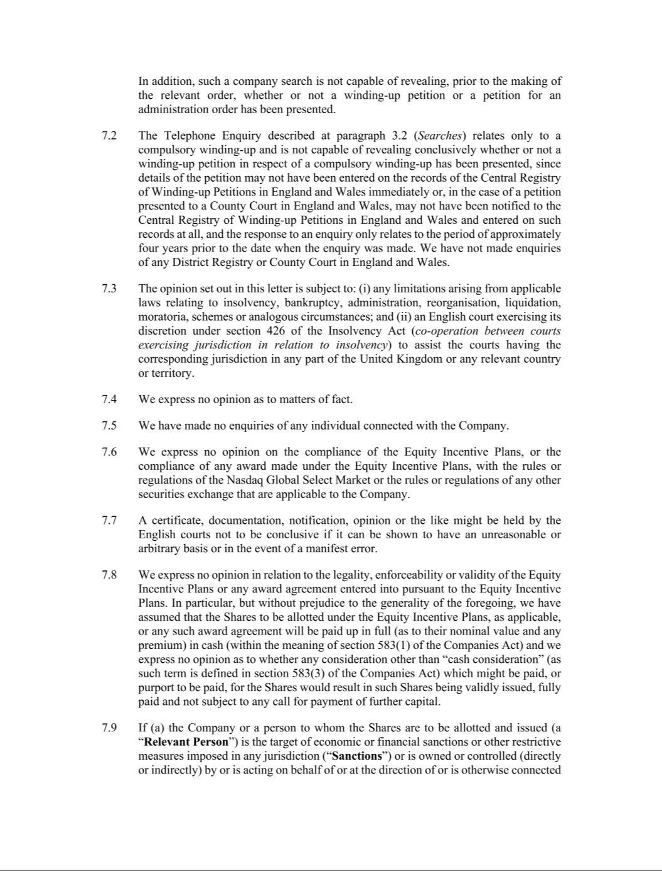

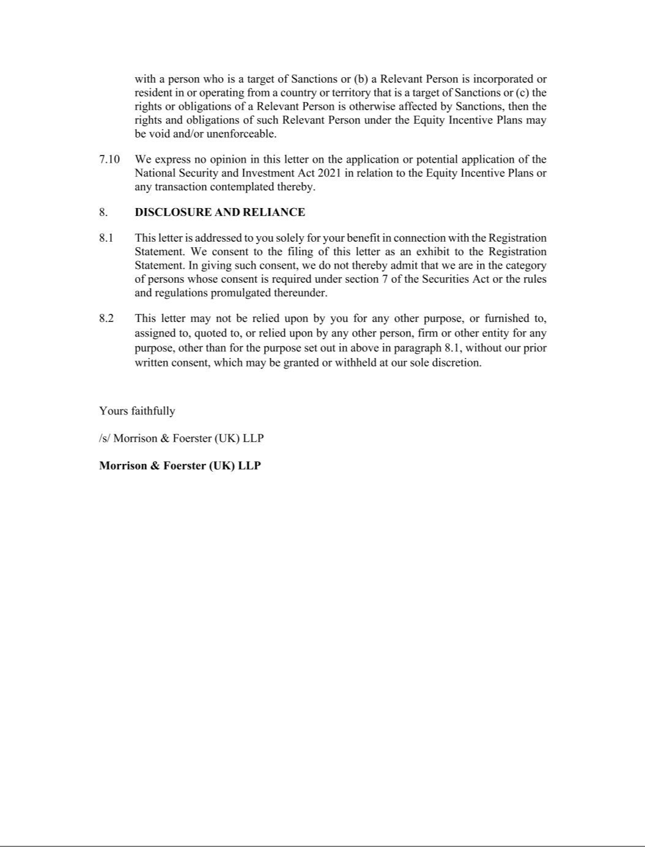

Exhibit 23.1

CONSENT OF INDEPENDENT REGISTERED PUBLIC ACCOUNTING FIRM

We consent to the incorporation by reference in the Registration Statement (No. 333-274544) on Form S-8 of our report dated May 29, 2024, relating to the financial statements of Arm Holdings plc, appearing in the Annual Report on Form 20-F of Arm Holdings plc for the year ended March 31, 2024.

/s/ DELOITTE & TOUCHE LLP

San Jose, California

September 12, 2024

